
MORNINGTON PENINSULA SHIRE
Place of Public Entertainment
Application for Temporary
Occupancy Permit

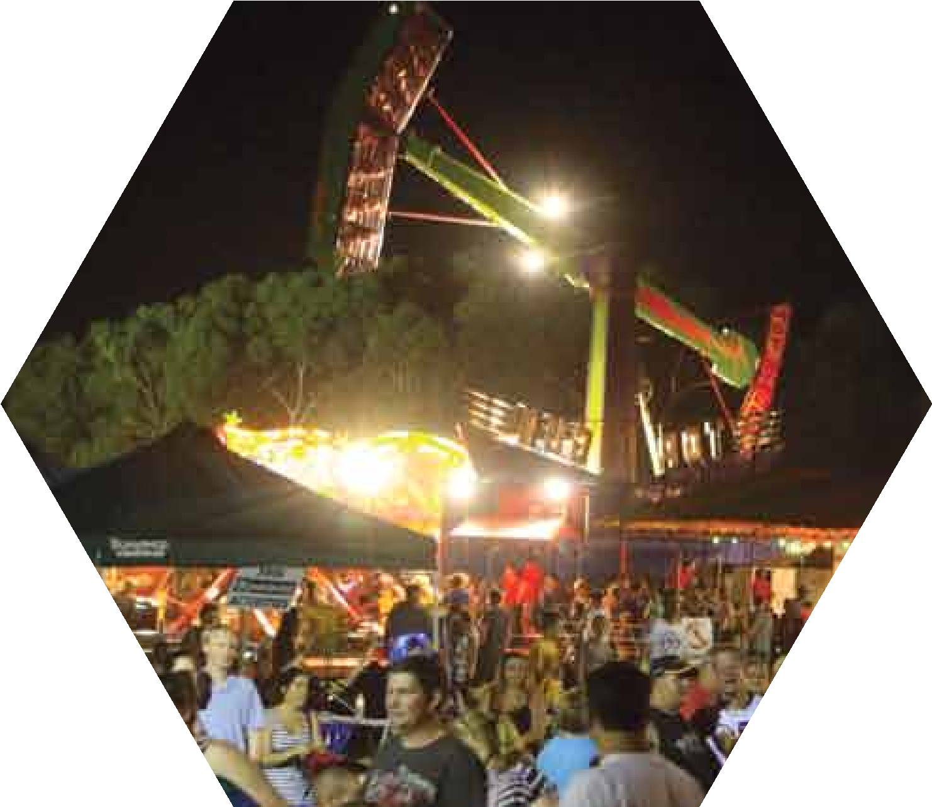

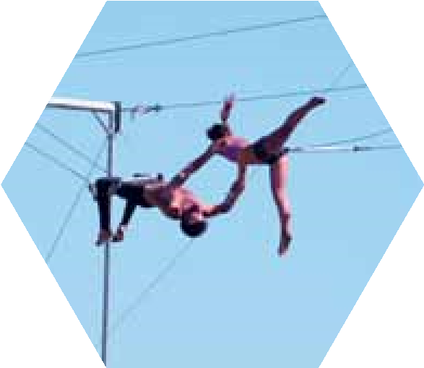

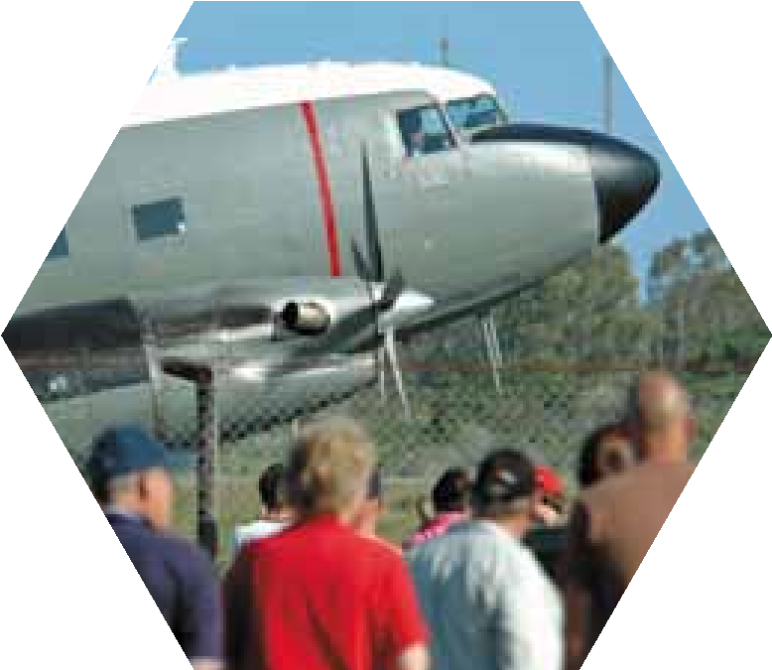

SECTION A
EVENT INFORMATION

Event Name
Event Location/Venue

Address of Venue

Is the event raising funds for a charity? Yes / No
Charity Exempt Number

Entry Fee/ticket price
Adult Child Consession Donation Yes/No
Event Website

Has this Event been held before? Yes / No
Brief Description of Event (intended audience, objective etc)

EVENT DATES/TIMES
Set Up (bump in) Date

Time

Event Start Times Date

Time

Event Finish Times Date

Time

Finish (bump out) Date

Time

ATTENDANCE

Estimated Spectators Estimated Participants

Estimated Peak Attendance (at any one time)

APPLICANT DETAILS

Organisation Name
Legal Status Not for Profit/Incorporated Registered Business

Contact Person

Postal Address
Mobile Phone

Email

SECTION B
FOOD AND BEVERAGE
Food will be Served Sold Given away

Please provide a list of food vendors attending your event

Vendor/Provider Streatrader Ref No

Vendor/Provider Streatrader Ref No

Vendor/Provider Streatrader Ref No

Vendor/Provider Streatrader Ref No

Vendor/Provider Streatrader Ref No

ALCOHOL
Will alcohol be available for consumption at the event Yes / No

Provider
Purpose

Serving Time Start Finish

EVENT INFRASTRUCTURE
Mark any of the following items at your event and provide details

Marquees Number Size Details
Stages Number Size Details
Lighting Equipment Number Size Details
Generators Number Size Details
Litter Bins Number Size Details
Recycling Bins Number Size Details
Portable Toilets Number Size Details
Amusement Rides Number Size Details
Other Structures Number Size Details

SECURITY
Will security be at the event? Yes No

Name of Provider
Contact Name Contact Number

No Personnel Start Time

FIRST AID

Name of Provider
Contact Name Contact Number

No of First Aid

Officers Start Time Finish Time

SAFETY OFFICER

Name of Provider
Contact Name Contact Number

No of Safety Officers Start Time Finish Time

TOILETS – Existing (on-site)

No. of Toilets on Site Male Female Accessible

Additional Toilets provided Male Female Accessible

AMPLIFICATION
Do you propose to have recorded or live music as part of your event? Yes / No
Will there be amplified noise on site? Yes / No
How will residents and/or businesses be notified of the amplification?
Letter Box Drop with organisers details Public Notice Other (Please specify)
Briefly explain the purpose and type of amplification being used at the event.

Hours of Amplification Start Finish
What time will sound testing begin? Start Finish
Event Day Contact for noise enquiries
Contact name Contact No.

TRAFFIC MANAGEMENT
Could your event impact the normal use of roads around your event site? Yes / No
What road/s will be effected?

Effected Times Start Finish

Other Details

If you are proposing to close a road or change normal traffic conditions, you will be required to supply a traffic management plan developed by a qualified traffic management company.

PUBLIC TRANSPORT
Will the event delay, detour or require additional public transport services? (Trains and/or buses) Yes / No
If Yes you may need approval from Public Transport Victoria (PTV) www.ptv.vic.gov.au

FIREWORKS
Are you using pyrotechnics or engaging a pyrotechnics (fireworks)display at the event? Yes / No
Name of Provider

Contact Name Contact No.

Display Start Time Display Finish Time

HIGH RISK ACTIVITIES
Are you engaging with any High Risk activity providers (motorcycle stunts, air displays etc) Yes / No

Activity Provider Contact

Activity Provider Contact

AMENITIES AND SERVICES
Shire managed reserves, park and foreshores have varying amounts of permanent amenities and services. In most cases a key is required to gain access to these services, please indicate below:
Does the event require access to restricted electrical outlets? Yes / No
Does the event require access to restricted water outlets? Yes / No
Does the event require access to restricted gates and entries? Yes / No
Does the event require access to restricted/locked public toilets? Yes / No
Please detail any other services required

EMERGENCY SERVICES
Have you notified the following organisations about your event?

Victoria Police Yes /No Station
Country Fire Authority Yes / No Station

Ambulance Victoria Yes / No Station

Please include the following with your application
Site Plan
Event Management Plan
Certificate of Currency
Emergency Management Plan
Risk Management Plan
Traffic Management Plan
VBA – Approval for any Prescribed Structures

For further information please contact the Statutory Building Team on 5950 1060.
Note – An invoice for the fee will be sent following initial assessment.

AUTHORISATION
I have the authority of the stated organisation to submit this application on behalf of the organisation and bind the organisation to comply with all the approval conditions, local laws and relevant legislation it generates. I declare that all details provided are true and correct and this event will be organised as described unless advised otherwise by Mornington Peninsula Shire. I understand that completing this event application does not constitute an event approval.
Name Position

Signature Date

Privacy Notification
I understand that the information being collected on this form is being collected by Mornington Peninsula Shire and event and contact information may be included on the Shires website and Shire printed publications.
This information will be subject to the Shires Privacy Policy and will be used solely for the purpose of promoting the event or activity. I understand that I may apply to the Shire to amend and update the information.

