|  |  |  |  |
| --- | --- | --- | --- |
| **GDP**  **(Australia)** | **Population (Australia)** | **Consumer Sentiment Index (Australia)** | **CO2 -e emissions**  **(Australia)** |
| **$544,222m (+3.2%)** | **25,766,605 (+0.5%)** | **99.2 (-4.1%)** | **497.7m tonnes (-3.6%)** |
| **GDP**  **(Victoria)** | **Population**  **(Victoria)** | **Consumer Sentiment Index**  **(Victoria)** | **CO2 -e emissions**  **(Victoria)** |
| **$132,262m (+10.8%)** | **6,559,941 (-0.05%)** | **100.6 (-3.9%)** | **83.27m tonnes (-5.8%)** |

In the last quarter, Australia's GDP increased by 3.2%. For Victoria, GDP increased by 10.8%. Population was up nationally, and down in Victoria. Consumer sentiment was down across the nation and down in Victoria. Total CO2-e emissions for the latest quarter decreased by -3.6% in Australia and decreased by -5.8% for Victoria.

**ECONOMY PEOPLE COMMUNITY ENVIRONMENT**

**Mornington Peninsula Shire Council**

**CONSUMER EXPENDITURE**

**Trending Down**

**Trend**

*Change in Total Local Spend*

**Daily Spending**

*Average Daily Spend by Day of Week*

**Peak Day** Saturday 22 January 2022: $15.7M

**Trough Day** Monday 07 March 2022: $9.04M

**JOB IMPACT**

**Net Negative**

**Estimated Impact on FTEs**

*Impact of Change in Total Local Spend*

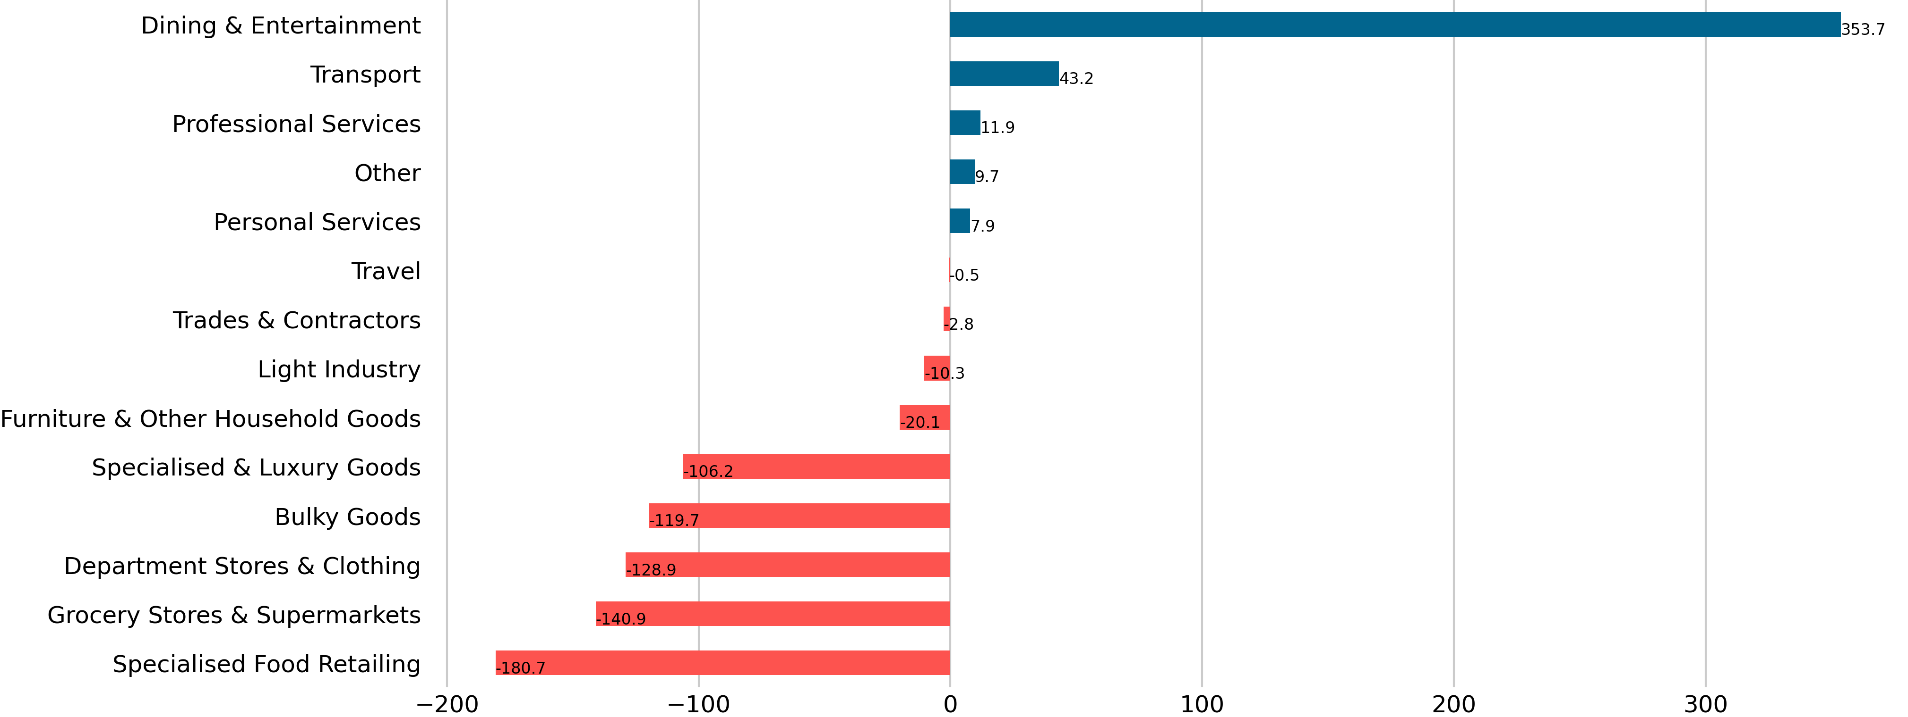

**Largest Increase** 353.7 FTEs, Dining and Entertainment

**Largest Decrease** -180.7 FTEs, Specialised Food Retailing

**Quarterly Economic Snapshot**



|  |  |
| --- | --- |
| **Victoria** | **Mornington Peninsula** |
| -5.7% | -1.2% |

|  |  |  |  |
| --- | --- | --- | --- |
| **Day** | **Total** | **Resident** | **Visitor** |
| Mon | $10.3M (-3.0%) | $6.33M (-7.4%) | $3.71M (+5.9%) |
| Tue | $10.5M (+0.7%) | $6.75M (-2.1%) | $3.5M (+6.0%) |
| Wed | $10.9M (-5.2%) | $6.92M (-11.6%) | $3.7M (+9.6%) |
| Thu | $11.8M (-5.3%) | $7.71M (-9.0%) | $3.8M (+2.5%) |
| Fri | $13.4M (+1.5%) | $8.14M (-6.0%) | $4.94M (+16.7%) |
| Sat | $13.8M (+9.2%) | $6.81M (-8.3%) | $6.65M (+35.1%) |
| Sun | $10.7M (+11.5%) | $5.21M (-5.9%) | $5.3M (+35.7%) |

Jan-22 to Mar-22

Sources: ABS, Cat. Nos. 3101.052, 5206.001, 5206.027; ABS Census 2016; Spendmapp.com.au; industry.gov.au; DISER, 2020

**SELF-SUFFICIENCY**

**Stable**

**WALLET SHARE**

**Escaping**

**Mornington Peninsula Shire Council**

**The Commuter Effect**

*Escape Spend and Commuting*

**Share of Resident Wallet**

*Latest and Previous Quarter*

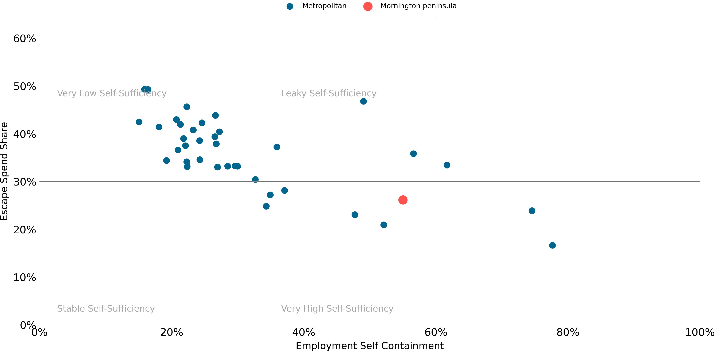

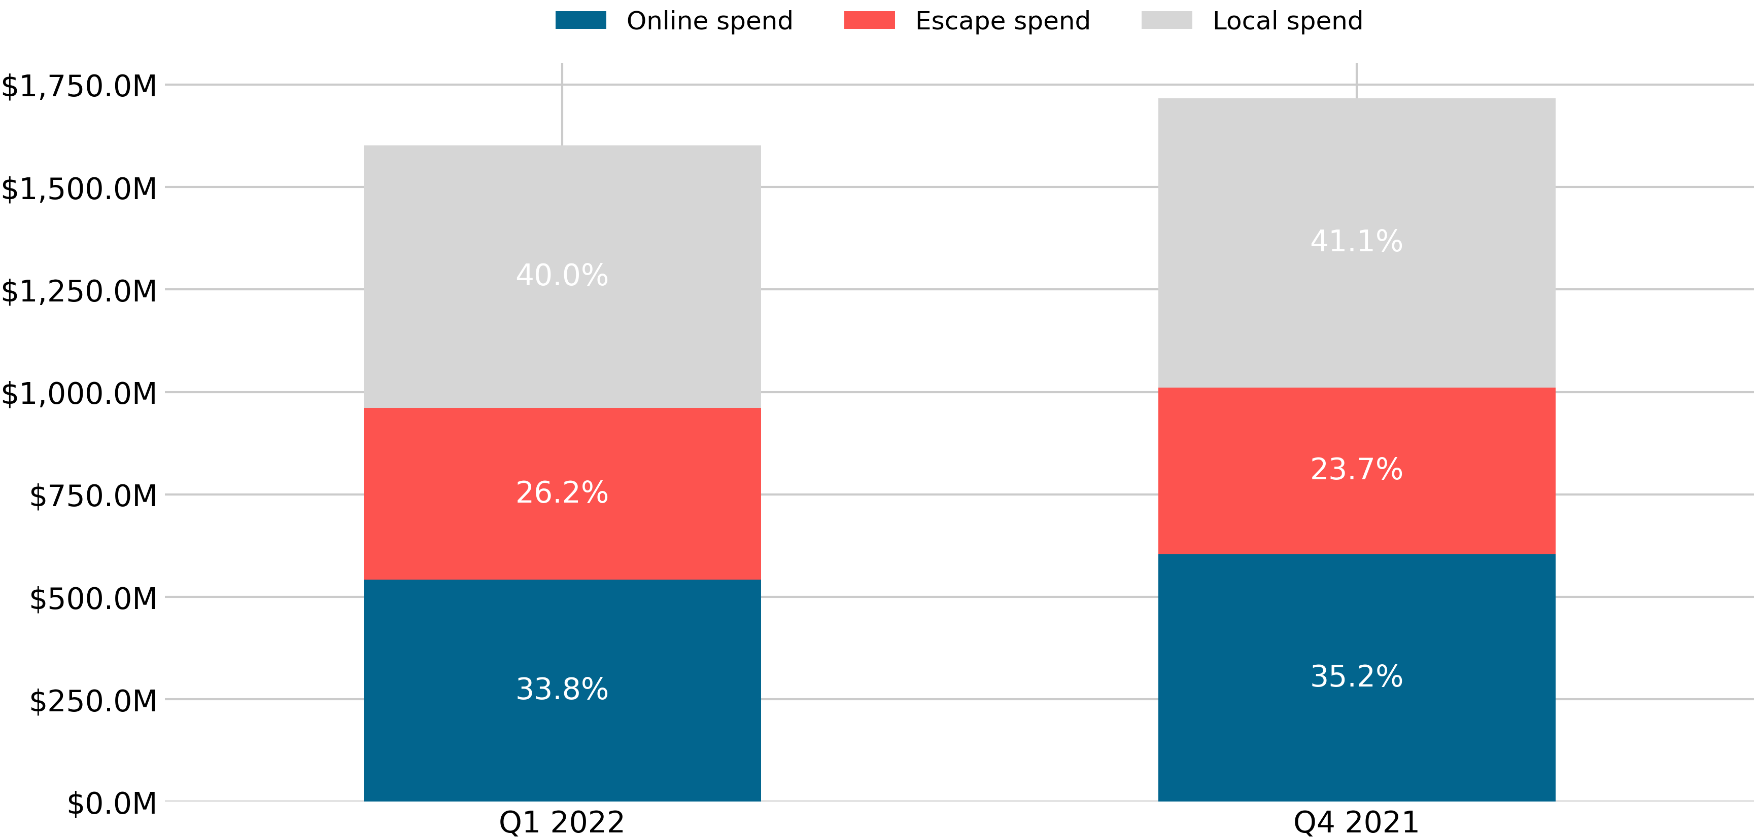

**Quarterly Economic Snapshot**



|  |  |  |
| --- | --- | --- |
| **Spend** | **Victoria** | **Mornington Peninsula** |
| Local Spend | -1.7% | -1.1% |
| Escape Spend | +2.2% | +2.5% |
| Online Spend | -0.5% | -1.4% |

Jan-22 to Mar-22

Compared with the previous quarter, in Q1 2022:

* Mornington Peninsula saw more escape spend as a share of Resident Wallet; and
* Escape spend in Victoria saw the greatest increase in share.

Compared with other Metropolitan councils, in Mornington Peninsula:

* There is very high economic self-sufficiency.
* There is high employment self-containment (based on the last Census).
* Resident Escape Spend has a low share of Resident Wallet.

*Change in Resident Wallet Share*

**Trend**

**Disclaimer**

This document has been prepared by Geografia Pty Ltd for Mornington Peninsula Shire Council and is intended for its use only. Any use of material from the report should be appropriately cited (i.e. source: Spendmapp by Geografia). While every effort is made to provide accurate and complete information, Geografia does not warrant or represent that the information contained is free from errors or omissions and accepts no responsibility for any loss, damage, cost or expense (whether direct or indirect) incurred as a result of a person taking action in respect to any representation, statement, or advice referred to in this report.