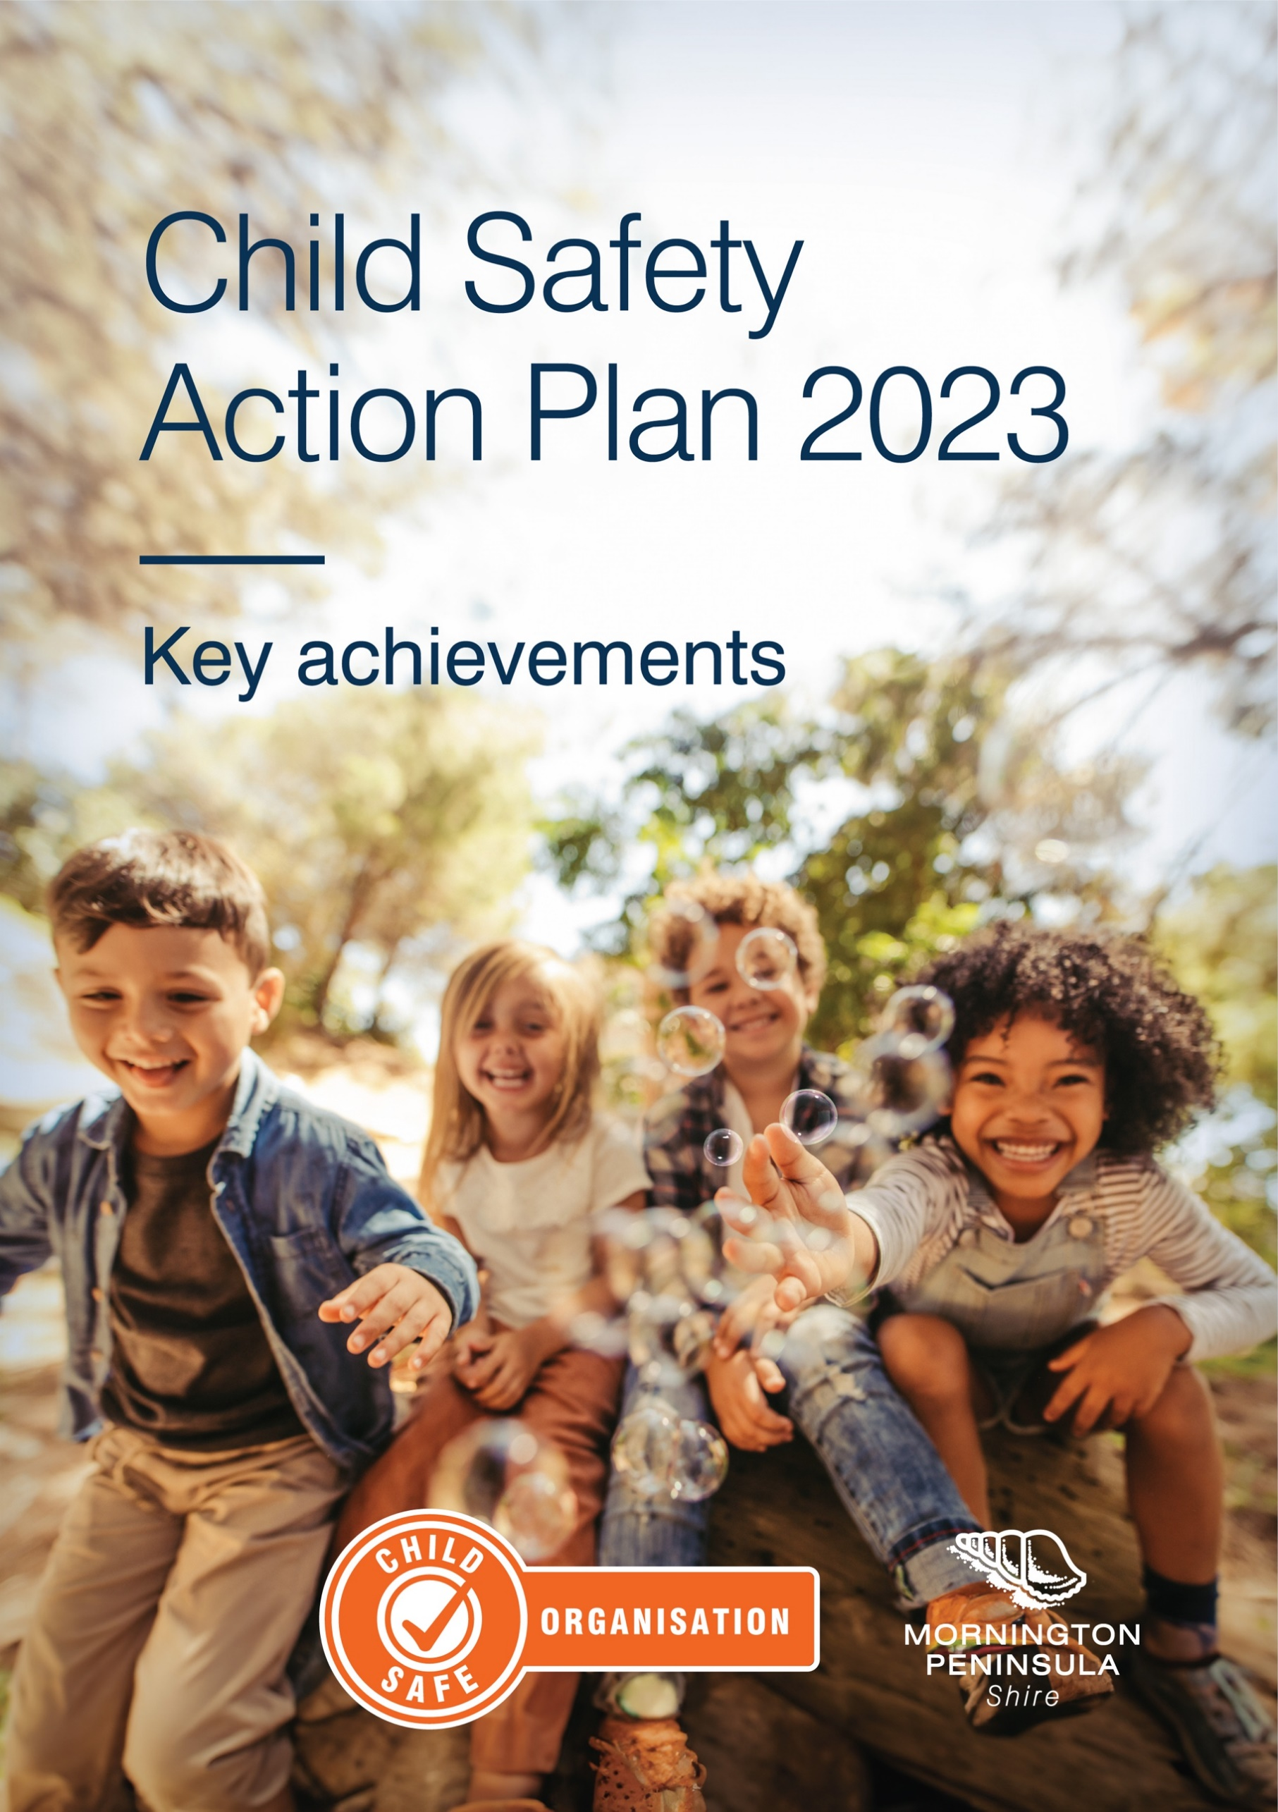

**Our Child Safe Commitment**

Mornington Peninsula *Shire* is committed to the safety and wellbeing of children and young people. We have zero tolerance of child abuse and robust training, policies and procedures in place to protect children from abuse and respond to any risks, allegations or safety concerns.

We want all children and young people to be and feel safe, welcome and included in our services and empowered to achieve their dreams, goals and aspirations for a bright future.

We take steps to ensure the voices of our children, young people and families are heard and we are proud to celebrate the diversity of our community.

We are unapologetically proactive in closing the gap for Aboriginal and Torres Strait Islander children and young people and supporting them to express their culture and enjoy their cultural rights.

We welcome and value the participation of all children and young people, including Aboriginal and Torres Strait Islander children, children with disabilities, children from culturally and linguistically diverse backgrounds, those that are unable to live at home and our LGBTIQA+ community.

We are proud to be a Child Safe Organisation.

**The Child Safe Standards**

The Victorian Government introduced a suite of legislative reforms that aim to improve child safety in organisations. In late 2015, the [Child Wellbeing and Safety Amendment (Child Safety Standards) Act 2015](https://www.legislation.vic.gov.au/as-made/acts/child-wellbeing-and-safety-amendment-child-safe-standards-act-2015), was passed in the Victorian Parliament, which introduced the Child Safe Standards to create and maintain child safe environments for organisations that work with children (or have regular and direct contact with children).

In 2019 the Victorian Government conducted a review of the [Child Safe Standards](https://ccyp.vic.gov.au/child-safe-standards/). Following the review, the Victorian Child Safe Standards were updated and came into effect on 1 July 2022. There are now eleven Standards with corresponding action areas (replacing the previous seven Standards). The new Standards provide greater clarity for organisations on the minimum actions required to meet each Standard by setting out 50 minimum requirements that organisations must meet.

The Standards are a compulsory framework that support organisations to promote the safety of children by requiring them to implement policies to prevent, respond to and report allegations of child abuse and harm, whether caused by adults or by other children. They are designed to drive cultural change and embed a focus on child safety by placing children’s rights and wellbeing at the forefront of everything an organisation does.

**Child Safety Action Plan 2023**

The *Shire* recognises its legal and moral responsibilities to keep children and young people safe from harm; it promotes their health and wellbeing and supports their best interests. The *Shire* continues to strengthen its approach in embedding its Commitment to child safety and building a culture where children’s safety and wellbeing is at the centre of its thoughts, values and actions.

The Child Safe Standards lay the foundation for the Shire’s Child Safety Action Plan 2023 and was developed in consultation with key stakeholders to provide a strategic framework for co-ordinating and implementing actions and initiatives that maintain and progress child safety both within the *Shire* and the community.

The following key achievements are from the Child Safety Action Plan 2023.

**Child Safe Working Group**

TheChild Safe Working Group supports the implementation of the organisation’s Child Safe Action Plan. Members will lead and support the culture of the organisation to be one that is child safe through ongoing reviews of processes and updating policies pertaining to the Child Safety Standards, and set out in the [*Child Wellbeing and Safety Act (2005)*](https://www.legislation.vic.gov.au/as-made/acts/child-wellbeing-and-safety-amendment-child-safe-standards-act-2015).

**KEY ACHIEVEMENTS**

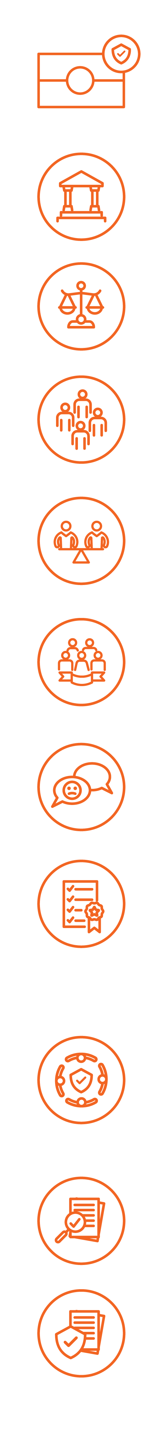 Victorian Child Safe Standard 1

**Organisations establish a culturally safe environment in which the diverse and unique identities and experiences of Aboriginal children and young people are respected and valued.**

The *Shire’s* Child Safety and Wellbeing Policy embeds its commitment to Aboriginal and Torres Strait Islander children and young people, ensuring an environment where they feel respected and valued. To reinforce this commitment all staff now have access to Cultural Awareness and Respect Training which ensures staff are aware of our expected behaviours and zero tolerance of racism.

To continue to enrich the lives of the community, the Maternal Child Health Service distributes cultural welcome packs to all families who identify as Aboriginal or Torres Strait Islander people and ensure that they are offered appropriate Key Age and Stage Programs.

Victorian Child Safe Standard 2

**Child safety and wellbeing is embedded in organisational leadership, governance and culture.**

Mandated online Child Safety training is now available to all staff and volunteers no matter what their role within the Shire is. Additionally Face to Face Child Safe Training for all staff that have or may have direct contact with children and young people has been developed and adopted mid-year with training sessions over June, July, September & November. This training aims to strengthen and promote strategies that raise awareness about child abuse, keeping children safe and responding to child harms and incidents.

An Internal response Team has been established to investigate and report child safety concerns. This group also fosters an approachable environment for staff to consult and discuss concerns around child safety.

Victorian Child Safe Standard 3

**Children and young people are empowered about their rights, participate in decisions affecting them and are taken seriously.**

Our Youth Services Team, with young people now discuss and set up expected norms at the beginning of every youth group meeting/activity. These are then displayed at the centre so that all attending the centres are aware of the rules and expected behaviours. Youth Services and Maternal Child Health conduct surveys for feedback from participants on activities and programs. This information is then used to review, change, and offer different programs in the future.

Commission for Children and Young People, Empowerment and participation guide is a mandate our Youth Services Team. It shows ways to empower children and young people and foster their participation as an important measure to prevent abuse, as well as responding to it effectively. The Youth Advisory Committee was designed using these principles.

Victorian Child Safe Standard 4

**Families and communities are informed and involved in promoting child safety and wellbeing.**

The Shire has reviewed and developed a Mornington Peninsula Shire, Child Safety webpage which contains Child Safety information, resources, and contacts for support. This is designed to connect with our community and enhance their knowledge about child safety.

Child Safe Standards Community Information sessions were held in October at three locations across the Peninsula. These sessions were designed to help the local community, businesses, sport or recreation groups and volunteers to strengthen their capacity to provide a safe and empowered environment for all children and young people.

Victorian Child Safe Standard 5

**Equity is upheld and diverse needs respected in policy and practice.**

The Youth Advisory Committee has developed a child friendly version of the Mornington Peninsula Shire’s Code of Conduct and Child Safety and Wellbeing Policy. This highlights the behaviours that children and young people want to see when adults have contact with them. These are now located at various venues including Community Centres, Youth Services, Customer Service Centres and Libraries.

Gender Equity Training is now available to staff which explores definitions of gender and gender equity, understanding the link between gender inequality and family violence and how gender equity can be addressed in workplace and community settings.

Victorian Child Safe Standard 6

**People working with children and young people are suitable and supported to reflect child safety and wellbeing values in practice.**

All advertising for Shire vacant positions includes a statement of commitment to child safety, diversity and inclusion. We promote our commitment to creating a diverse and safe environment and are an equal opportunity and Child Safe employer. We welcome applicants who identify as Aboriginal or Torres Strait Islander; have disability; and/or a culturally and linguistically diverse (CALD) background.

As an employer, we are committed to providing an environment that is safe and engaging and therefore also require Police and Working with Children Checks for all positions.

Victorian Child Safe Standard 7

**Processes for complaints and concerns are child focused.**

We have reviewed our Complaints Handling Policy to include various ways to make a complaint, information about the support and assistance that will be provided to those making the complaint and Reportable Conduct Scheme information. Additionally, a one-page accessible complaints flowchart has been developed and can be accessed on the Mornington Peninsula Shire website.

Further, our Customer Support staff have been trained in child safety and are equipped to take customer complaints and concerns on child safe incidents and forward this to the Child Safe Coordinator (this includes both during and after business hours).

Victorian Child Safe Standard 8

**Staff and volunteers are equipped with the knowledge, skills and awareness to keep children and young people safe through ongoing education and training.**

The Shire has made available a range of professional training and resources to increase the knowledge of our staff about Child Safety (Victorian Child Safe Standards) and the Reportable Conduct Scheme. The Shire has mandated online Child Safe training for all staff. Further, 459 staff and volunteers who are likely to, or have contact with children and young people have completed face to face training.

Information for all our staff is accessible on an internal software system and this includes a Reportable Conduct Incident Report flowchart, online child safe incident reporting forms, training opportunities, child safe resources and child safe consultation contact details.

Victorian Child Safe Standard 9

**Physical and online environments promote safety and wellbeing while minimising the opportunity for children and young people to be harmed.**

To better protect our children and young people the *Shire* has developed a suit of documents for information at all our Libraries. These include a Conditions of Entry poster, an Online Safety Statement, and a ‘no photograph’ practice.

Further to this the Shire’s Child Safety website has information for parents about how to keep their children safe online and our Youth Services team have an online safety checklist which they go through whenever they have online meetings with young people.

Victorian Child Safe Standard 10

**Implementation of the Child Safe Standards is regularly reviewed and improved.**

The Shire’s Child Safe Working Group was reinvigorated in early 2023 to support a workplace culture that is transparent and a continually improving environment in relation to child safety and wellbeing through communication, education and advocacy.

This group ensures the Child Safety Action Plan is implemented and the requirements are met within agreed timeframes. They have developed guidelines to address breaches of the Child Safe and Wellbeing Policy and procedures and reviewed child safety documentation.

Victorian Child Safe Standard 11

**Policies and procedures document how the organisation is safe for children and young people.**

Over 2023 the Shire has reviewed, developed and implemented various child safety processes and documents for both staff and the community to ensure the safety of children and young people.

These include:

* A child Safe Commitment
* A revised MPS Child Safety webpage which has various information, polices, procedures and resources and a link to our Community Child Safety Reporting Flow Chart [Child Safety Commitment - Mornington Peninsula Shire (mornpen.vic.gov.au)](https://www.mornpen.vic.gov.au/About-Us/About-Our-Organisation/Child-Safety-Commitment)
* Revised Complaints Policy and Accessible Complaint Process Flowchart - [Complaints - Mornington Peninsula Shire (mornpen.vic.gov.au)](https://www.mornpen.vic.gov.au/Contact-Us/Complaints)
* [Reportable Conduct flow chart](https://www.mornpen.vic.gov.au/About-Us/About-Our-Organisation/Child-Safety-Commitment) for both staff and the community

**WHERE TO FROM HERE?**

Mornington Peninsula Shire is excited about how we can continue to work to build a culture in which children’s safety is embedded in everyday thinking and practice.

Children deserve to feel safe and protected by the Shire when they interact with us. They need to feel confident sharing their views and concerns and trust that these will be heard and taken seriously.

A two-year Child Safety Action Plan 2024-2026 has now been developed to strengthen actions and our commitment to safeguarding children and young people and embedding the Child Safe Standards Shire-wide.

Key focus areas of our Child Safety Action Plan 2024-2026 areas will be:

* investigation of a Shire-wide Child Safety Risk Assessment and Management Plan 2024. This will lead to an organisational wide risk assessment to identify child safety risks and document controls.
* more input from our community, children and young people on child safe documentation. This will ensure that we are developing child friendly and easy to understand documents.
* more community information sessions centred around specific child safe standards. This means the Shire will receive feedback on its approach to child safety and wellbeing, whilst educating the community to understand their obligations and equipping them with information and resources to keep children and young people safe.
* relationships being formed and built with relevant cultural peak bodies to understand the diverse circumstances and needs of children and young people within their community. This will enable a continued effort by the Shire to establish a culturally safe environment in which the diverse and unique identities and experiences of children and young people are respected and valued.
  + strengthening our procurement, lease and contract agreements to be in line with the Child Safe Standards and ensure child safety is embedded in these documents. When engaging third-party contractors the Shire will ensure that our processes prevent or reduce risks of child abuse or harm. This will include requiring third-party contractors to comply with the organisation’s policies and procedures, monitoring compliance with the Child Safe Standards and working with third-party contractors to identify, prevent and reduce risks of child abuse and harm.
* staff continuing to participate in professional development programs to increase their skills when working with children and young people. This will ensure staff adopt appropriate safeguarding practices and behaviours when carrying out their roles.
* enhanced empowerment of children in programs and services so they are aware of their rights and responsibilities. This will help them speak up about what’s important to them, including if something is wrong.

