

MONTHLY REPORT
TO THE COMMUNITY AND
FINANCE REPORT

SEPTEMBER 2015



Your Councillors

0 1 2 3 4 5 km
Effective - August 2014

TABLE OF CONTENTS

Unit Summaries
Chief Executive Officer’s Group | 1
1. Chief Executive Officer’s Summary | 2
2. Economic Development | 3
3. Corporate Planning | 6
4. Governance | 7
5. Customer Service | 8
Corporate Services | 9
6. Chief Financial Officer | 10
7. Director Communities | 12
8. Child, Youth and Family Care | 13
9. Aged and Disability Services | 15
10. Libraries, Arts and Culture | 16
11. Information Services | 18
12. Finance | 20
13. Property and Valuation | 21
14. Communications and Events | 23
- Human Resources  - Environment Protection | 25  26
Infrastructure and Planning | 27
17. Chief Operating Officer | 28
18. Strategic Planning | 29
19. Statutory Planning | 31
20. Building and Planning Compliance | 33
21. Infrastructure Strategy | 34
22. Infrastructure Maintenance | 36
23. Project Delivery | 38
24. Renewable Resources | 40
25. Buildings and Facilities | 43
Capital Works Overview | 44

The Monthly Report to the Community summarises, for the information of the community and other interested stakeholders, all of the many activities of the Shire for the preceding month, ranging from policy development and implementation through to service delivery, the provision of infrastructure, and the Shire’s financial position.
Given the scope of the Shire’s wide ranging activities, there is a great deal to report. Every effort is made to provide information in a readily understandable, easy-to-read form.

Any resident, ratepayer or other stakeholder seeking further information should contact the relevant Shire manager or director, or in the first instance can contact:
Communications Ph. 5950 1200

CHIEF EXECUTIVE OFFICER’S GROUP

Reporting direct to the Council, the Chief Executive Officer (CEO) leads the entire Shire administration and his key reports include the Chief Financial Officer (as the head of the Corporate Services Group) and the Chief Operating Officer (as the head of the Infrastructure and Planning Group).

Other direct reports to the CEO who, along with their teams, form the Chief Executive’s Group are:

- Governance (Governance and Mayor & Councillor Support)
- Economic Development & Tourism
- Corporate Planning
- Customer Service

CHIEF EXECUTIVE OFFICER’S SUMMARY

Dear Ratepayers and Residents of Mornington Peninsula Shire,

I am pleased to provide for your information, on behalf of your Council, the Monthly Report for September 2015. The September Report marks the end of quarter one of the financial year (Q1) and at such time, within the organization we take time to review what we achieved against all of our targets for Council, to make sure we are delivering on goals for serving the community as effectively as possible.

I am pleased to report that we have made a very positive start to the new financial year, with solid progress made in all areas. Most pleasingly as a Shire we are on track to deliver our capital works program, including the carry forward amounts from the previous financial year. At the end of Q1 we have over 30% of works programmed and committed.

The Shire released an Expression of Interest (EOI) into the market to replace our telecommunications infrastructure which is very outdated now. Thirty eight different vendors participated in the process and during October we will begin the shortlisting process. The new Unified Communications infrastructure will allow us to provide you with better service and internally will enable officers to be more effective in their work time by cutting down travel, reducing carbon emissions and allowing information sharing to be real time, further improving efficiency.

Elsewhere in the Shire organization our Economic development team have worked very hard to finalise the Mornington Peninsula Shire Economic Development Strategy 2016-2019 for Council. This document, to be approved by Council in October is an important blueprint for Council to shape the future activities of the Shire to help grow our local economy, create employment and enhance the overall amenity of the Shire.

During September Council approved the Annual Report for the Shire, this is available on the Shire’s web site and is a comprehensive summary of operations for the previous financial year. It highlights the tremendous amount of work your Council has managed to action throughout the year and we recognize that there is much more to be done and my management team and all officers understand this and are working hard to deliver more effectively throughout this financial year and beyond.

We welcome any feedback you care to give us and will continue to strive for improvement in serving the communities needs.

ECONOMIC DEVELOPMENT AND TOURISM

Business Engagement
The Economic Development Unit has met with 10 local Mornington Peninsula businesses on a variety of areas this month. The topics of discussion have included expansion opportunities, advocacy support with state government or specific business issues.

Discussions have been held and information provided to 2 external businesses who are exploring options to locate to the Mornington Peninsula.

The following networking and industry association activities have occurred for the month:
- Food Industry Advisory Body (F.I.A.B) – monthly meeting to implement actions from Local Food Strategy
- Victorian Farmers Federation (V.F.F) regarding discussions on establishing an Agribusiness Network
- Queen Victoria market – identifying opportunities for a Mornington Peninsula regional provenance stand in Melbourne
- Business in the Rye Industrial Estate – met with businesses to discuss opportunities to support their business growth and how businesses can work together to promote each other
- Western Port Oberon Association – update on project and discussions regarding funding submissions to other levels of government
- Marine Alliance business workshop –workshop hosted by Marine Alliance with various other industry sectors represented. Marine Alliance hosted the workshop to discuss opportunities of working with other sectors
- Rye Beach Business Association – attended meeting to provide support for their projects
- Support has been provided to a number of art gallery businesses who are wishing to establish a local association to undertake joint promotion activities

Commercial Activities on Footpaths
Type of Permit | Approved Permits | Permits Pending | Expired/Cancelled
Liquor Licence Permits | 8 | 1
Footpath Permits Renewals (373 posted) | 65 | 10
Footpath Permits New Applications | 5

Chamber Support
Main Street Mornington Activity Centre Special Charge Scheme
Feedback has been received by VCAT that there were no objections lodged regarding the Special Charge Scheme for the Main Street Mornington Activity Centre. A management agreement has been provided to the Mornington Chamber of Commerce and Industry for their approval to enable payments to commence.

Chamber of Commerce Coordinators
Meetings with Chamber coordinators have been taking place to support Chambers to undertake joint projects and identify areas where they can group purchase to enable savings.

Research
Nursey Industry Audit
The final research stages of the Nursey Industry Audit are being undertaken. The Nursery and Garden Industry Victoria association has been consulted providing information on the industry at a strategic level.

TOURISM

Destination Promotion

Official Visitor Guide
The new look regional visitor guide is well into production with 115 businesses advertising. The Guide will be used as an ‘offline’ planning and dreaming tool for visitors with a greater focus on out of region distribution. The Guide will also be available as three download eBooks (To Do, To Stay and full guide) that will be available via the Regional Website.

Familiarisation Tours
In partnership with Tourism Victoria, the region hosted Anthony Dennis, National Travel Editor of Traveller Magazine, one of the most respected travel journalists in Australia. His visit was part of a state wide ‘epic famil’ in which he undertook a nine-day drive across regional Victoria. The tour will be run as a cover story to tie in with the launch of the regional Victoria drive campaign in February 2016.

Industry Development
Workshops/Training
The following activities were conducted during September:
  - Wine Food Farmgate workshop sessions with 48 participants from 39 businesses;
  - Regional Booking Service online one:one training with two businesses.

e-Communications
An average of 299 tourism businesses were sent 10 industry communication eNewsletters during September. Information provided included details of upcoming workshops, campaign communications, and business updates. The eCommunications continue to have an average open rate of over 60% which is well above the industry standard of 14%.

Business Events
Business Events Mornington Peninsula (BEMP) has been invited to submit an expression of interest to host a Pre-AIME familiarisation tour. AIME is the Australian Incentives and Meetings Expo and is Asia Pacific's premier event for the meetings, incentives, conferences and exhibitions industry. The famil tours provide an opportunity to showcase the region personally to corporate buyers.

Volunteer Ambassador Program
For the September Ambassador famil tour 10 volunteers attended the Melbourne Tourism Industry Exchange (MTIE). The MTIE event allows volunteers from all Visitor Centres to gain knowledge about Melbourne and surrounds who exhibit at the event. These tours help the Ambassadors to see other Visitor Centre operations as well as broadening their product knowledge to assist with visitor dispersal.

Visitor Services

Retail
The focus over recent months has been to stock the Dromana Visitor Centre with new Mornington Peninsula branded retail items. This is proving quite successful with retail sales up 22.5% on the year to date forecast.

Dromana Visitor Information Centre Statistics
Walk in figures are up substantially for year on year comparison due to the 2014 temporary relocation in Rosebud which impacted visitation to the centre.

Month | Walk Ins | Phone Calls
Sep-15 | 2340 | 608
Sep-14 | 618 | 493
Variance % | 278 | 28
Aug-15 | 1871 | 641
Aug-14 | 1478 | 607
Variance % | 27 | 5

Baxter Service Centre

Month | Figure
Jul-15 | 1127
Aug-15 | 3007
Sep-15 | 2168
Total | 6302
The service centre has dedicated information display panels with web references and the regional touring map for distribution.

Regional Booking Service
The number of bookings made during September was down by 23% on last year (89) which also means revenue decreased by 26% ($33,006). There was no real difference between the average length of stay with 1.6 nights compared to 1.7 nights booked in 2014. Although bookings were down, the average spend per night did increase from $215 to $228 per night. Staff assisted bookings increased from 26% to 44% of bookings made either over the phone or in person at the Visitor Centre.

CORPORATE PLANNING

This month the Corporate Planning team;

Corporate Reporting

- Finalised Performance Statement and Local Government Performance Indicators for inclusion in the draft Report of Operations.
- Finalised Annual Report.
- Debriefed units on year-end audit processes to put in place improvements for 2015/16.

Advocacy

- Assisted South East Melbourne submission on the Port of Melbourne Lease Transaction.
- Attended Port of Melbourne Privatisation Forum.
- Participated in Interface Environmental Mangers Forum.
- Supported Mayor and CEO meeting with local MPs.
- Finalised Interface Growth Fund 2016/17 - Project Priorities/List and prepared grant funding documentation.

Other Projects

- Participated on the assessment panel for Community and Arts Grant applications.

GOVERNANCE

GOVERNANCE

Citizenship Awards

The September 10 Citizenship Ceremony was held at the Peninsula Community Theatre, a total of 79 local residents became naturalised at this Ceremony.

Governance Officers, Caitlin and Nadine played host to Toorak College Year 1 students who visited the Mornington Office Council Chambers on the 16 September. The excursion was aimed to develop the student’s understanding of ‘The connections shared by groups of people form communities’. The young audience were treated to an insightful and fun look into Local Government.

MAYOR AND COUNCILLOR SUPPORT

Councillors have been engaged in conversations around the future of the Port of Melbourne, with the Mayor attending the hearings in Melbourne in early September. Councillor Support have spent much of September planning and preparing for October’s many charity events.

The following events were also represented by various Councillors including the Mayor.

- Community Consultation – Customer Service Transformation Project Thursday 3 September, Mornington Office
Thursday 10 September, Hastings Office Saturday 12 September, Rosebud Office

- Dial-A-Bus 10 Year Celebration, Thursday 3 September

FREDOM OF INFORMATION

Freedom of Information Requests
Requests in progress at the start of the month | 12
New requests during the month | 6
Withdrawn Requests | 0
Non valid requests | 1
Requests resolved | 4
Requests in progress at the end of month | 13

Freedom of Information Commissioner Reviews & Complaints
Reviews in progress at the start of the month | 0
New Reviews during the month | 0
Reviews resolved | 0
Complaints | 0

CUSTOMER SERVICE

The Mornington Peninsula Shire Customer Service team is embarking on a new way of doing things which focus on putting the customer first, in alignment with the SeeChange Project. Every opportunity to put the customer at the heart of everything we do is the main focus of continuous improvements opportunities across the team.

The Customer Service team have been considering prospects to improve customer engagement and interaction, both from an efficiencies perspective but also from customer experience point of view.

The team have experienced exceptionally busy periods with renewals of boat ramps, business registration renewals, rate payments amongst the many other responsibilities which sit within the customer service operations, so it has been challenging to ensure our level of service caters for our level of demand.

As a new innovation within this sphere, we now have self-service computers located at each of the three customer service centres, being Rosebud, Mornington and Hastings, where customers can now drop by the customer service areas and look up information themselves, without having to wait in line as well as seeking the assistance of customer service officers where required.

Customer Service is also working towards streamlining its processes with integrating across other departments more efficiently such as the Rates department to reduce the double handling of calls, with the aim to enable the customer to receive the right information the first time around.

We are continually striving to improve our service to the community. We are very happy to talk to anyone in the community about how we can do things differently and welcome any opportunity to sit down and have a chat. If you would like to speak to the Acting Manager of Customer Service, please contact Lisa Gray on lisa.gray@mornpen.vic.gov.au or 5950 1832.

CORPORATE SERVICES

The Corporate Services Group is led by the Chief Financial Officer (CFO) and includes the following units and teams:

Corporate

- Information Services
- Finance
- Property & Valuations
- Communications and Events
- Human Resources
- Environment Protection

Communities Directorate

- Child, Youth and Family Care
- Aged and Disability Services
- Libraries, Arts and Culture
- Social Planning and Community Development

CHIEF FINANCIAL OFFICER

The end of the first quarter (Q1) of the financial year has been reached and year-to-date (YTD) performance figures (from the Corporate Performance Statement) indicate an overall significant favourable variance ($2.1M) to forecast (being the Adjusted Budget) for the quarter.

In addition to usual monthly scrutiny it is opportune to review our performance after each quarter to identify any trends that might arise. This allows analysis of the YTD variance to see what behaviour might need to be altered and also to re-forecast the full-year result if appropriate.

Analysis of Q1 performance indicates that the majority of the favourable variance is temporary and is predominantly due to timing rather than quantum of operating expenditure. When the budget was phased estimates of when operating expenses would be incurred and revenue would be received were necessarily made. Some of those estimated timings have proven to be inaccurate. For example $1.6M of materials and services expenditure has been delayed or deferred as distinct from avoided or saved. Major areas for delays in expenditure are service contracts (e.g. seasonality of programmed works particularly roads), utilities and computer maintenance contracts. These expenditures are still anticipated to be incurred later in the current financial year.

After eliminating the abovementioned temporary timing variances Officers also considered any permanent variances that need to be reflected in the Q1 Proposed Forecast for the Full Year. The net impact of the proposed reforecast changes for the full financial year is an increase to the cash deficit (i.e. an unfavourable proposed variance) of $2.8M (compared to the Adjusted Budget as presented in the August report), bringing the full-year forecast deficit to $16.996M (as per the Corporate Performance Statement). It is relevant to note:

  - $3.3M [being approximately half of the Victoria Grants Commission (VGC) funding for 2015/16] was received on the eve of 30 June 2015 – i.e. during the 2014/15 financial year, but after the date of the adoption of the 2015/16 budget;
  - the entire $6.6M VGC amount was budgeted to be received (in four equal quarterly instalments phased for August and October 2015 and February and April 2016) during the 2015/16 financial year;
  - accordingly, this single item is the main change proposed as the Q1 Full Year Reforecast; and
  - these negative impacts on 2015/16 full year are effectively a reversal of the positive impacts on 2014/15 that resulted from the early payment of the 2015/16 Grants Commission funds.

Otherwise, there are some favourable changes proposed that slightly offset this item including additional rates revenue of $411k (as reported in the July report) and staff savings in Aged & Disability Services ($50K full year impact) as a result of vacant positions within assessment and support staff. All of the proposed changes to the full year forecast appear as variances in the Full Year columns of the various pages of the Monthly Financial Report.

Key balance sheet movements for the month were in cash holdings (increased $9M) and trade and other receivables (decreased $19M). Significant cash receipts, taken in as ratepayers paid their first instalments of 2015/16 rates, were utilised to fund operations (refer to the cash flow statement for the breakdown between Employee costs and Materials & services which were the major outflows).

Other items of interest that occurred within the Corporate Services Group for the month include:

  - the Family Day Care service has increased educator numbers to 44, which will allow increased utilisation of the programme;
  - the “Cool Creations” school holiday programme was held from 21 September to 2 October;
  - 20,000 copies of the gallery “What’s On” brochure were published and distributed;
  - the Information Services Steering Committee (ISSC) endorsed a significant suite of updated IS policies and supporting procedures which will be communicated to relevant stakeholders during October;
  - the Unified Communications tender was briefed to the market and tender documents were downloaded by more than 40 parties indicating solid interest from the market for this very important project to deliver a much improved communication network including telephone system;
  - kiosk personal computers were set up in public access spaces at three locations;
  - a parcel of vacant commercial land at 35 King St, Hastings was acquired to facilitate the proposed Streetscape Design Framework and the Hastings Laneway Strategy;
  - public advertising procedure has commenced with respect to the intended disposal at auction of land at 19 King St, Hastings to contribute towards the cost of the acquisition of 35 King St;
  - the Zirka Circus was facilitated to operate at Mornington Civic Reserve and Recreation Centre. Zirka Circus provided a special charity evening session for which it donated tickets to the Mayor’s nominated charity Girls Night In. Those ticket sales raised $4,000+ for local cancer charities;
  - discussions commenced with Victoria Police in relation to the New Year’s Eve Strategy;
  - Exercise Warrener, a multi-agency emergency management test exercise involving activation of the Shire Municipal Emergency Coordination Centre (MECC) was held on 29 September 2015.
    - Exercise Warrener also involved the activation of an Emergency Relief Centre (ERC) at the Civic Reserve Recreation Centre, Mornington;
    - The aim of the exercise was to test local emergency management response (with a focus on relief) in accordance with the Mornington Peninsula Municipal Emergency Management Plan; and
    - The exercise scenario was based on a hypothetical hazardous materials (HAZMAT) event in Hastings resulting in a toxic smoke plume.
  - with the Fire Season almost upon us this exercise was a timely and valuable test of Shire resources, plans and especially integration with other agencies.

DIRECTOR – COMMUNITIES

The Mornington Mobility Map is now available to download on the Shire’s website. This map has been developed as part of Council’s commitment to healthy, safe and connected communities for all.

The “Marketing and Recruiting for Community Organisations” Workshop was held on 2 September in Rosebud. Eighteen representatives of volunteer groups attended.

The Family Day Care service has recently had a significant increase in educator number. There are now 44 educators in the program which will significantly increase utilisation of the Program and its longer term sustainability.

Maternal & Child Health (MCH) have commenced a Tuesday morning consultation at Southern Peninsula Community Support and Information Centre. The aim is to connect the most vulnerable families that have no current connection to MCH or other family services.

The School Holiday Program, “Cool Creations”, was held from 21 September to 2 October 2015. Twelve events for school-aged children were held across our Libraries with 281 children and 153 adults attending.

Downloadable digital collections available to our Library members have increased in popularity with increases in loans this quarter (July to September) from the last quarter (April to June). eBook loans have increased by 13%; eTalking Book loans have increased by 12%; and eMagazine downloads have increased by 6%.

Popular exhibitions, “Storm in a Teacup” and “Ways to Draw”, concluded at the Mornington Peninsula Regional Gallery.

The next “What’s On” brochure for the Gallery (for the “Salon des Refusés exhibition) was published with 20,000 copies being distributed to specialist mailing list and tourism operators. Media coverage included “The Age”, the “Herald Sun”, “MP News” and the “Leader”.

CHILD, YOUTH AND FAMILY CARE

SOCIAL PLANNING AND COMMUNITY DEVELOPMENT

Disability Access
The Mornington Mobility Map has now gone live on the Shire’s website. This map helps to enhance independent travel for electric scooter and wheelchair users by providing information that facilitate access to public spaces and places within our townships. These maps have been developed as part of Council’s commitment to healthy, safe and connected communities for all.

Housing and Social Justice
The White Ribbon Day breakfast will be held at the Mornington Golf Club on 25 November. Dean Clinton, Acting Inspector – Mornington Peninsula Local Area Commander Southern Metro Div 4 will present the keynote speech.

Volunteering and Community Building
Eighteen representatives of volunteer groups or volunteer involving organisations attended the “Marketing and Recruiting for Community Organisations” Workshop on 2 September 2015 in Rosebud. Trainer, Sue Driscoll led participants on an enlightening and entertaining path to identify the needs of the organisation, their target audience, and how to structure an effective marketing campaign.

Placemaking
A number of placemaking grant projects are underway with key events and activities being planned over the next couple of months. The Booked in Hooked in Early Literacy Project at Mornington Park Kindergarten will commence in October with an archaeological dig in the Kindergarten’s sandpit. The dig will begin the creative writing process as children explore a number of artefacts including wooden clap sticks, ochre to make paint, an aboriginal stone knife and shell midden. Following the dig a series of creative workshops facilitated by Kids Own Publishing will be held throughout October and November with kindergarten children and their parents/carers along with teaching staff. The children’s final work will be published in a book and launched in December.

EDUCATION AND CARE/EARLY YEARS

The early years have been a rapidly developing space where we have been evolving to maximise best outcomes for our children and families in an ever changing environment. Our Family Day Care service has recently had a significant increase in educator numbers. There are currently 44 educators in the program which will significantly increase utilisation of the program to ensure longer term sustainability. Deb Mellet has recently joined our team to work alongside the Best Start stream, Deb will be working with the team to increase participation for Aboriginal and Torres Strait Island children and families into early years services.

Our school holiday program had a number of highlights. The importance of the program can be shown in this example of a child initiated experience that produced an opportunity for further intentional teaching. At the program held at Bentons Square
Community Centre, the children were interested in what happens at the vet, so they first constructed a box replication of what they thought was needed at the clinic. The boxes reflected the spaces where sick animals went in to recover. The staff then extended the interest by inviting a vet in to the program to discuss with the children what it means to be a vet. The vet bought in a dog and tested his heart etc. The children then practiced putting bandages on soft toys. The experience was extremely popular and was a great example of learning through play.

MATERNAL & CHILD HEALTH

This month sees the commencement of the “Community Bubs” program. This is an intensive outreach support program for families residing in Tootgarook or Rosebud West. Community Bubs Tootgarook is philanthropically funded by The Barr Family Foundation. MCH are assisting with referrals where appropriate.

MCH Service is gearing up for a new “Child Development Information System” (CDIS). This is an agreement between MAV and DET. to enable the MCH service to efficiently gather, share and securely store client information, out in the field and in the office environment, across the State of Victoria. D.R.A Computing will be conducting the training on-site and we will be training 43 staff.

MCH have commenced a Tuesday morning consultations at Southern Peninsula Community Support and Information Centre. The aim is to connect the most vulnerable families that have no current connection to MCH or other family services.

YOUTH SERVICES

School Holidays
Youth Services have been in full swing over the School holidays. Shed11 has been abuzz with quite and large number of Young people enjoying the Space and participating in a number of activities which included; DJ workshops, Pool Comps, Art/ tie dying and the AFL eve eve BBQ.

Freeza
The Freeza Crew hosted there 2nd Annual Short Film Festival at Rosebud Secondary College Performing Arts Centre or SPAC. Five amazing short films where shown in front of 75+ family friends and fellow film makers.

Combined VCAL Health and Wellbeing day
ADVANCE VCAL groups from both Hastings and Rosebud came together for a combined health and wellbeing day at the Shed 11 Youth Centre. The day was an opportunity for the students to learn more about Services in their local area as well gain further information surrounding topics such as: Mental health, sexual health, alcohol and drugs and life choices.

Bright Sparks
The group of students at Moorooduc primary thoroughly enjoyed learning about and discussing the range of topics covered in the four sessions of the Bright sparks program. The students were very keen to explore topics that are soon to be quite relevant to them as they embark upon transitioning into high school and becoming a teenager. This photo is of a team building activity the students did in the first session which required communication and problem solving and provided lots of laughs and competition!

AGED AND DISABILITY SERVICES

Preventing Elder Abuse
Research indicates that Elder Abuse affects up to one in twenty older people and that the most common type of abuse is financial. Aged and Disability Services provides support and assistance to 5,000 clients in their own homes, so it is imperative that team members are equipped to observe for potential signs of Elder Abuse and report to their Team Leaders for follow up.

Aged and Disability Services team members receive regular training (both face-to-face and on-line) to learn how to recognise signs of Elder Abuse, note factors that may increase the risk of Elder Abuse, understand duty of care as a community services worker and acknowledge that Elder Abuse situations are complex. The training contributes to building the capacity of our organisation to effectively respond to Elder Abuse.

We continue to provide training which is current, relevant and builds the capacity and resilience of our workforce to best meet the needs of our ageing population.

Positive Ageing Update
On Thursday, 1 October 2015, a wide range of people gathered at THE Safety Beach Community Centre to celebrate The International Day of Older Persons at the Shire’s inaugural Positive Ageing Community Summit. The aim of the annual summit is for both the community and the Shire to come together to reflect on progress of the Shire’s Positive Ageing Strategy 2013 - 2018, “A Community for All Ages”, as well as to consider new and emerging issues in facilitating an age- friendly Mornington Peninsula.

The Mayor, Councillor Colomb welcomed over 60 attendees - individual community members, representatives from a variety of groups, services and clubs, and Officers from a range of Council teams; the event was emceed by Councillor Celi, the Chair of Council’s Positive Ageing Strategy Steering Committee.

Attendees enjoyed the hilarious comedy of actor, Evelyn Krape, before participating in a workshop. The workshop focused on the age-friendliness of the Mornington Peninsula by utilizing the eight domains of the World Health Organisation’s framework for creating age-friendly communities – Transport; Housing; Social Participation; Respect; Volunteering and Employment; Communication and Information; Community and Health Services; and Outdoor Spaces and Buildings. Annual feedback from the Community Summit will be used to assist Council to keep the Positive Ageing Strategy a living plan; not a static document.

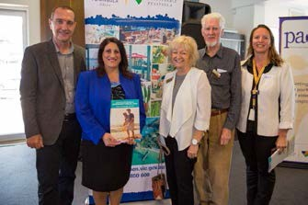The Shire’s community Advisory Committee for Elders (PACE), has been closely involved in all stages of the Positive Ageing Strategy and also in the inaugural community summit.

At the Shire’s inaugural Positive Ageing Community Summit, from left: Positive Ageing Consultant Roland Naufal, Councillor Antonella Celi, Mayor, Councillor Colomb, PACE Chair Bill Darby, Manager Aged and Disability Services Jenny Van Riel.

September at a Glance
During the month, the 264 employees and 160 volunteers of the Aged and Disability Services team delivered the following services to support 5,000 clients to stay living at home safely, actively and independently:

- 13,903 hours of home/personal/respite care
- 5,774 Meals on Wheels
- 969 hours of “living at home” assessments
- 1,503 Dial A Bus passenger trips
- 363 hours of activity program for people with dementia
- 284 hours of home maintenance/modifications

LIBRARIES, ARTS AND CULTURE

LIBRARY SERVICES

Community Engagement and Programs
- Spring into Sundays @ Our Library - Sunday activities during September included a fun- packed array of events:
  - Music with Mojo Pearls, Steve Romig, Olive, Fox DeRoche, Marty Williams and Rob Papp.
  - Dr DeClutter – a workshop on how to reduce paper clutter at home and in the office
  - 3D Printing – an introduction and active session on 3D printing
  - Young Engineers
  - SnakeBusters Reptile Show
  - Pilates at Rosebud Library
  - Lego workshop at Mornington Library
  - Author talk with Claire Dunn at the Hastings Library
- Cool Creations - School Holiday Program 21 September – 2 October. Our Library held 12 events for school-aged children across our libraries, with 281 children and 153 adults attending.
- Our Rosebud Library team promoted our services at the Rosebud Shopping Plaza during the school holidays and joined up 127 new library members during the three day visits.
- The Brotherhood of St. Lawrence facilitated a Let’s Talk About Dementia session on 28 September at the Mornington Library with 49 people attending.

Collections
Our downloadable digital collections available to our Library members have increased in popularity with the following increases in loans this quarter July-September compared to last quarter April- June:
- eBooks loans have increased by 13%.
- eTalking Book loans have increased by 12%.
- eMagazine downloads have increased by 6%.

ARTS AND CULTURE

- The Foyer Exhibition Space @ Mornington Library exhibition program is currently showing the Water and Colour watercolours exhibition by Tammy Warner from 4 September to 3 October.
- The artsblog (www.artsonthepeninsula.com) published 28 arts & cultural events and activities this month with 602 subscribers and attracted 3,300 hits.
- The Cultural Planner was invited by Maroondah City Council to present a talk Marketing on a Shoestring to their arts and music audiences on 23 September.
- The Creative Community Grants panel completed a review of 14 submissions lodged by community groups.
- The Cultural Planner assisted the Youth team as a judge of their Short Film Competition 25 September.

MORNINGTON PENINSULA REGIONAL GALLERY

Exhibitions and Public Programs
- The enormously popular exhibitions Storm in a teacup and Ways to draw concluded at the end of the month.

- Over the September school holidays the MPRG Education Officer ran four workshops for children from 5-12 years of age. She also conducted tours and workshops for Storm in a Teacup, with students and teachers from Rosebud Secondary School, The Peninsula School, Flinders Christian College, Chisholm Institute, Mt Erin and Frankston High School staff.
- The pantomime with the Flying Bookworm Theatre Company was very well attended with over 60 participants. After the pantomime the children enjoyed activities at the Civic Reserve Recreational Centre. Our September ‘Young at Art’ session and specialist lecture ‘Dejeuner in the Garden’ attracted many people as well.
- The next 'What's On' brochure (for the Salon des Refusés exhibition) was published with 20,000 copies being distributed to our specialist mailing list and tourism operators. Media coverage included The Age, Herald Sun, MP News and Leader.

LOCAL HISTORY

- The Local History Coordinator visited and assisted the Mornington and Hastings-Western Port Historical Societies with cataloguing and training.
- A brief for the 2015/16 Oral History Project has been sent to 4 consultants.
- The Nepean Historical Society has completed a visual presentation for their 50th anniversary celebrations which were held in September.
- The Digitisation Officer photographed the Rye Pier, foreshore, the Harley House at Balnarring Beach and Mornington Reservoir at Mt Eliza for various historical societies.

STATISTICS AND REPORTING
KPI | This month | Last Month | 2014
Library Membership | *64,222 | *64,222 | 78,218
Library Loans | 103,244 | 101,372 | 121,094
eBook Loans | 2,356 | 2,600 | 1,694
eTalking Book Loans | 965 | 978 | 593
eMagazine Loans | 2,281 | 2,257 | 3,780
Home Library Service Loans | 1,386 | 1,359 | 1,631
Library Visits | 61,376 | 58,244 | 60,255
Public PC Reservations | 6,457 | 6,331 | 6,561
Library Website Visits | 21,063 | 22,818 | 20,698
Library Website Unique Visitors | 10,144 | 12,463 | 11,982
Library Enquiries | 4,833 | 4,682 | 5,004
Community Engagement Events | 97 | 94 | 91
Community Engagement Attendance | 2,856 | 2,715 | 2,984
Gallery Attendance | 2,534 | 5,750 | 200
*static figure – membership database currently undergoing audit and review

INFORMATION SERVICES

IT Operations
- Information Services Steering Committee (ISSC) endorsed suite of IS policies
- Printer Rationalisation plan endorsed by ISSC
- IS Strategy endorsed by ISSC
- Governance process for IS projects endorsed by ISSC
- Responses to briefing session for the UC tender were very pleasing with 42 downloads of the tender documents
- Participate in MECC exercise Warrener, no IS issues identified.
- Introduction of more secure Wi-Fi access points for public use. (David Collings Rec centre and tourism centre).TP-Link EAP120’s
- Re cabled Waterfall gully MACH centre.
- Re cabled Alison’s office for 4 people.
- Re cabled Councillor Support office (Todd’s office) for up to 3 people
- Kiosk PC’s setup at 3 locations (Hastings waiting for power point expected next week)
- Responded to 675 helpdesk calls.
- Open helpdesk calls (that have not been escalated to L2) reduced to fewer than 10.
- Hastings office setup for IS staff to provide better support to the Hastings office and surrounding areas.
- Work has commenced with redesigning active directory in line with new organisational structure.
- Work has commenced on a new locally hosted database to record Council decisions.
- IS has been facilitating a third party network audit to determine future requirements.

GIS
- Various data extractions for mail outs and maps created.
- Detailed map created of Briars property for emergency management.
- Map created for Cleanaway showing pits and past inspection frequency, to determine if work area frequency can change. As a result, changes made to work area boundaries.
- Additions/improvements to Geomedia Smart Client, including rollout of email functionality to garden beds and grassed area forms, and addition of easement pipes to Cleansing and Drainage project for Cleanaway.
- Within GIS\Property & Rating, a number of changes were made to both our property database and the submissions to State Government to facilitate the map base updates.

Information Management
- Incoming mail processed same day on 22 out of 22 work days.
- Incoming planning correspondence processed within 24 hrs 22 out of 22 work days.
- Central records file requests fulfilled with 24 hrs 22 out of 22 work days.
- Incoming mail volume 9747 items 747 (7,399 Post, 849 DX, 1,345 e-mails, 183 fax).
- Outgoing mail volume 9482 items (9383 Post, 99 DX).
- Helpdesk enquiries 184.
- Files/folders created or approved 492.
- Trial of electronic planning application processing running since May 15 has been successful. Paper applications received after 1 October will by-pass planning admin and be sent directly to Information Management for processing. Completed paper planning application files will no longer be created.
- From 10 September correspondence sent to multiple Councillors will see one copy scanned rather than all copies and Councillor Support will take responsibility for distribution to the Councillors named in the correspondence.
- Proposed corporate file and document naming convention was endorsed by the ISSC.

- Updating of the business classification scheme in Objective is continuing in line with the new organisational structure.

FINANCE

The year to date operating surplus of $118.5M is $2.1M above the year to date September adopted budget surplus of $116.4M. Operating Income is unfavourable by $489K mainly due to early receipt of Financial Assistance Grant in the last financial year ($818K) which was partly offset by increased rate revenue from supplementary rates ($411K). Council’s year to date operating expenditure of is $37.5M is $1.9M under the year to date adopted budget.

Cash and investment holdings are $40.6M as at 30 September which has increased by $9.1M primarily due to receipt of first instalments of rates notices and lower than budgeted payments to suppliers part due to timing of creditor payments and expenditure delays. The Balance Sheet as at 30 September indicates a satisfactory result, with total current assets of $198.4M and total current liabilities of $57.6M (working capital ratio of 3.44 to 1). The working capital ratio of 3.44 to 1 will diminish over the course of the year as Council funds its operating programs and capital works.

Revenue Management
This month the focus has been on the completion of the final report for 2014/2015 to the State Revenue Office for the Fire Service Levy reporting, the year beginning report as well as preparing figures for the first quarter report due at the end of October. As is usual for this time of year, the number of new pension applications have increased with over 400 applications processed during September. Following the issue of rate notices there is an influx of the number of changes of address to be processed along with over 1150 changes of ownership also processed this month.

A review of all sundry accounts has been completed this month and the 90 day reports will be discussed with new Business teams to ensure follow up procedures are maintained.

Accounting Services
Council’s Audit Committee reviewed the 2014/15 Financial Statements at its meeting on 9 September 2015. Council formally approved the Financial Statements “in-principal” before being forwarded to the Auditor-General for final sign-off and subsequently, have now been certified without qualification and have been included in the 2014/15 Annual Report.

Management Accounting team have commenced our first quarter budget review as at the end of September. On a monthly and year to date basis, we continue to adjust for budget phasing issues. There will be a number of offsetting changes required throughout individual unit budgets, but no net variations to forecasts are proposed this stage of the year. Our next major budget review will be at mid-year.

PROPERTY AND VALUATIONS

PROPERTY

Land Acquisition – 35 King Street Hastings
Council determined at its meeting on 24 August 2015 to authorise Council Officers to undertake the negotiation for the acquisition of a parcel of vacant commercial land at 35 King Street Hastings for the purposes of facilitating the proposed Streetscape Design Framework and Hastings Laneway Strategy. Council has now successfully negotiated the acquisition of this property for a price of $460,000 (plus GST) with a settlement scheduled for 10 December 2015.

Land Disposal – 19 King Street Hastings
Council determined at its meeting on 24 August 2015 to authorise the sale by auction of a parcel of Council owned land at 19 King Street. Council has commenced its public advertising process under Section 189 of the Local Government Act 1989. Subject to the outcome of any public submissions received, Council will proceed with the disposal of the land by public auction. The land will be sold by Council, with the funds generated from the sale to offset part of the cost of acquiring 35 King Street Hastings.

Western Port Angling Club – Building Extension
Western Port Angling Club plans to extend their current premises on Hastings foreshore. The Hastings Coastal Management Plan supports the club remaining on the foreshore and the club is proposing to extend their leased premises to accommodate new members. The club is also proposing to provide an additional fish cleaning table near the boat ramp and install a roof over the table. The proposal will require planning approval and consent under the Coastal Management Act 1995. Increase of the leased premises will require a variation to the lease.

Rye Yacht Club – New Lease
Property and Coastal Planning met with the Rye Yacht Club on site to view the club premises and discuss the clubs request for a new lease. The Rye Boating Precinct Master Plan recommends extending the club boat storage yard. The new lease will include the additional area as well as incorporate a small area enclosed by fencing which has been used by the club for many years. Coastal Planning supports the re-configured lease area.

Zirka Circus
Property facilitated the Zirka Circus operating at the Rosebud and Hastings foreshores as well as the Mornington Civic Reserve and Recreation Centre for 4 weeks in September. The circus, which has no exotic animals, also provided a special charity night for which it donated tickets to the Girls Night Out. The charity night raised in excess of $4,000 for local breast cancer charities.

VALUATIONS

Progress – 2016 General Valuation

Task | Description | Due Date | Progress to Date
Stage 1 | Statistical Analysis of recent sales against the 2014 Revaluation | 27/02/2015 | Completed and certified 30/01/2015
Stage 2 | Residential & Rural Preliminary Valuations | 30/10/2015 | Submission 1 certified on 05/05/2015 Submission 2 certified on 14/07/2015 Submission 3 lodged for certification
Stage 3A | Specialised Valuations | 31/08/2015 | Lodged for certification on 31/08/2015

Task | Description | Due Date | Progress to Date
Stage 3B | Commercial, Industrial Valuations | 29/01/2016 | 100% of commercial and 27% of industrial inspections have been completed.
Stage 4 | Final Residential & Rural Valuations | 31/03/2016 | Commences on 1 November 2015
Stage 5 | Valuation Return | 29/04/2016 | Not yet commenced

Supplementary Valuations
The Valuation team completed 461 supplementary valuations during September 2015. At the time of this report there were a total of 143 supplementary valuations outstanding. The Valuation team has been concentrating on the Revaluation program and rate notice enquiries. Extra efforts will be made during October to clear the backlog.

Mornington Peninsula Shire Valuation Objections

 | 08/09  2008  Reval | 09/10  2008  Reval | 10/11  2010  Reval | 11/12  2010  Reval | 12/13  2012  Reval | 13/14  2012  Reval | 14/15  2014  Reval | 15/16  2014  Reval
Formal Objections | 75 | 36 | 43 | 10 | 159 | 53 | 134 | 5
Disallowed, withdrawn & invalid | 53 | 11 | 18 | 6 | 64 | 16 | 85 | 0
Completed – changes recommended to VGV | 22 | 24 | 20 | 3 | 95 | 37 | 49 | 1
Incomplete as at 02/09/2015 | 0 | 0 | 0 | 0 | 0 | 0 | 0 | 4

State Revenue Office Objections – Land Tax

 | 2009  (2008  level Reval) | 2010  (2008  level Reval) | 2011  (2010  level Reval) | 2012  (2010  level Reval) | 2013  (2012  level Reval) | 2014  (2012  level Reval) | 2015  (2014  level Reval)
Formal Objections | 152 | 17 | 50 | 13 | 187 | 49 | 33
Disallowed, withdrawn & invalid | 106 | 7 | 38 | 7 | 118 | 8 | 14
Completed – changes recommended to VGV | 46 | 10 | 12 | 6 | 69 | 41 | 19
Incomplete as at 02/09/2015 | 0 | 0 | 0 | 0 | 0 | 0 | 0

Shire Appeals
There are no VCAT applications at this time.

COMMUNICATIONS AND EVENTS

As the bridge between winter and spring, September always proves to be a busy month for the Communications and Events team. Not only do the number of activities and events start to build, but so too does planning for such significant regular events as the Pet Expo and Australia Day celebrations. September also marks the completion of the Annual Report process which provides the community with a detailed description of the Shire’s financial performance over the past 12 months.

Peninsula-Wide
The September edition of Peninsula-Wide was printed and distributed. Planning for the December edition of Peninsula-Wide is underway.

Media & News
18 media releases and web news items were issued in September, including:
- Rosie Weiss Exhibition
- CTC LAG launch
- Claire Dunn Author talk
- Impact for Women Market Day
- Seniors Festival Coming Events
- Mental Health Week Film Screening
- Eco Living Display Centre garden workshop
- Film Screening – Seniors Festival
- Circus for breast cancer fundraising
- Dial-A-Bus 10th Birthday
- Powerful Owl monitoring project
- September School Holidays
- Awards for heritage projects
- Burn off restrictions: October
- Western Port Biosphere LifeSearch event
- Victorian Young Achiever Awards
- Storm Safe Awareness Week
- McDowell St/Jetty Road Traffic lights

One hundred and twenty six articles relating to the Mornington Peninsula Shire and Council activities were recorded and summarised in September.

Photography & Video
- Warringine boardwalk rebuilding - Cr David Garnock
- Briars volunteer celebration - Cr Bev Colomb, Carl Cowie
- Dial-a-Bus 10 year celebration - Cr Bev Colomb, Cr Antonella Celi, Cr David Garnock, Cr David Gibb
- Baxter men’s shed planter boxes
- Rosebud pier redevelopment - Cr Bev Colomb, Cr Graham Pittock, Cr David Gibb, Cr Antonella Celi
- Keep Australia Beautiful regional awards - Cr Bev Colomb, Cr Antonella Celi, Cr David Garnock
- Debunking the myths of ageing
- Rosebud - Portsea CTC community action plan
- Hastings Modbox launch - Cr David Garnock
- Spin a coin for literacy - Cr Bev Colomb, Cr Antonella Celi

Graphic design
Internal graphic design was provided for varying projects in addition to the completion of the Shire’s Annual Report document.

External website
External website stats for September 2015 - Visits: 79,648 and Page Views: 213,621. Mobile is 36% and tablet 15%. Top page views - Markets on the Peninsula, Advertised Planning Applications & Current Vacancies. Social media update: Shire Twitter now has 825 followers (up five on last month). Forty posts and retweets over September, with most successful posts being on local shire events and storm safety awareness.

Community and Special Events
The Events Team is finalising the last arrangements for Peninsula Pet Expo. All exhibitors, food vendors, entertainers and contractors have been confirmed.

Discussions have commenced with Victoria Police in relation to the New Year’s Eve Strategy. The Police Operational Plan will have the same commitment as to 2014/15 NYE. Contractors and community organisations have been secured.

The first Australia Day 2016 committee meeting was held in early September. Planning for the eight events is well underway with building corporate sponsorship partnerships and working closely with the committees to ensure processes and protocol is being followed.

For the month of September, there were eight registered events of which Red Hill Spring Garden Festival was funded by the Shire, one filming application and six wedding ceremonies held on public open space on the peninsula, with around 5,330 event participants in attendance.

HUMAN RESOURCES

Corporate Learning and Development
Included in the range of corporate programs delivered during the month was Personal leadership and effectiveness, an interactive and practical course providing a sound overview of what it takes to be an effective leader. Participants were introduced to their preferred style of operating, which has a bearing on personal leadership style helping them to develop their own leadership capability.

Also undertaken was a Building Resilience program. This program contributes to the Shire’s commitment to employee health and wellbeing. Designed to assist Team Members who are seeking strategies on becoming more resilient – being able roll with the ebbs and flows of working life and being able to ‘bounce back’ and manage reactions at work. Participants develop a sound understanding of the impacts of stress, physically and emotionally and learn that these impacts can be positive or negative. It is important to understand that mild levels of stress can often be positive by acting as a motivator and energiser. On the other hand, high levels of stress can lead to negative feelings, anger etc. and can cause serious health problems.

Recruitment
A total of 261 applications were received in September. The total number of applications received for the 2015/2016 financial year, amounts to 321.

Included in these application where 42 applications for Community Care Workers. Community Care Workers provide individual assistance and care to older people, people with a disability and their carers, which assists them to live independently in their own homes, and local community. These roles contribute to a range of services provided by the Shire designed to support, frail, older people and people with a disability and their carers to stay active and independent and living at home.

Risk and Safety Management
The current policies are under review and currently in the consultation phase with Health and Safety Representatives and OHS Committees:
- Occupational Health and Safety Policy
- Contractor OHS Management Policy
- Occupational Violence Policy
The OHS gap analysis work continues. This work will determine the Shire’s compliance with OHS legislation and standard. Once complete, an implementation plan will be developed to assist the Shire to continue meeting its OHS obligations.

Work continues on the review of the Risk Management Framework, due for review in 2015/2016. The revised framework will include all areas of risk (corporate/public, OHS, compliance, environmental etc.).

ENVIRONMENT PROTECTION

FIRE PREVENTION AND EMERGENCY MANAGEMENT

Exercise Warrener
A number of Shire staff, emergency services and other key stakeholders participated in a multi- agency emergency management exercise on Tuesday 29 September 2015. The exercise involved the activation of the Shire Municipal Emergency Coordination Centre (MECC) at the Mornington office and the activation of an Emergency Relief Centre (ERC) at the Civic Reserve Recreation Centre also in Mornington. The aim of the exercise was to test local emergency management response with a focus on relief, to a significant (hypothetical) emergency event in accordance with the Mornington Peninsula Municipal Emergency Management Plan. The exercise also involved the setting up and running of a generator to simulate a power outage at the Mornington office. The exercise scenario was based on a hazardous materials (HAZMAT) event in Hastings that created a significant toxic smoke plume that impacted on the neighbouring residential areas.

COMMUNITY ANIMAL SHELTER

Eighty-three dogs came in to the Community Animal Shelter and once again an incredible reuniting success rate with 77 of the dogs being reclaimed promptly. There were no dogs euthanised. Forty- two cats were impounded and disappointingly none were registered. Eleven were de-sexed and seven microchipped so only three were able to be reclaimed by their owners. Due to regulations for feral, aggressive behaviour and extremely poor health 12 cats were euthanised.

The direct adoption program through our website, in conjunction with PetRescue, also proved a success with 12 pets adopted in September.

Our valuable partnership with rescue groups also continues with 17 pets ‘rescued’. We recognise this month: Forever Friends, Labrador Rescue, Australian Working Dog Rescue, Homeless Hounds and Rescue-a-Cat. These groups, together with our staff, our volunteers and our Peninsula Vet Care group form a highly recognised, valuable partnership which endeavors to provide all suitable pets another chance at a new home.

SHIRE RANGERS

The Shire Ranger Team received and actioned 950 reactive merit cases this month. Workload starts to build as we approach the summer season, parking management programs have commenced across the Shire with additional officers working across the school holidays.

In court this month there were 17 matters finalised, one of these being an appeal which was heard in the County Court.

ENVIRONMENTAL HEALTH

Food Premises Registration Renewals
All of the Shire’s 1273 registered food premises have been sent their application to renew their Food Act registration for 2016, with payment due by 1 November 2015.

The Shire’s 868 Class 2 food premises (cafes, restaurants and take-aways etc) were also sent the new educational booklet “Preventing Stormwater Pollution – Information for Food Businesses” to assist food businesses prevent pollution of local drains and waterways. This booklet was developed by the Shire’s Renewable Resources Team with funding from the Melbourne Water Living Rivers Program. A promotional poster on stormwater protection has also been developed and given to food businesses during their annual food safety inspections.

INFRASTRUCTURE AND PLANNING

The Infrastructure and Planning Group is led by the Chief Operating Officer (COO) and includes the following units and teams:

- Strategic Planning
- Statutory Planning
- Statutory Building
- Planning Compliance
- Infrastructure Strategy
- Infrastructure Maintenance
- Infrastructure Project Management
- Buildings and Facilities

CHIEF OPERATING OFFICER

September within Planning and Infrastructure saw a number of key projects initiated.

Notably the Strategic Planning Team presented the High Street Hastings Streetscape Design Framework, Hastings. Council resolved to exhibit the Draft Framework, Draft Laneways Strategy and the Draft Laneway Closure Plan, on 14 September. These documents have been placed on public exhibition until 2 November to seek community input. Community consultation activities have been held, including a market stall in High Street (to coincide with Market Day), a Stakeholder Consultation Session and a Drop-In Session. Another Drop-In Session has been scheduled for October 21.

The Shire planning applications continue to be managed effectively, with Council receiving 203 planning applications and decided 222 in the reporting month. As of the end of the month, 758 planning applications remain in hand. Of the applications decided, 75% of applications were decided within the statutory timeframe, exceeding the Unit’s monthly target of 67% of applications to be decided in time and exceeding the State average of 64%.

Our compliance team has continued to refine systems for processing applications to build on flood prone land and have been able to reduce processing timeframes to an average of 27 days. Further improvements are under planned with a target to reduce the average processing timeframe to 15 days.

In Infrastructure the team has implemented additional in Baxter and Mornington Park as part of the Shires Placemaking works programs. Works include planting of trees, vegetation pruning, garden bed transformation, landscaping, painting and street furniture installation. Currently consultation with key community groups in Rye Shopping Precinct, Safety Beach Foreshore, Tyabb, Flinders and the Mount Eliza in preparation for a further works programs.

The Project Delivery Unit has recently entered into an agreement with Telstra to standardise the process and costs to alter Telstra assets which are affected by Council capital works projects. The agreed process will improve efficiencies and reduce the cost of works by implementing a works order process which references a schedule of standard items with agreed costs.

The excellent spring weather resulted in an early start to the peak season for the Shire’s Service Providers, in particular our Cleansing contractors who again will provide employment opportunity for Mornington Peninsula Shire residents to not only gain local employment for up to 6 months, but to be on the front line improving the appearance and liveability of the Mornington Peninsula for residents and visitors alike. Over the Peak Season approximately 50 extra people are employed to undertake cleansing activities, providing a 7 day per week service across 16 Mornington Peninsula Townships.

The Foreshore and Halls teams also continue to ramp up for the busy summer period. A number of process improvements have been achieved to provide a more efficient level of service.

A significant Council decision in September saw Shire officers commence work on the documentation for the Expressions of Interest (EOI) process for the Shire’s kerbside waste to be bulk hauled off the Mornington Peninsula Shire. It is envisaged that the EOI will be advertised in October 2015.

STRATEGIC PLANNING

STRATEGIC LAND USE PLANNING
Mornington Peninsula Activity Centres Strategy and Mornington Peninsula Industrial Areas Strategy. Suitably qualified consultants have been interviewed. The consultant selection process will be completed early October, with the project to commence in November. In the meantime officers are completing an inventory of all existing commercial and industrial development across the Peninsula, which will provide a data-base for the preparation of the above strategies.

COASTAL PLANNING
Jetty Road (Rosebud) Precinct Master Plan. Officers have prepared a report for the Council meeting of 12 October to enable Council to review the submissions received and to consider the adoption of a final Plan.

Stage 3 of the Boat Ramp Capacity and Demand Study – Simulation of MPSC Managed Boating Facilities has been completed. In his stage Coastal Planning commissioned a simulation model, which uses a multi-criteria analysis of all of our boat ramps to test different scenarios. The simulation model tests how different improvements might improve or change user behaviour and experience at different boat ramps to assist in decisions on the best value for investment for improvements.

NATURAL SYSTEMS PLANNING
Mornington Peninsula Biodiversity Conservation Plan. Ecology Australia (EA) has been appointed to prepare the Conservation Plan. EA has prepared a web-based survey and an Existing Conditions Report, to enable the next stage of the community consultation process.

The Department of Environment, Land, Water and Planning (DELWP) has announced a review of the Permitted Clearing Controls for Native Vegetation for release in mid-2016. The terms of reference include consideration of the extent to which the current regulations sensibly protect sensitive vegetation and the appropriateness of current vegetation-offset rules to provide adequate compensation. DEWLP has also announced the development of a Draft State Biodiversity Strategy for public release in February 2016.

URBAN DESIGN
High Street Hastings Streetscape Design Framework, Hastings. Council resolved to exhibit the Draft Framework, Draft Laneways Strategy and the Draft Laneway Closure Plan, on 14 September. These documents have been placed on public exhibition until 2 November to seek community input. Community consultation activities have been held, including a market stall in High Street (to coincide with Market Day), a Stakeholder Consultation Session and a Drop-In Session. Another Drop-In Session has been scheduled for October 21.

Hastings Activity Centre Laneways Strategy. This has been placed on public exhibition as described above.

The Four Step Guide to Context Analysis and Design Response Guidelines. Following the completion of the public exhibition process, the Four Step Guide was adopted at the Council meeting of 14 September.

Design Advisory Panel. A DAP Workshop was held on 16 September 2015 to review a proposed mixed use development at 142-146 Ocean Beach Road and proposed Streetscape Improvement Works, also in Ocean Beach Road, Sorrento.

HERITAGE
An officer submission made in response to the State’s Discussion Paper about the Review of the Heritage Act 1995 was endorsed at the Council meeting of 14 September.

Mornington Peninsula Heritage Study Review – Stage 2 (Dromana, Rosebud and Rye). The heritage consultancy firm Context has been appointed for this project. They have completed the historic background research for the approximately 60 places identified for possible heritage protection. They have started the preparation of draft citations (that specifically describe the heritage values that warrant heritage protection) for these places.

Ocean Beach Road Sorrento Heritage Policy. Following the completion of the exhibition, officers have – in consultation with Heritage Architect, Helen Lardner, - prepared a report for Council to enable the consideration of the submissions and of the adoption of a final Policy. The report will be presented to the Council meeting of 12 October.

AMENDMENTS & PLANNING SCHEME REVIEW
- Amendment C161 - Yaringa – The Independent Panel’s report has been received and now awaiting further advice/fee from the applicant before a final report is made to Council.
- Amendment C184 Part 2A – Bungower Road, Mornington – was adopted by Council on 24 August and has now been submitted to the Minister for Planning for approval.
- Amendment C188 Part 2, including Bittern Design and Development Overlay and Tootgarook Wetland Environmental Significance Overlay 30 - was adopted by Council on 14 September and has now been submitted to the Minister for Planning for approval.
- Amendment C189 - A general amendment including items relating to Beleura Hill, Birdrock Avenue precinct and Moorooduc Coolstores – was considered by Council on 24 August and has now been submitted to the Minister for Planning seeking authorisation for exhibition.
- Amendment C191 - 11-13 Mountain View Road in Mount Eliza – was considered by Council on 14 September and has now been submitted to the Minister for Planning seeking authorisation for exhibition.

PLANNING SCHEME AMENDMENT REQUESTS
One new planning scheme amendment requests was received in September for 856 – 858 Melbourne Rd, Sorrento, being a proposal for a rezoning from the General Residential Zone to a Mixed Use Zone with a combined permit application.

REFERRALS AND DEMOLITION REQUESTS
- Referrals from statutory planning (August 2015) 22 referrals were received and 17 were completed.
- Demolition requests (August 2015) 21 requests were received and 14 were completed.

STATUTORY PLANNING

Planning Applications
Council received 203 planning applications and decided 222 in the reporting month. As of the end of the month, 758 planning applications remain in hand.

Of the applications decided, 75% of applications were decided within the statutory timeframe, exceeding the Unit’s monthly target of 67% of applications to be decided in time and exceeding the State average of 64%.


Planning Applications
includes normal stream and VicSmart
900

800
774 776
729
763
758
712
720
700
651
649
661
686
658
600

500

400

300 252232
200
189203 204
218
181
123
184184
204
237
228
172
188
211
180 182
205188
202198
203
222
100

0
Received
Decided
No. in hand at end of month

The Planning Support team received a total of 3662 telephone calls in the reporting month. Of these, 89% (target is 80%) of calls were answered within twenty seconds and 97% (target is 95%) of calls were answered within two minutes. The team also serviced approximately 898 counter enquiries this month.

The Planning Support team completed 93% of tasks within timeframe (target is 85%).

Planning S72 Amendment Applications
Council received 43 applications under Section 72 of the Planning and Environment Act to amend planning permits and decided 34 planning amendment applications. 133 planning amendment applications remain in hand.

Secondary Consent Applications
Council received 48 planning amendment applications and decided 41 planning amendment applications. 62 secondary consent applications remain in hand.

Significant Applications
P13/1992.02 – Arthurs Seat State Park – Skylift Proposal
The permit holder for the Arthurs Seat Skylift facility has lodged an amendment under secondary consent provisions to amend the design of the retaining walls at the lower station (from a Crib Wall

design to a Durahold system). The proposal will be presented to Council at its meeting on the 26th October 2015 for a determination.

P15/1525 – 50 O’Neills Road, Somerville
This application relates to land at the rear of the existing wholesale plant nursery fronting Frankston Flinders Road. The company intends to expand onto the rear lot fronting O’Neills Road (presently vacant) to accommodate the increased demand for their nursery produce. The two sites would essentially operate as a single entity, with the new site to accommodate a large cultivation shed, as well as dedicated parking facilities for existing and future employees. Additional information has been sought from the applicant. Once received, the proposal will proceed to public notification.

P15/1764 – 265 Sandy Road, Fingal
An application has been submitted to use the land for leisure and recreational purposes (hot springs). The land is located within the Green Wedge Zone. The proposal which includes 10 massage villas, a rehabilitation building, associated outbuildings, vegetation removal and car parking is currently undergoing a preliminary assessment against the relevant provisions of the planning scheme.

P15/1627 – 178 Main Street, Mornington
An application has been received for a three storey building with 14 apartments and a basement car stacker. A preliminary assessment of the proposal is currently under way against the relevant provisions of the planning scheme.

VCAT
P12/1754 – Foreshore adjacent to 3074 Point Nepean Rd, Sorrento
This is an appeal against Council’s decision to grant a permit for the construction of a walkway around the base of the Eastern Sister. The purpose of the walkway will be to link Camerons Bight to Sullivans Bay, and thus provide a pedestrian link between the two beaches.

At this stage, no date has been set down for the hearing.

P05/1437 – 166 Balnarring Road, Merricks North (Willow Creek Winery)
This proposal relates to an application to amend the existing permit, which allowed the land to be used and developed for accommodation and conference facilities. A Compulsory Conference was held at VCAT, attended by Council, the landowner, and an objector who was party to the appeal (other objectors were notified of the appeal, however did not choose to join the appeal process). The key issue in dispute related to the increase in height of the roof form of the yet to be constructed accommodation and conference building. The height increase was due to a consolidation of rooftop plant and equipment towards the southern end of the building.

At the hearing, the applicant tabled amended drawings which made a slight reduction to the lowered the roof height. Further alterations were also proposed, including modifications to the car- parking layout (to move parking and access driveways further from common boundaries) and the provision of additional landscaping. Based on the amendments as proposed, all parties agreed to the Tribunal making an Order that an amendment be made to the existing permit, incorporating the necessary new conditions to give effect to the changes as agreed to at the Conference. The merits hearing listed to commence on 4th November has been cancelled as the matter has now been settled.

BUILDING AND PLANNING COMPLIANCE

PLANNING COMPLIANCE
This month the Unit was involved in a joint inspection with the Building Unit and Environmental Health team of a boarding house facility that has been operating in the municipality for some years. Council had received reports that people were being housed in a garage on the land contrary to the approvals that apply to the land. It was confirmed that two people were being house in the converted garage. Council worked with the operator to properly accommodate these people and further consideration is being given to how the site is operating.

Officers have been addressing an operation occurring within an industrial area whereby the land is being used without a permit to store refuse (mainly scrap building material). The operator has been advised to cease and clean up the site.

STATUTORY BUILDING
The Unit have continued refining systems for processing applications to build on flood prone land and despite receiving 178 applications for the month, have been able to reduce processing timeframes to an average of 27 days. Further improvements are under investigation with a target to reduce the average processing timeframe to 15 days.

An electronic system for producing property information certificates is currently being trialled. Known as Eprop, they system allows an applicant to apply for the certificate on line and receive the certificate almost instantaneously via email. A significant efficiency and resource saving.

INFRASTRUCTURE STRATEGY

INFRASTRUCTURE PLANNING AND POLICY

Placemaking Township Works
Works are currently underway in Baxter and Mornington Park as part of the Shires Placemaking works programs. Works include planting of trees, vegetation pruning, garden bed transformation, landscaping, painting and street furniture installation.

The Shire is currently consulting with key community groups in preparing works programs for Rye Shopping Precinct, Safety Beach Foreshore, Tyabb, Flinders and the Mount Eliza.

Capital Works Reporting & Delivery Framework
The Infrastructure Planning team have been working on transferring project reporting from Projects Pro into Chameleon in order streamline our processes of capital works monitoring. Project managers are currently being supported to input data, including project stages and progress of projects. Three staff information sessions were delivered on the project planning and delivery framework this month.

TRAFFIC AND ROAD SAFETY

Peninsula Link Signage Project
The Traffic and Road Safety Team have been working closely with Bruce Billson’s Office, VicRoads, Tourism Victoria and community groups to develop an approved scope of works for the Peninsula Link signage project. This project was successful in receiving funding through a Community Development Grants Programme and aims to improve the tourism and township directional signage along the Peninsula Link. Throughout September the scope of works for this project has been approved by VicRoads and the project is now progressing with the aim for the works to be completed before December his year.

Get Me to Class – Smartphone Application
The Get Me to Class smartphone application was developed by students in partnership with the Mornington Peninsula Shire in 2012/2013 to give students (predominately university students) a personalised journey planning tool, with all high school and tertiary institutions pre-loaded, right down to building location.

However, due to iOS and Android upgrades it had dropped off the stores and was unavailable. The good news is that now, current RMIT I.T. students have embraced the challenge to upgrade the application and simplify its operation before reloading onto the relevant stores again for download. It will be hosted indefinitely by RMIT for I.T. student projects moving forward.

ASSET MANAGEMENT

Victoria Grants Commission (VGC) – Local Roads Grant
The Asset Management Team is currently compiling data required for the VGC in determining the allocation of general revenue assistance to local government. Supplied data will be used in calculating the Shire’s local roads grant, and also to provide information to the Australian Bureau of Statistics, Department of Transport Planning and Local Infrastructure, Australian Local Government Association and Municipal Association of Victoria.

Significant time has been spent prior to compilation of the VGC return ensuring that traffic count data and commercial and school bus route data used in calculating the grant has been updated. This will ensure that the Shire maximise their funding opportunity.

Safer Local Roads – Pavement Performance Measurement
As a measure of performance within the Safer Local Roads (SLR) contract, a 3 yearly assessment of road pavement condition is undertaken to determine the current Pavement Condition Index (PCI).

Date has been provided to our road network service provider Downer in order to facilitate calculation of pavement condition indices (PCI) for each of the 5 PCI road hierarchies within the Shire. The condition targets set 3 years ago will compare against the current condition data (see comparison table below) to determine, if our service provider has achieved compliance.

Road Hierarchy | Target PCI | 2014 PCI  (including Cure Plan)* | Achieved Compliance?
A | 82.44 | 82.45 | Yes
B | 78.14 | 78.19 | Yes
C1 | 74.38 | 74.38 | Yes
C2 | 89.05 | 89.16 | Yes
D | 89.49 | 89.64 | Yes
*2014 PCI score include cure plan condition resets.

New PCI Targets are also to be established for each of the five PCI road hierarchies for the next Pavement Performance Review in 2017-2018.

INFRASTRUCTURE MAINTENANCE

CONSERVATION PARKS

Mount Eliza Village Green
Over the past six months Shire Officers, Mount Eliza Chamber of Commence and Mount Eliza Secondary students have worked together to add vibrancy and life to the Village Green in the centre of Mount Eliza. The students worked with the Shire’s Natural Systems Team and community to create design options for the area. Their hard work was realised this month with the installation of a new banksia garden bed and three colourful bikes, complete with flower and herb baskets. Other project partners, in this great example of the community achieving a shared goal, include Advance Community College, Mount Eliza Rotary Club, Mount Eliza Lions Club and Mornington Men’s Shed.

Roadside Fire Management
Stage One of the 2015/16 roadside fire management works program is underway in Blairgowrie, Merricks, Mount Martha, and Red Hill. These works reduce fuel loads on priority access and egress roads, identified in the multiagency Mornington Peninsula Shire Roadsides Fire Management Plan. The Plan, including the full works plan, can be found on the Shire website.

CLEANSING

Peak Season Planning
Peak season activities provide a tremendous opportunity for Mornington Peninsula Shire residents to not only gain local employment for up to 6 months, but to be on the front line improving the appearance and liveability of the Mornington Peninsula for residents and visitors alike. Over the Peak Season approximately 50 extra people are employed to undertake cleansing activities, providing a 7 day per week service across 16 Mornington Peninsula Townships. It is pleasing to note that there is a good level of returning Street Presence staff from last season who will provide a strong starting point for 15/16.

Township Street Bins

Mt Eliza township received an upgrade to all the old bin surrounds during September. All 120 litre surrounds were replaced with the new 240 litre MPS stainless steel surrounds. The aesthetic improvement to the township was immediate while the physical increase in litter capacity in Mt Eliza will be well received by all.

BUILDINGS, FURNITURE & SIGNS, PARKS & ROADSIDES

Somers Hall – Painting Program
The Building services team continue to roll out the painting refurbishment program. Somers Hall and associated toilet block was recently completed, photos above. During the School holidays in late September the Buildings team have been painting Mount Martha Preschool and Waterfall Gully Preschool. Over the last 2 years over 100 buildings have been refurbished as part of the Cyclic Painting program.

Rye Foreshore Sand Barrier
The Furniture and Signs team has refurbished the sand barrier at Rye Foreshore. The previous barrier had no supporting structure behind the shade cloth and was getting damaged by strong winds and vandals. The existing fence was refurbished with a heavy duty black chain wire mesh to the existing fence to provide the durable support for the new shade cloth.

The refurbished fence is now; vandal resistant, high wind resistant making it more durable, presents really well in the landscape and has been installed in time for the warmer months of the year.

SAFER LOCAL ROADS

Thirty internal quality audits have been completed for the month of September. These audits covered a range of activities completed under the Safer Local Roads Contract, for example pavement works, footpath works, line marking, gravel roads and drainage works.

Programs
Several of our key FY 15/16 programs have already commenced, these including the unsealed road and shoulder, footpath and kerb/channel programs.

Sealing works have commenced, with the completion of approximately 110,000 square metres in September.

Drainage and verge removal works were completed on Browns Road. This has made a significant improvement to the drainage of this section.

The 2015/16 Reseal/Rehab Program is nearly finalised with all sites marked out ready for preparation works to commence in early October.

PROJECT DELIVERY

Telstra Agreement
The Project Delivery Unit has recently entered into an agreement with Telstra to standardise the process and costs to alter Telstra assets which are affected by Council capital works projects.

Previously, works such as the location of a new footpath, may have necessitated the relocation or adjustment of a number of Telstra access pits. These works were quoted, programmed and paid for on an individual basis.

The agreed process will improve efficiencies and reduce the cost of works by implementing a works order process which references a schedule of standard items with agreed costs.

This agreement will be trialled initially for a 12 month period.

Innovation – Surveying
We have upgraded our survey briefs to include IproLive compliance and introduced a hold point for traffic management. Currently there are twelve surveys that I am involved with.

We have engaged Taylors Development Strategists to Survey Canadian Bay Road and Nepean Hwy Intersection. This intersection poses risk to survey workers if traditional survey methods are used. An extensive traffic management plan would be required which is costly compared to the amount of survey information required. Taylors are a well-known and respected firm with more 50 years’ experience in multiple civil engineering, urban planning and project management fields. Having both Australian and international experience, there extensive network extends nationally through Victoria and Queensland, and to the Asia Pacific region through New Zealand and Indonesia.

The survey method proposed is called Terrestrial Laser Scanning. Now in its 3rd generation it has mainly been used in mining and landfill applications until recently. Data extraction programs have now caught up with this technology and easily allow conversion of data into usable drafting formats. This technology utilises a 3D laser scanner to capture millions of individual measurements (at speeds of up to 976,000 pts/sec) in a very short space of time to produce a full colour “point cloud”, from which 3D objects are extracted and thus enabling CAD manipulation.

This method of survey reduces time in the field, which has the benefits of little or no traffic management, increasing safety outcomes, and reducing project costs. Terrestrial Laser Scanning captures more information than traditional survey methods, meaning return visits to the site to obtain additional information are usually avoided.

The following photo shows the point cloud data captured at Hisense Arena.

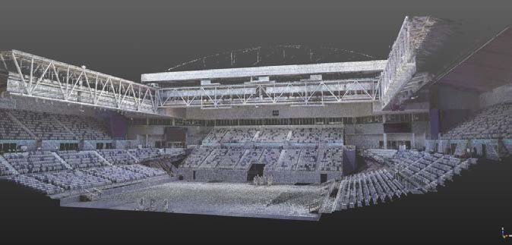

Procurement Strategy – Provision of Professional Support Services
The Project Delivery unit is currently working on the establishment for the provision of professional support services in line with its program delivery approach to capital works.

This will see long term arrangements with a various service providers to assist the Project Delivery team delivery the capital works program. The proposed term of the contract is for 3 years.

The service delivery efficiencies and indirect benefits to the Shire are significant when compared to tendering those services for individual projects. The advantages of a long term arrangement with service providers are numerous:

  - One contract to administer
  - Greater understanding of client needs
  - Fewer meetings required with service provider and community groups
  - Adaption of standard design templates to multiple sites
  - Long term relationship based on trust and shared commitment
  - Quality improvements through specifying the right materials and fittings
  - Reduced maintenance costs
  - Better programming of works
  - Flexibility in the contract to cater for variables

Subdivisions Engineering Approvals
The development engineering team received 115 referrals from the planning department during September. A total of 102 referrals were responded to, leaving a balance of 120 at month end. In addition, 27 sets of engineering drawings were approved for development works, typically for commercial, residential and multi-unit sites.

Legal Points of Discharge
For the month of September, 104 stormwater legal point of discharge responses and 8 build over easement responses were issued.

Capital Works Construction
There are currently 16 capital works projects currently in delivery phase equating to approximately
$5.4m worth of civil infrastructure works currently underway, with 34% of the capital works budget awarded, $11.7M of the $34.4M approved budget.

A more detailed update of specific projects is described in the CAPITAL WORKS section of this report.

Asset Protection
For the month of September;
  - 129 Asset Protection inspections were undertaken and 74 permits to undertake works in roads were issued.
  - The Asset Protection Team responded to 40 customer service requests, 401 phone calls and 101 pieces of correspondence.
  - 1061 dial before you dig queries were received

Capital Works Program
The Infrastructure Project Management unit has made significant progress with the delivery of the 2015/16 capitals works program and a more detailed update of specific projects is described in the CAPITAL WORKS section of this report.

RENEWABLE RESOURCES

ECOHOUSE

Tours and Meetings
On Wed 23rd and Thursday 24th September participants of the Energy Saver Study run by the Shire participated in tours of the Centre to find out how they can further mitigate climate change by adopting sustainable design principles and behaviours.

Several internal teams held meetings at the Centre this month and the Devilbend Conservation group held their regular meeting at the Centre.

Regular Groups
Our two regular groups met at the Centre several times this month. The Collaborative Garden Group, comprising of clients from Kankama and Konnections and Shire staff members, have been undertaking an arts project with local artist Samm Menzies this term. The Carers groups, comprising of disabled residents and a staff member of the Brotherhood of Saint Lawrence, meets at the Centre every Tuesday.

Sustainable House Day
On Sunday 13th September approximately 100 people visited the Centre as part of Sustainable House Day. Staff and volunteers were busy all day leading tours and answering enquiries relating to sustainable design and building.

The Victorian Spring Flower and Garden Festival
The Shire participated in the Victorian Spring Flower and Garden Festival from 25 – 28th September at the Mornington Racecourse. Staff and volunteers from Renewable Resources, Economic Development and the Shire nursery manned displays and gave presentations over the weekend to promote local farm produce, recycling, indigenous gardening and sustainable living. Over 2000 people visited the Show over the weekend.

ENERGY

Australian Smart Lighting Summit 2015
Shire officers attended the Australian Smart Lighting Summit in Melbourne on 8 - 9 September. The summit had a strong focus on LED street lighting with an abundance of presentations on completed upgrades and trials from municipalities and regional alliances around Australia. Further to street lighting and energy efficiency; the summit touched on lighting design and the role of lighting in urban spaces and streetscapes, regulations and several case studies.

Victoria’s Renewable Energy Action Plan Consultation
The Department of Economic Development, Jobs, Transport and Resources hosted a public forum in Frankston to discuss Victoria’s Renewable Energy Roadmap. The roadmap had already recognised four key areas to address when developing the Renewable Energy Action Plan including:
- Transforming Victoria’s generation stock towards renewable energy;
- Addressing barriers to distributed generation and storage;
- Encouraging household and community renewable generation; and,
- Government role in facilitating the uptake of renewable energy.
The Shire advocated for energy generation via alternate waste treatment to phase out landfills, a preference of Mornington Peninsula residents that was very evident in the waste strategy community consultation. Setting a strong renewable energy target as a first step was also discussed.

WATER

Stormwater Pollution Trial - Mt Eliza and Mornington
The new business education materials for food businesses on the Peninsula have been printed.

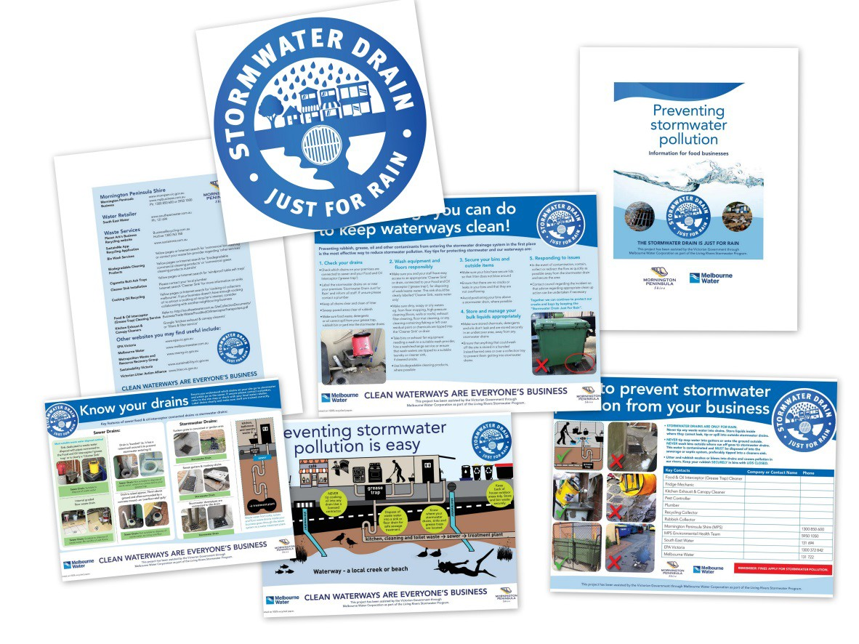
The booklet “Preventing stormwater pollution, information for food businesses”, is a key component of the Shire’s proactive preventative approach to addressing potential stormwater pollution issues and protecting our beaches and waterways. The information booklet has been sent to all Mornington Peninsula Class 2 food businesses, including restaurants, cafes, hotels and fast food outlets, with their annual business registration renewals notice. These materials are to assist them to manage their waste water appropriately, protect public health and protect the quality of water in our beaches and creeks.

The remaining materials, A4 fridge magnet, A3 Poster and plaques for labelling stormwater drains on their premises will be issued by Environmental Health officers on their routine visits and audits over the coming 6 months.

Awards
The work the Shire has done to proactively improve Stormwater water quality on the Peninsula is being recognized! Recent awards outcomes are:
- State Finalist: 2015 Tidy Towns Sustainable Communities Awards – Clean Beach/Waterway Category (Winner Announced 17 October 2015)
- State Finalist: 2015 Stormwater Victoria Awards for Excellence in 3 categories -
Policy/Education, Research and Innovation, and Strategic/Master Planning
  - Highly Commended in Research and Innovation, and
  - Highly Commended in Strategic/Master Planning Categories
- State Finalist: 2015 Victorian Coastal Council Awards (Winner Announced 14 October 2015)
- Entrant: 2015 Premier’s Sustainability Awards
- Entrant: 2015 River Basin Management Society Awards (Winner Announced 9 Oct 2015)

WASTE MANAGEMENT

Waste Management Strategy
Following the Council Meeting held on the 14 September 2015, Shire officers have commenced work on the documentation for the Expressions of Interest (EOI) process for the Shire’s kerbside waste to be bulk hauled off the Mornington Peninsula Shire. It is envisaged that the EOI will be advertised in October 2015.

Resource Recovery
In September 2015, 1,706 tonnes of material was recovered and recycled through the Shire’s kerbside recycling collection service. The monthly environmental savings for this month through the recycling of this material include.
- 9,647 trees
- 4,265 barrels of oil
- 46,471 GJ of energy
- 4,606 cubic metres of landfill
- 13,973 kL of water
- 2,151 households annual electricity requirements

BUILDINGS AND FACILITIES

The Buildings and Facilities team is responsible for the strategic planning of all shire buildings and facilities; the maintenance of all shire buildings; the operations of Pelican Park Recreation Reserve, Somerville Recreation Reserve Centre, Crib Point Pool, Hastings Community Hub, Civic Reserve Recreation Centre and Mt Martha Golf Course; and the operation of Foreshore Camping and the coordination of the community halls.

Facilities Planning
The primary focus of the Facilities Planner is the review of the Pavilion Strategy. The Pavilion strategy is a $49m project focused on improving the standard of the sporting pavilions across the Shire. The review is to ensure the strategy is achieving its original intent, and to understand what opportunities may exist to enhance the delivery of these works.

The Facilities Planner will also be identifying the requirements for a broader facilities strategy, to ensure we have a coordinated approach to the development, operation and maintenance of our facilities.

Foreshore Camping and Community Halls
The foreshore and halls teams continue to ramp up for the busy summer period. A number of process improvements have been achieved to provide a more efficient level of service. Improvements include changes to how we service halls after they have been used, improved invoicing processes and improving the booking system.

Building Maintenance
The building maintenance team has been focusing on ramping up external works as we move into the summer period. Examples of current works include;
- The replacement of the rook at Somerville Mechanic’s Hall
- The replacement of the roof at Mornington Football Club
- Numerous painting programs across pre-schools
- Repairs to the Old Mornington Post Office
- Painting at Mt Martha House

Sports and Leisure
The Sports and Leisure team is responsible for the daily operations of the Shire’s Aquatic and Recreation facilities. The facilities are dynamic facilities, with large number of groups and individuals attending each day.

Mt Martha Golf Course is busy with the spring growth, the course looks fantastic, it’s a great time to get the trusty clubs out and check the course out! The recreation facilities at Civic Reserve, Somerville and Hastings Hub are busy ramping up programs to help users reach their summer fitness objectives. School holiday programs have just been completed and were very successful. Planning is underway to see how we can improve our service offering, if you have any great ideas please let us know on customerservice@mornpen.vic.gov.au. and don’t forget Crib Point Pool which reopens in November.

CAPITAL WORKS OVERVIEW

BUILDINGS

Mornington Youth Resource Centre, Wilsons Road Mornington
Construction activities are approaching completion at the Mornington Youth Resource Centre site next to the Peninsula Community Theatre in Wilsons Road, Mornington. The former classroom buildings are being refurbished into a much-needed youth drop in centre and a second base for the Mornington Men’s Shed. The official opening and launch of the new facility is scheduled for early November.

New Rotunda at Mornington Park – Community Capital
The Shire is assisting Mornington RSL with the construction of a new rotunda in Mornington Park. The rotunda is a replica of one which originally stood in the park and celebrates the Avenue of Honour. A launch event is scheduled for 8 November.

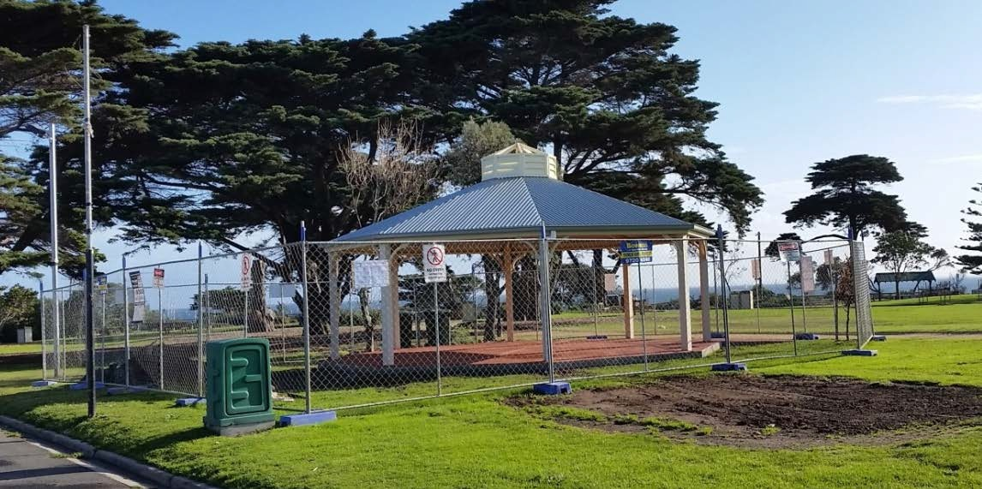
Image – New rotunda in Mornington Park under construction

Somerville Community House
Architects Williams Kaye Hofer are undertaking a detailed refurbishment design of the former Annie Sage Child Care Centre for use by Somerville Community House. While the building condition is tired, it is structurally sound and its significant size (approximately 350 square metres) would potentially accommodate a variety of municipal uses. The building is currently vacant.

Mount Martha Tennis Pavilion
The construction of the Mount Martha Tennis Pavilion is nearing practical completion. The next few weeks will see the completion of plumbing, painting, handrails and floor finishes prior to the final handover. The new building includes a new social room, multipurpose change rooms, toilet and shower facilities, office store room, kitchen/kiosk first aid room and internal/external public disabled toilet. The existing pavilion has been demolished and rebuilt as a stand-alone covered viewing area within the new development. Heritage Victoria supports the reuse of the existing pavilion as its form will be retained and clearly distinguished from the new building. Works are anticipated to be completed in November 2015.

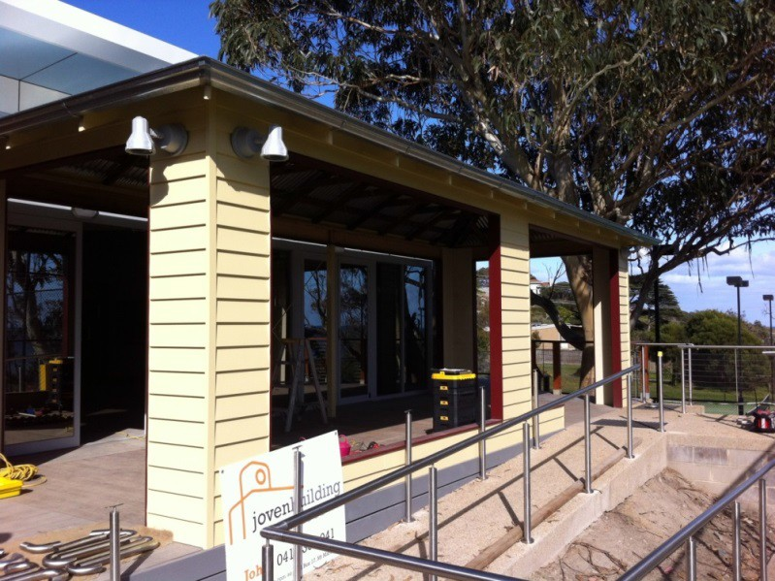
Image: External view of covered viewing area

Fruit Growers Reserve Sports Pavilion, Somerville
The recent completion of stage one - building works at Fruitgrowers Pavilion has allowed stage two civil works and demolition of the old pavilion and toilet block to commence. Over the next few weeks the external landscaping and fencing will be completed following the car park works. The new car park will provide for four car spaces including one disabled space.
It is anticipated stage two of the works will be completed in October 2015
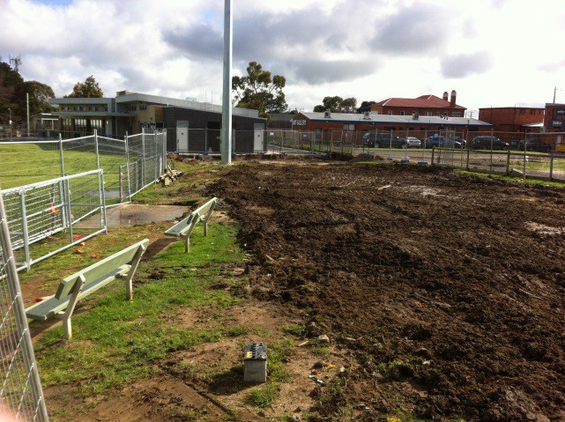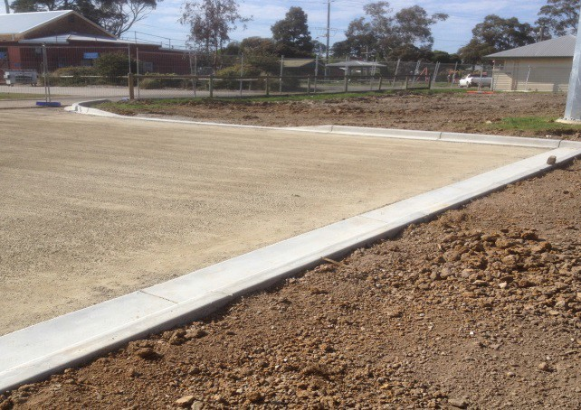
Image: View form demolished pavilion to new pavilion and car park works

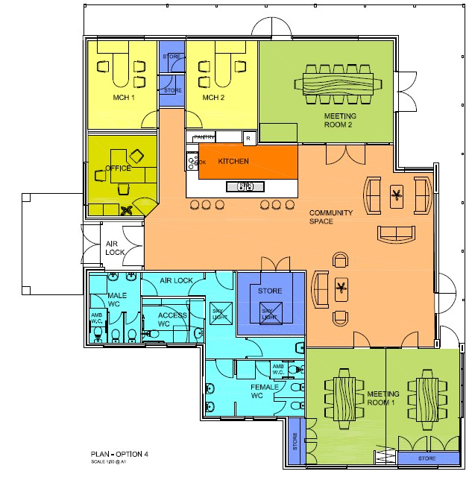
Image: Option for Somerville Community House

OPEN SPACES & RESERVES

Police Point Shire Park, Portsea
Contracts have been awarded for works to the value of $175k including visitor car park, Moonah walking trail, open space pathways and garden beds and visitor information shelter. Constructions of the open space walking trails were undertaken in September 2015.

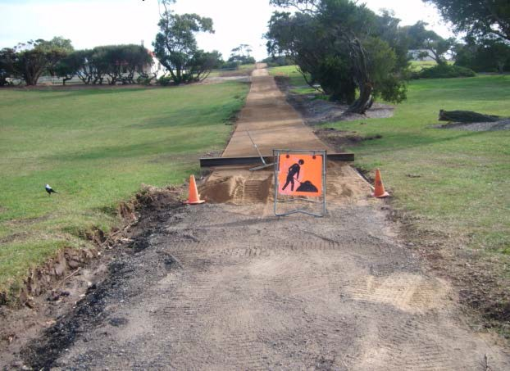
Image: Police Point Shire Park pathway works

Balnarring Recreation Reserve Master Plan Implementation
Balnarring Recreation Reserve Master Plan Implementation is a project for improving sporting facilities inside the reserve for sports club users. These works are part of the State Government Funding Program.

It is proposed to construct netball courts, cricket nets, proposed access road, drainage works and other associated works in Balnarring Recreation Reserve.

The works include the following key components not limited to:
- Construction of three new netball courts (fenced);
- Relocation and construction of four new cricket nets (to be moved and upgraded from current position to allow for netball courts);
- Demolition of public toilets (new toilets will be included in pavilion upgrade);
- Formation of new car-parking area (to replace lost car-park spaces due to location of netball courts;
- Upgrade to the roadway entrance to the reserve;
- Drainage Works;
- Tree removal / re-vegetation; and
- Other associated works.

The contract has been recently awarded and construction works are about to commence by late October. Because of present weather condition the major civil construction works are getting delayed.

At this stage, trees removing and demolition of existing cricket nets have been completed. Existing Toilet will be demolished this week once all paper works are completed for building permit.

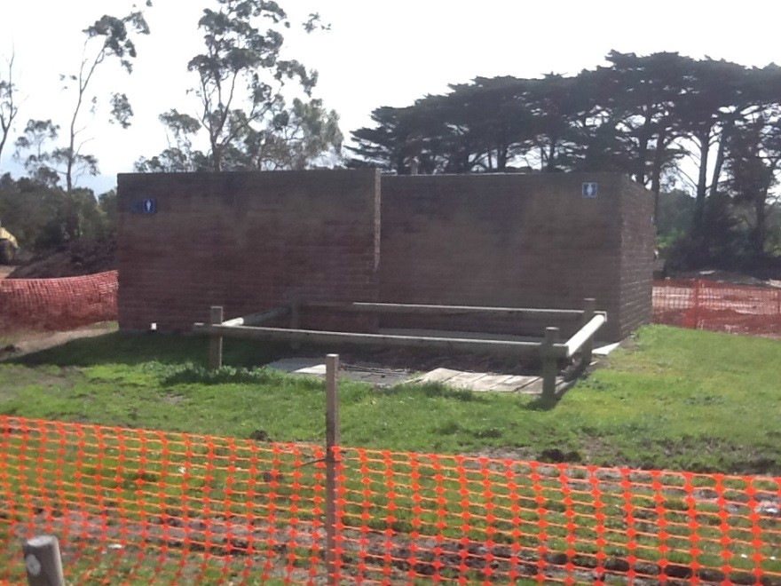
Image: Balnarring Reserve – photo of existing toilet to be demolished

Red Hill Station Playspace and Picnic Area
Requests for quotation for the playspace and picnic area at Red Hill Station Reserve were sent out to selected contractors in late September. The works consist of general landscaping across the reserve, the construction of a natural-play oriented playspace, a BBQ and picnic area with shelter and a trail head area with shelter, bike rails and hitching rails.

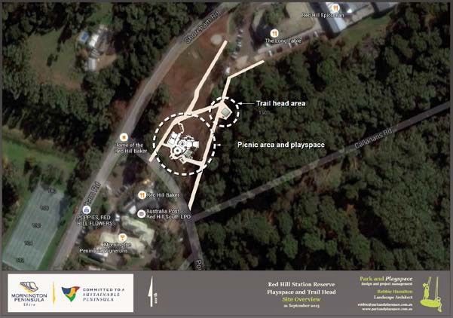
Image: Overview of Red Hill Station Site

This project is to be funded jointly by the Shire and the Communities for Nature grant secured by David Maddocks of the Mantons and Stony Creek Landcare group. It is anticipated that the majority of works will be completed by Christmas this year.

Junction Road Shared Trail, Merricks Beach and Balnarring Beach
The majority of the community consultation has been undertaken for the opening of the Junction Road Shared Trail. The trail will link Merricks Beach Road and Balnarring Beach Road (via local roads), creating an alternative route that is safer and much more picturesque than riding along Frankston-Flinders Rd between Balnarring and Merricks. The land that is to be fenced for this trail is owned by the Shire but has been previously unused as road reserve.

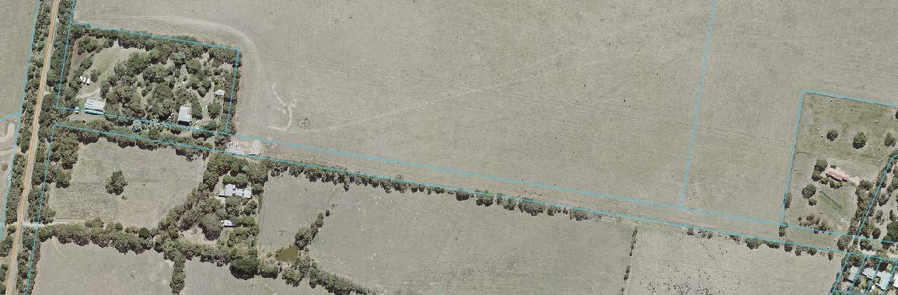
Image: The proposed route of the Junction Road Shared Trail

The works include fencing the trail, minor trail works and screen-planting to maintain privacy along adjoining properties. The planting will consist of plants from the local Ecological Vegetation Class. The procurement stage of the project will begin in October and it is anticipated that works will be completed by Christmas this year.

ROADS, STREETSCAPES & FOOTPATHS

Loders Road - Reconstruction, Moorooduc
Major civil construction works now are completed, with a minor works still to be undertaken at the intersection work at Graydens Road and Loders Road. This section of works are have been placed on hold, due to wet weather conditions. It is anticipated that the remaining construction works are to be completed by end of this calendar year.

Wooralla Drive Shared User Path, Mt Eliza
A shared path is to be constructed along Wooralla Drive from Emil Madsen Reserve to Mountain View Road, Mt Eliza. The proposed shared path will provide a safer passage for pedestrians.

In constructing the shared path, a rail crossing will be required. An application to VicTrack has been made seeking approval to construct the rail crossing. Recently Risk Workshop (as part of the approval process) with Vic Track, Mornington Tourist Railway, Public Transport Victoria and Mornington Peninsula Shire has been completed regarding the risk associated with pedestrian crossing at railway line. From the Risk Workshop, it has been advised to hold the footpath construction until the footpath at railway crossing approval.

Recently a consultant has engaged to design the pedestrian crossing at railway line. The design work of pedestrian crossing is progressing. Tenders are currently being evaluated for the construction of shared path between Tower Road to Emil Madesen Reserve. The report to Council has recently submitted for approval which will be held on 12 October 2015 Council Meeting.

Eastbourne Road Traffic Management Project, Rosebud
A contract has been awarded to Healey Infrastructure Pty Ltd for the construction/installation of Traffic Signals at the intersection of Jetty Road & McDowell Street Rosebud.

This project is for traffic improvement between Boneo Road and Jetty Road and is being funded by the Federal Government through the National Black Spot Program.

The objective of the works is to improve the functionality and safety for road users (both motorists and pedestrians).

Scope of the Works:
- Relocation of existing traffic lanes to include a continues centre of the road right turning lane
- The inclusion of bicycle lane on one side and parking on other side.
- Installation of at least 8 pedestrian refuges.
- Few intersections treatment along the sections
- Line marking to identify the new traffic lanes

Works are anticipated to be completed by December, 2015.

Mills Avenue Road Construction, Woolleys Reserve, Crib Point
Works are currently within Tender phase for the road construction, with a recommended contractor to be appointed in the coming weeks.

The proposed access road will extend over a length of 250 metres, consisting of a 5 metre wide sealed pavement to accommodate two-way traffic flow, in addition to 0.9 metre wide unsealed shoulders. Open drainage will be constructed for the majority the works, with the installation of kerb and channel in close vicinity of the Stony Point Road intersection.

Planning Permit P15/0707 has been issued for vegetation removal, with construction anticipated to commence in November 2015.

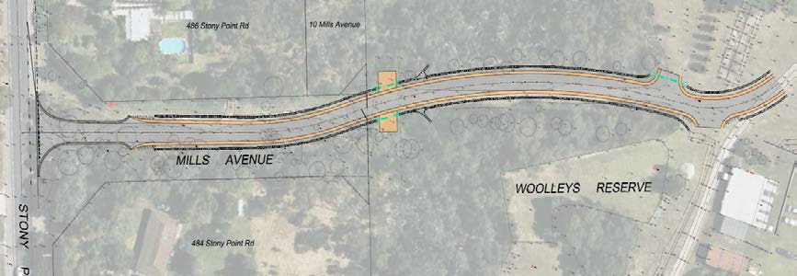
Drawing: Mills Avenue Proposed Access Road, Crib Point

Laneway 1 – Steamship Walk – Main Street, Mornington
Construction of Laneway 1 - Steamship Walk has now been completed, positioned between No.7 and No.13 Main Street in Mornington. The completed works improve connectivity, pedestrian safety, and the visual appearance of the walkway. The works included the installation of exposed aggregate pavement, feature bands of contrast pavement, internally illuminated decorative bollards and feature lighting.

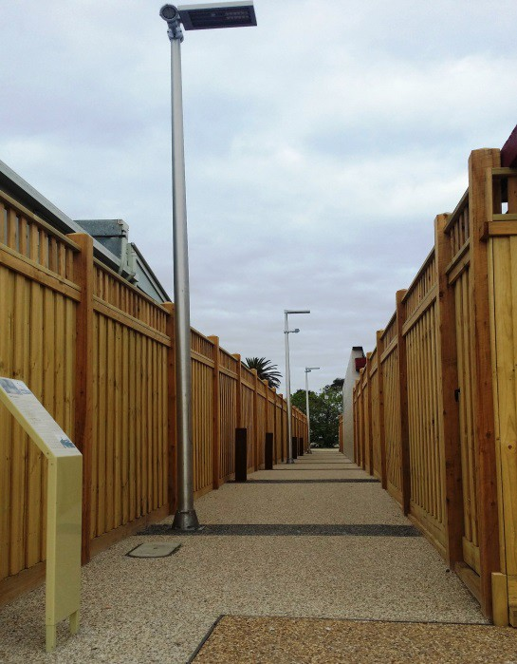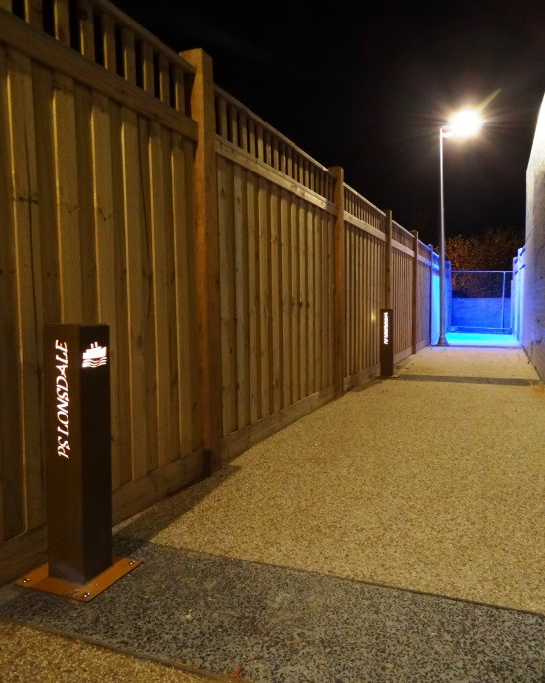
Images: Laneway 1 – Steamship Walk, Mornington (Day / Night)

Mount Eliza Way, Mount Eliza – Road and Drainage Upgrade
Detailed design is currently underway for the future road and drainage upgrade of Mount Eliza Way from Redbourne Ave to the Wimbourne Ave / Kenaud Ave Roundabout (currently under construction) in Mount Eliza. Funding for this project is provided by the Federal Government through the Roads to Recovery Program and Shire Local Integrated Drainage Strategy.

The works will improve road safety for motorists and cyclists through the provision of widened traffic lanes, dedicated on-street bicycle lanes, formalised indented parallel parking, the provision of increased sight lines at intersections and improved surface condition. They will also include drainage upgrade works, to reduce the risk of flooding to nearby residential properties and the Mount Eliza Village Precinct.

Planning Permit P15/1638 has been lodged for vegetation removal, with project communication newsletters to be distributed to nearby residents during October.

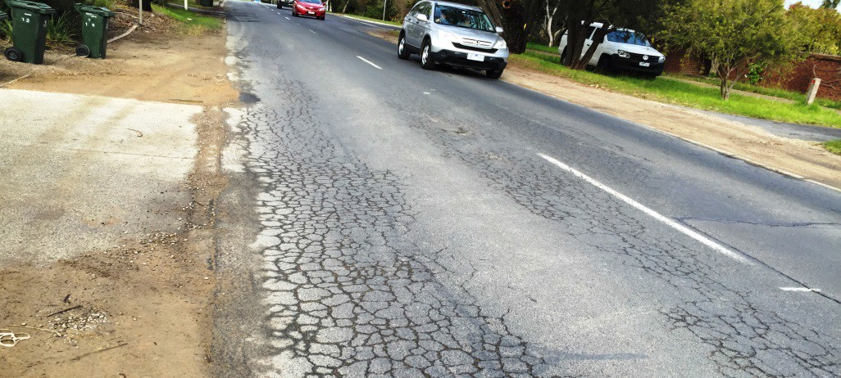
Images: Mount Eliza Way Existing Road Pavement

Tenders are anticipated to be called in early 2016, with construction expected to take place in April 2016

Truemans Road Footpath, Tootgarook – Footpath Construction
As part of the Mornington Peninsula Shire Footpath Strategy, the Shire has developed detailed design plans for the construction of a footpath along Truemans Road, from Booran Parade to Alma Street, in Tootgarook. Grist Archaeology Heritage Management was recently appointed to investigate and prepare a cultural heritage management plan for the works, with the investigation expected to take place over a three month period. Advertising for Planning Permit application P15/1110 for vegetation removal has closed, with a notice of decision anticipated to be issued in October. Pending permits / investigations, it is anticipated construction of the footpath will take place early 2016.

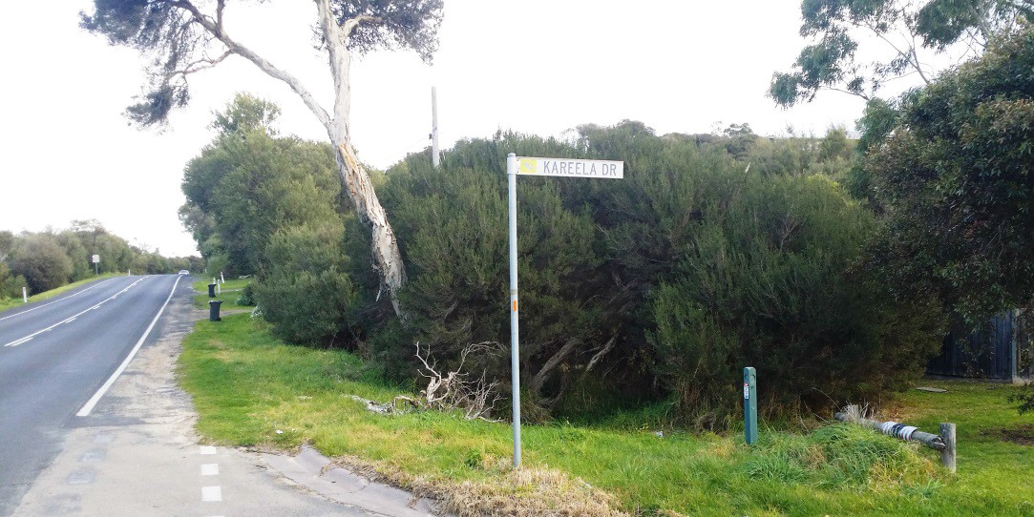
Images: Truemans Road Existing Nature Strip

Mills Beach, Esplanade, Foreshore Upgrades, Mornington
Civil works are now well underway, with the new sea wall almost completed. The works will provide for a high quality public space. Stage 1 will upgrade the foreshore area surrounding the lifesaving club and will also provide a link from the existing car park to the facility.

The proposed upgrade works will include, but not limited to, the following:
- Exposed aggregate concrete pavements,
- Various coloured concrete pavement patterns,
- Outdoor seating,
- Blue stone retaining wall (match to existing wall),
- Boat ramps,
- Beach access pedestrian ramp,
- Re-vegetation areas.

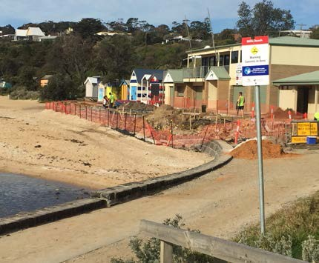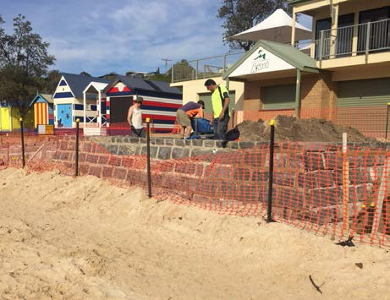
Image – Construction works underway

Work are anticipated to be completed by late November ,2015

Currawong Community Centre car park
Detailed design of the Currawong Community Centre car park (57 spaces) has been completed and ready for tendering. This car park has been designed on water sensitive urban design principles to improve the water quality and limit the rate of stormwater fun-off into the Tanti Creek catchment. The use of concrete kerbing is being limited in keeping with the heritage setting of the original Tanti farm buildings. It is anticipated construction works will commence in early 2016.

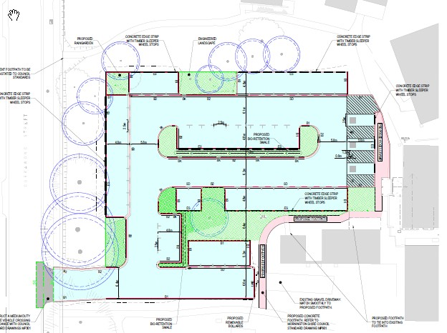
Image: Currawong Community Centre car park design

DRAINAGE

Cook Street Drainage Mitigation Works, Mornington
The construction Cook Street drainage mitigation works of the drainage works is now well underway. These works will involve partial reconstruction of the stormwater network that services both commercial and residential areas of the Mornington Township. As a result of the mitigation works, Cook Street, Grange Road, Franklin Place, Gordon Street, Murray Street, Barkley Street, Pearson Street, Eastern Ring Road, Main Street, Tanti Avenue and The Esplanade should see significant drainage improvement.

The Cook Street Drainage Mitigation Works as part of the “Integrated Local Flood Management and Drainage Strategy”. The strategy has several key outcomes, to flood map the entire Peninsula, to implement a capital flood mitigation program as a result of the mapping and to develop planning overlays to protect future development.

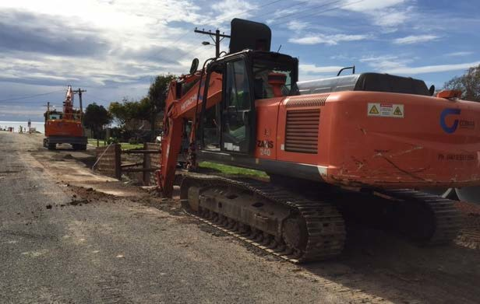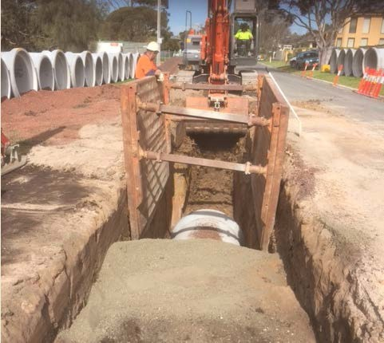
Image – Construction works underway

Works are anticipated to be completed by December, 2015

Mornington Pier Forecourt and Traffic Management Works.
Works have commenced for the construction of the Mornington Forecourt and Traffic Management works. The forecourt works will complement the newly refurbished Pier by Parks Victoria. The Traffic Management works will greatly improve the traffic flow for the Cars with Boat Trailers accessing the boat ramp whilst proving pedestrian safety.

Works including the following key functions:
- Improvements in pavement surface
- Pedestrian Crossings
- New Toilet Block
- Decking with seating
- Public and Specialised Lighting
- Interpretive Signage
- Improved Car and Boat Trailer Access

Having recently completed refurbishment works of the Pier, Parks Victoria are vacating the site to allow commencement of the Forecourt works in September. It is anticipated the works will be delivered prior to the summer peak period.

OTHER PROJECTS

CCTV Public Safety Infrastructure – Mornington, Mt Martha and Mt Eliza

The Mornington CCTV surveillance system has begun installation. The Mornington CCTV network is on track to be fully operational by the end of October. Mt Eliza and Mt Martha will follow closely behind.

Over the next two weeks the telecommunication poles will be installed in Mt Eliza in time for the CCTV Surveillance system to be installed at Mt Eliza for the relay off information from the Mt Eliza precinct back to the Mornington Police Station.

King Creek Master Plan
The design of the bioretention system for Wallaroo Reserve is reaching the detailed design vase. This design should be completed and ready for external quotation before the end of this month with the construction planned for over the summer period. Water sampling is currently being undertaken on a fortnightly basis to monitor the water quality of the creek. A clean-up day will soon be organised for the reserve.

Briars Master Plan
Consultation with the Briars Visitor centre staff has commenced to identify the key issues and areas requiring some improvement at the notorious Mount Martha Briars to develop a master plan that will be implemented over a period of five years or so. Preliminary plans have been completed for the various nodes of works in the Briars to get a sound estimate to what the Briars needs for the next few years and how much will be required to fund the various projects. Further external community consultation will be included at a later stage when more detailed plans are available.



Monthly Financial Report

September 2015

Contents
Page
Key Financial Highlights and Overview | 1
Operating Performance | 2
Capital Works Performance | 3
Priority Works Performance | 4
Priority Projects Performance | 5
Asset Conversion Program | 6
Borrowings | 6
Group Analysis
Chief Executive Officer’s Group | 8
Corporate Services (including Communities) | 9
Infrastructure and Planning | 10
Financial Statements
Standard Income Statement | 12
Balance Sheet | 13
Cash Flow Statement | 14
Corporate Performance Statement | 15
Project Listings
Capital Works | 17
Priority Works | 22
Priority Projects | 24
Q1 Forecast Summaries
Capital Works | 27
Priority Works | 28
Priority Projects | 29

Key Financial Highlights and Overview
For the period ended 30 September 2015

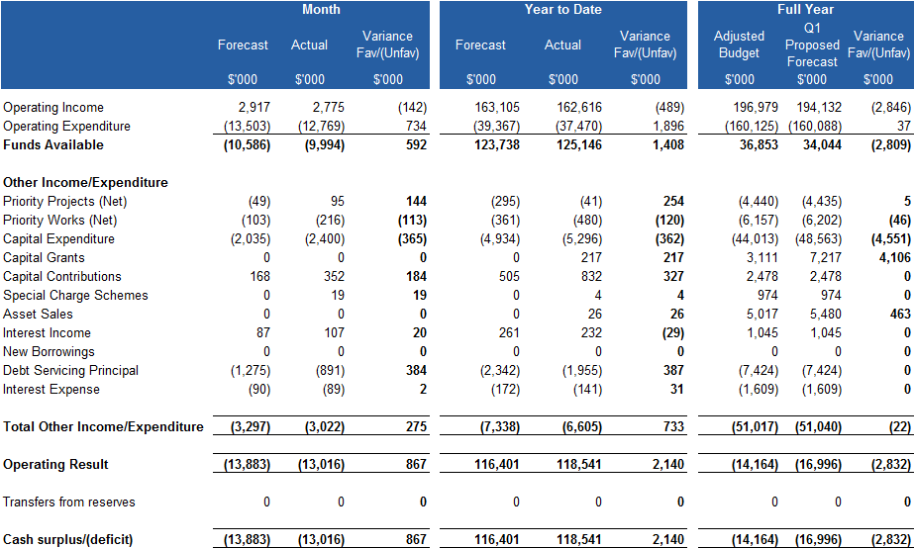

The above table is an excerpt from the Corporate Performance Statement and shows a high level breakdown of Operational and other expenditure before attribution of internal charges. Income and Expense is categorised either operational or capital in nature.

Year to date, Mornington Peninsula Shire (MPS) has a favourable surplus of $2.1m. This is primarily due to timing of operating expenditure ($1.9m), in particular various materials and services accounts ($1.6m). At this point, no savings are expected as the underspend is attributed to timing of receipt of invoices (utilities), seasonality of programmed works (roads) and timing of expenditure on items such as computer maintenance and printing and stationery. Other favourable year to date variances relate to early receipt of capital ($544k) and Priority Project income ($253k) which will fund project expenditure and budget phasing of debt principal and interest payments.

Operating Income is unfavourable by $489k mainly due to the early receipt of the Victoria Grants Commission funding in the prior financial year ($818k). This has been partially offset by increased rate revenue from supplementary rates ($411k) and greater take up of the opt- in green waste service ($141k). Project expenditure in Capital Works has an unfavourable variance due to works for Black Spot program in Mt Eliza occurring earlier than forecasted ($362k).

The 1st Quarter Review for budget forecast update has been completed and the impact is
$2.832m unfavourable to the Approved Forecast mainly due to Victoria Grants Commission funding ($3.271m), offset by increased Rate revenue of $411k. In addition, the other changes to forecast are Operating - $50k favourable, Capital Works – $18k favourable, Priority Works – ($46k) unfavourable and Priority Projects – $5k favourable.

Further explanations regarding financial performance are included in the rest of this report.

Operating Performance
For the period ended 30 September 2015

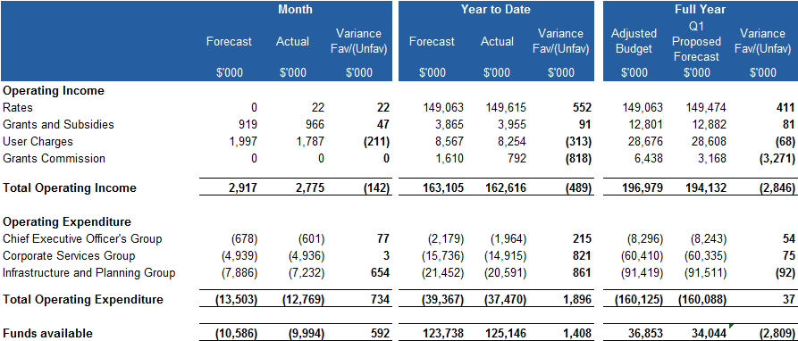

Source: Corporate Performance Statement

The above table illustrates the breakdown of income and expenditure from the Key Financial Highlights and Overview (previous page) and is designed to show the funds available from operating activities that are available for expenditure on Capital and Priority Works, Priority Projects and debt principal repayments. It differs from the Standard Income Statement in that it does not include capital grants, contributed assets, depreciation and user fees from Special Charge schemes as these are considered to be either non-recurrent (eg capital grants) or non- cash entries (eg. depreciation).

For the month of September, operating income has an unfavourable variance of $142k primarily due to cancellations in foreshore camping, delayed invoicing for the community halls ($107K) and unbilled waste fees ($79k). There is no year-end impact expected. Year to date, the unfavourable variance of $489k is primarily due to reduced Victoria Grants Commission funding received ($818k) offset by additional Rate revenue. These variances are reflected in the Quarter 1 forecast review.

Operating expenditure is favourable by $734k for the month, mainly in the Infrastructure and Planning group. Works on unmade roads is under budget ($182k) and expected to occur over the summer months. In addition, water utilities are yet to be invoiced for the previous 2 months.

Year to date expenditure is lower than forecast ($1.9m) across MPS, primarily in:
  - Contract expenditure - $625k (mainly in Renewable Resources and Infrastructure Maintenance)
  - Timing of utility invoicing (water and electricity) - $300k
  - Corporate items including printing and stationery, subscriptions and memberships and photocopier costs - $273k
  - Computer maintenance and operating lease costs (IT) - $310k
  - External contractors and legal expenditure - $233k
  - Travel and fuel - $105k

Changes proposed in the Quarter 1 Forecast Review mainly relate to Victoria Grants Commission funding ($3.271m) & additional Rate revenue of $411k coupled with operating savings in Aged & Disability services $50k. Detail on individual Group performances is included later in the Group Analysis section of this report.

Capital Works Performance
For the period ended 30 September 2015

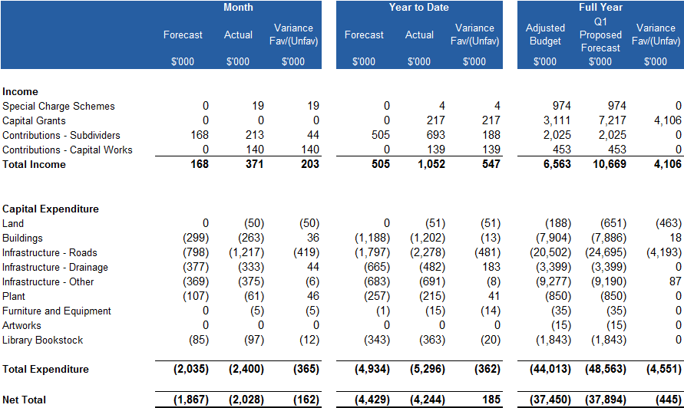

*Note – excludes internal income and expenditure (as per Corporate Performance Statement)

The unfavourable variation for Capital Works for the month of September is primarily due to expenditure on Road Infrastructure, namely the Black Spot program in Mt Eliza, occurring earlier than forecast ($399k). No year-end impact is expected.

Funds were also received from Council’s insurers during September for the clean-up works on the Warringine Boardwalk ($138k) in the prior year.

The Capital Works program (net result) is showing a favourable year to date variation due in part to increased income:
- Unbudgeted funding $160k received for CCTV works in Mornington
- Continuing increased Contributions from Subdividers (Recreation Open Space contributions)

It is proposed that for the Quarter 1 Forecast Review the Capital Works budget be increased by $4.551m. This will be funded in part by income to be received:

  - $3.506m for Blackspot Programs
  - $600k for Roads to Recovery (Shands Rd Bridge)
  - Asset Sales - $463k (offsetting land purchases shown above)

The net favourable change of $18k represents budget directed towards funding investigation works in Colchester Road (Priority Works) as per Council decision. A summarised listing of proposed changes is provided on page 27, with a detailed listing provided in the Project Listing section (page 17).

Priority Works Performance
For the period ended 30 September 2015

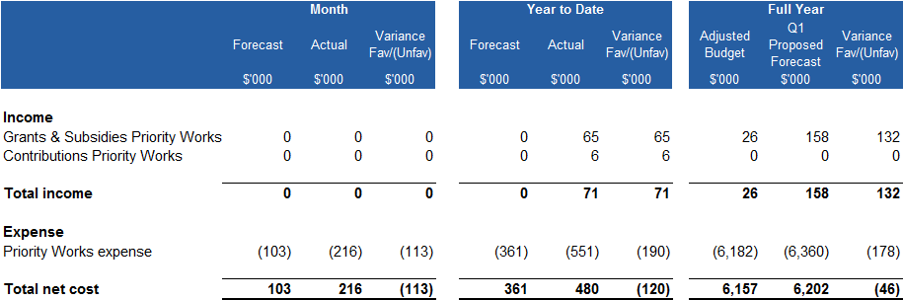

*Note – excludes internal income and expenditure (as per Corporate Performance Statement)

Priority Works are similar in nature to Capital Works, however, they are not individually material in value or do not add to the capitalised value of an asset, or they may be a contribution to another entity’s assets.

The net unfavourable variance in Priority Works of $113k for the month of September is primarily due to backdated SIMS expenditure transferred during the month ($97k) with no bottom line impact expected.

Following the Quarter 1 Review, there is an increase of $46k to the Adjusted Budget which is made up of:

  - Mt Eliza Bowls Club lighting ($23k) – funds received from the Club in the prior financial year.
  - Colchester Rd investigations ($18k) – to be funded from the Southern Peninsula Aquatic budget (as per Council resolution).

There is a summarised listing of Priority Works Quarter 1 forecast changes included on page 28 of this report, with a detailed listing provided in the Project Listing section (page 22).

Priority Projects Performance
For the period ended 30 September 2015

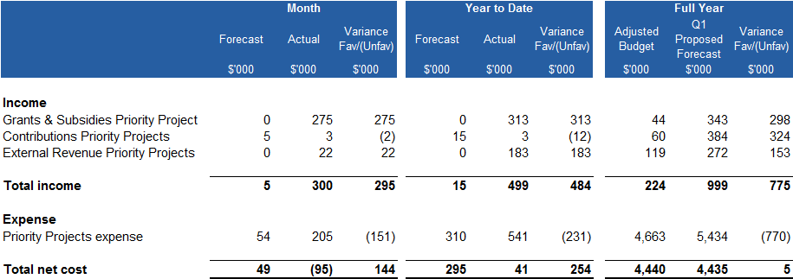

*Note – excludes internal income and expenditure (as per Corporate Performance Statement)

Priority Projects are generally “one-off” or at least not recurring costs. Examples are strategy development or specific funded projects.

As at the end of September, there is a favourable result as compared primarily due to unbudgeted income.

    - Funding received from Tourism Vic towards funding Mornington Peninsula Tourism activities ($275k). The income and corresponding matching expenditure have been included in the Q1 forecast review.

The expenditure variance for the month is due to budget phasing for various projects and no change to budget expected.
The $5k favourable variance in the Q1 Proposed Forecast is the transfer of budgeted matching grant funding to the Priority Works program for the Hastings Boat Ramp Extension Deepening Study.

There is a summarised listing of Priority Projects Quarter 1 Forecast changes included on page 29 of this report, with a detailed listing provided in the Project Listing section (page 24).

Asset Conversion Program
For the period ended 30 September 2015

Property | Type of Asset | Status | Date of Sale | Net Sale Proceeds  $'000
525 The Esplanade Mt Martha- cnr road splay | Road | Complete | 23.07.2015 | 16
Toyota Prius XFG-572 | Car | Complete | 21.07.2015 | 10
Total |  |  |  | 26

Asset Sales for 2015/16 are listed above.

Borrowings

Loans Maturing | Opening Balance  01/09/2015  $'000 | Principal Paid  September 2015  $'000 | Closing Balance Budgeted Principal Budgeted Closing  Repayments Balance  30/09/2015 2015/16 30/06/2016  $'000 $'000 $'000
0 - 5 Years | 18,342 | 718 | 17,624 | 5,797 | 13,220
5 - 10 Years | 12,467 | 174 | 12,293 | 1,508 | 11,348
10+ Years | 2,493 | 0 | 2,493 | 153 | 2,340
33,302 |  | 891 | 32,410 | 7,458 | 26,908
Loans outstanding have been categorised according to their term to maturity as at the commencement of the financial year.

During the month of September, MPS paid $891k leaving an outstanding loan principal of
$32.4m. This will further reduce by 30 June 2016 to $26.9m in line with Council’s commitment to reduce borrowings.

Group Analysis

For the period ending 30 September 2015

Group Budget Performance
For the period ended 30 September 2015

Chief Executive Officer’s Group

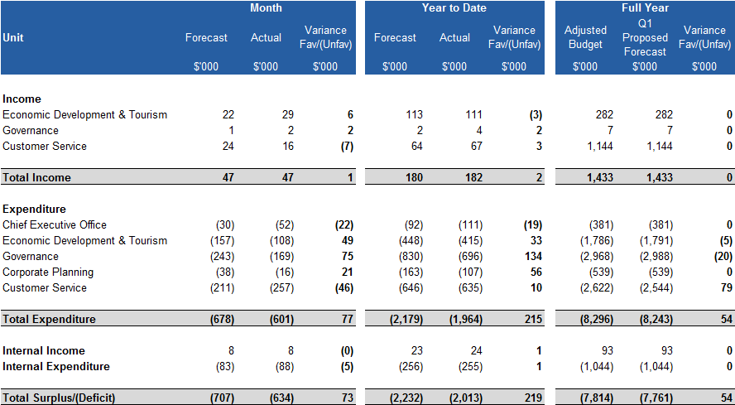

The above table shows a high level of breakdown of Operational income and expenditure per Unit. Internal income and expense charges are shown separately as a line item for the group. They represent recharges of internal services and overheads.

The favourable result for the Chief Executive Officer’s group is mainly due to underexpenditure in Governance on council memberships and photocopier expenses, combined with savings due to vacant positions.

The favourable variation in forecast adjustments is primarily due to the reallocation of a staff member to Information Services (in the Corporate Services group).

Corporate Services Group

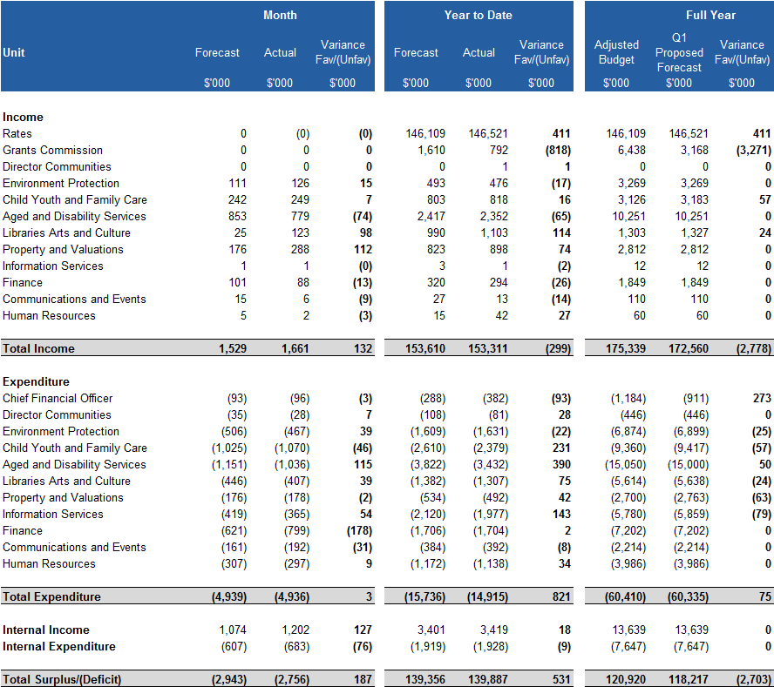
The above table shows a high level of breakdown of Operational income and expenditure per Unit. Internal income and expense charges are shown separately as a line item for the group. They represent recharges of internal services and overheads.

The Corporate Services Group has a favourable monthly variation to budget to date primarily due to early invoicing of for property rentals, timing of expenditure in IT (computer maintenance and operating leases) and vacant positions in Aged and Disability Services.

The variation in the Quarter 1 forecast adjustment is primarily due to the early receipt of Victoria Grants Commission funding in the prior financial year and increased Rate revenue.

Infrastructure and Planning Group

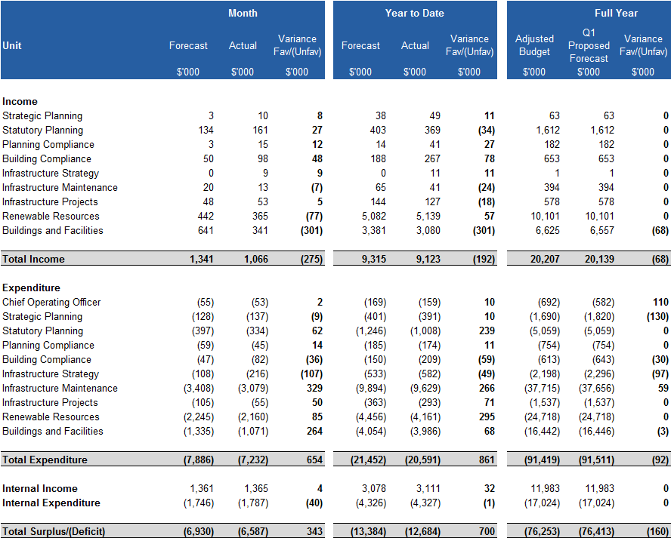

The above table shows a high level of breakdown of Operational income and expenditure per Unit. Internal income and expense charges are shown separately as a line item for the group. They represent recharges of internal services and overheads.

The Infrastructure and Planning Group’s result for the month is favourable by $343k. This mainly relates to timing of utility payments ($136k Water) and expenditure on Roads which is related to the timing of the unmade road grading and crushed rock re-sheeting program ($189k), with the majority of works completed during the warmer months.

Lower income in Building and Facilities mainly relates to cancellations of foreshore camping bookings. This is a temporary variance as waiting list bookings will proceed in the coming month. Revenue for community halls ($107k) will also correct in the coming month as invoices are sent in October.

The changes in forecasted expenditure primarily relate to the transfer of budgeted expenditure from the Corporate Services group.

Financial Statements

For the period ending 30 September 2015

Standard Income Statement
For the period ended 30 September 2015

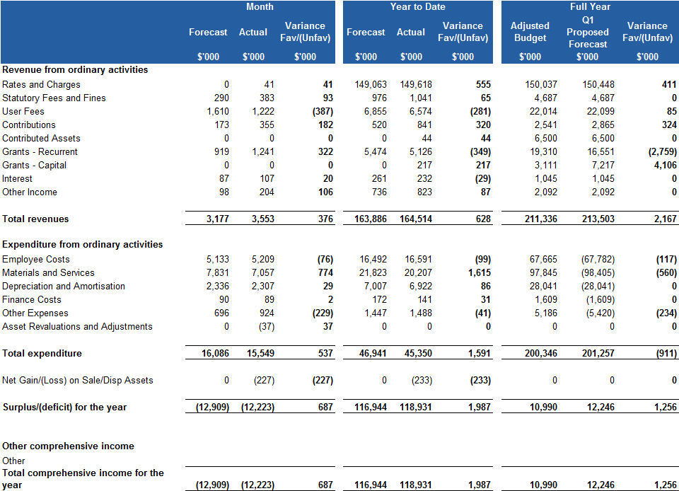

*Commentary is included in the sections Key Financial Highlights and Overview and Group Analysis.

Balance Sheet
For the period ended 30 September 2015

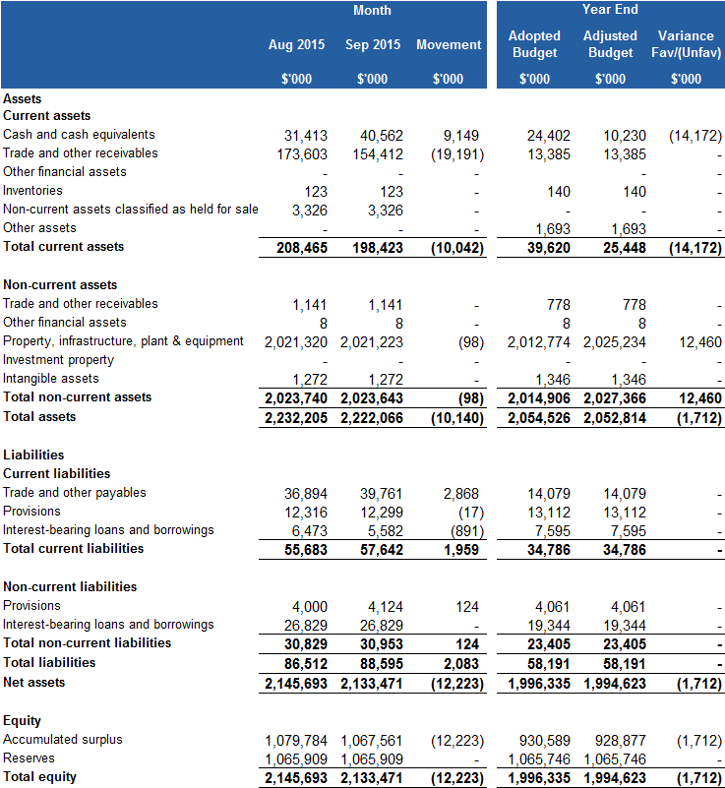

*Commentary is included in the sections ‘Key Financial Highlights and Overview’ and ‘Group Analysis’.

Cash Flow Statement
For the period ended 30 September 2015

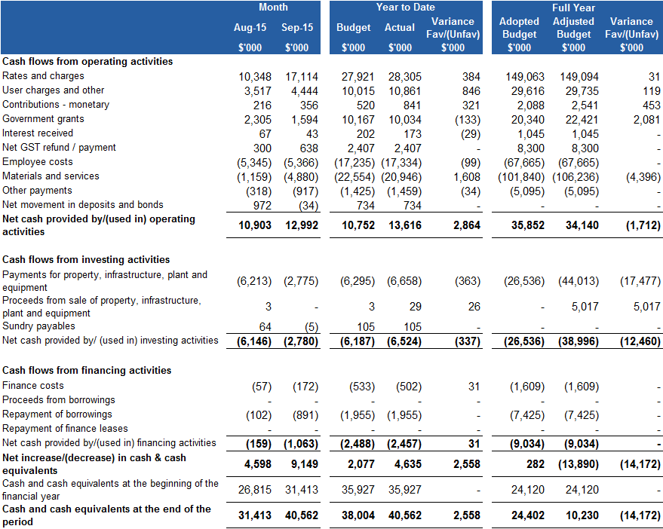

Corporate Performance Statement
For the period ended 30 September 2015

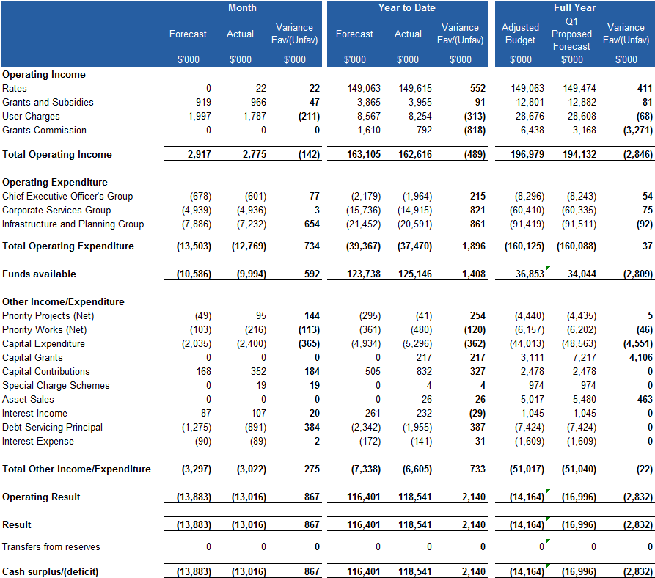

*Commentary is included in the sections ‘Key Financial Highlights and Overview’ and ‘Group Analysis’.

Project Listings

Capital Works Priority Works Priority Projects

Capital Works (Expenditure only)
For the period endingSeptember 2015

Month
Activity
Variance
Forecast Actual Fav/(Unfav
)
$'000 $'000 $'000
Year to Date
Variance Forecast Actual Fav/(Unfav
)
$'000 $'000 $'000
Full Year
Adjusted Q1 Forecast Proposed
Forecast
$'000 $'000
Variance
Fav/(Unfav
)
$'000

7032. Acquisitions - M'ton Pen Reg Galler | 0 | 0 | 0 | 0 | 0 | 0 | 15 | 15 | 0
7062. Signage - Traffic/Parking Areas | 0 | 0 | (0) | 0 | 0 | (0) | 20 | 20 | 0
7082. Sale of Roads | 0 | 0 | (0) | 0 | 1 | (1) | 0 | 0 | 0
7187. Fruitgrowers Reserve Machinery Shed | 0 | 0 | 0 | 0 | 0 | 0 | 15 | 15 | 0
7444. Hastings Com Area Parking & TMT Imp | 0 | 0 | 0 | 0 | 0 | 0 | 43 | 43 | 0
7482. Safer Local Roads Program | 0 | 0 | 0 | 0 | 0 | 0 | 4,000 | 4,000 | 0
7486. Southern Peninsula Aquatic Recreati | 0 | 3 | (3) | 0 | 3 | (3) | 738 | 719 | 18
7489. Rye Traffic Man Strategy Implementa | 10 | 0 | 10 | 15 | 5 | 10 | 77 | 77 | 0
7549. Bicycle Strategy | 0 | 0 | 0 | 0 | 0 | 0 | 143 | 0 | 143
7584. Activity Centre Structure Plan - Im | 0 | 0 | 0 | 0 | 87 | (87) | 0 | 140 | (140)
7630. Peninsula DriveSafe - High Risk Tar | 0 | 0 | 0 | 0 | 0 | 0 | 15 | 15 | 0
7657. M'ton Youth Hub-Former Sec/College | 0 | 6 | (6) | 330 | 335 | (5) | 453 | 453 | 0
7665. B/Spot Shands- Mton Flind Shoreham | 0 | 0 | 0 | 0 | 2 | (2) | 0 | 0 | 0
7667. Sorrento Seawall | 0 | 0 | 0 | 0 | 0 | 0 | 119 | 119 | 0
7674. Ticketing System Foreshore B/Ramps | 0 | 0 | 0 | 0 | 0 | 0 | 9 | 9 | 0
7675. Tennis Strategy | 10 | 0 | 10 | 17 | 7 | 10 | 52 | 52 | 0
7676. Net Ball Strategy | 0 | 0 | 0 | 0 | 0 | 0 | 4 | 4 | 0
7677. BSpot Melb Rd (Canterbury Jetty Rd) | 4 | 3 | 1 | 100 | 103 | (3) | 100 | 100 | 0
7678. BSpot Browns Rd/Boneo Rd-Flders Rd | 0 | 0 | 0 | 0 | 0 | 0 | 27 | 27 | 0
7679. BSpot Marine Pd/Western Port/Skinne | 0 | 0 | 0 | 0 | 1 | (1) | 64 | 64 | 0
7685. Disabled Parking | 0 | 0 | 0 | 0 | 1 | (1) | 0 | 0 | 0
7692. Bentons Square Preschool-Additions | 0 | 0 | 0 | 0 | 0 | 0 | 15 | 15 | 0
7695. RTR - Bungower Rd / Tyabb-Tooradin | 200 | 204 | (4) | 507 | 517 | (10) | 1,115 | 1,115 | 0
7696. Mornington Structure Plan Traffic M | 4 | 0 | 4 | 7 | 3 | 4 | 66 | 66 | 0
7697. Rosebud Activity Centre Structure P | 20 | 3 | 18 | 60 | 48 | 12 | 61 | 61 | 0
7699. Unmade Carpark Construction Strateg | 0 | 0 | 0 | 0 | 0 | 0 | 9 | 9 | 0
7701. Active Sports Strategy - Impl | 10 | 0 | 10 | 15 | 4 | 11 | 79 | 79 | 0
7706. Alfred Street Streetscape Works | 7 | 1 | 6 | 19 | 14 | 6 | 19 | 19 | 0
7708. BSpot Shands/Main Creek Roundabout | 0 | 0 | 0 | 0 | 0 | 0 | 79 | 79 | 0
7709. BSpot Jetty/McDowell Signals | 5 | 0 | 5 | 8 | 2 | 6 | 276 | 276 | 0
7710. BSpot Sandy Road Fingal | 0 | 0 | 0 | 0 | 0 | 0 | 40 | 40 | 0
7714. Mt Martha Life Saving Club | 0 | 0 | 0 | 0 | 0 | 0 | 37 | 37 | 0
7716. Mens Shed Mornington | 0 | 0 | 0 | 0 | 0 | 0 | 60 | 60 | 0
7722. Somerville Pedestrian Strategy | 0 | 0 | (0) | 0 | 3 | (3) | 40 | 40 | 0
7725. Guardrail Renewal Program | 0 | 0 | 0 | 39 | 39 | 0 | 50 | 50 | 0
7727. Storm Water Quality Program | 10 | 0 | 10 | 15 | 4 | 11 | 55 | 55 | 0
7728. Mills Beach Master Plans - Implemen | 30 | 50 | (20) | 75 | 94 | (19) | 198 | 198 | 0
7730. B/Spot - Mt Eliza | 30 | 429 | (399) | 45 | 451 | (406) | 689 | 689 | 0
7731. B/Spot - Graydens Rd/Boes Rd | 0 | 31 | (31) | 0 | 31 | (31) | 1,343 | 1,343 | 0
7732. B/Spot - Loders Road - Moorooduc | 200 | 197 | 3 | 534 | 538 | (4) | 800 | 940 | (140)
7733. B/Spot - Browns Road - Rosebud | 10 | 12 | (2) | 15 | 14 | 1 | 358 | 358 | 0
7734. B/Spot - Eastbourne Road - Rosebud | 0 | 1 | (1) | 0 | 4 | (4) | 247 | 247 | 0
7738. Police Point Management Plan | 20 | 20 | (0) | 54 | 55 | (1) | 147 | 147 | 0
7743. Land Acq. - 13 Ninth Ave, R'bud | 0 | 0 | 0 | 0 | (1) | 1 | 0 | 0 | 0
7744. R2R 4 Mt Eliza Way | 18 | 8 | 10 | 18 | 17 | 1 | 700 | 700 | 0
7745. Board Walk Warringine Park | 60 | 81 | (21) | 60 | 85 | (25) | 60 | 60 | 0
7747. R2R 4 Tasman Road | 0 | 4 | (4) | 0 | 4 | (4) | 300 | 300 | 0
7748. R2R 4 Browns Road | 0 | 0 | 0 | 0 | 0 | 0 | 100 | 100 | 0
7749. Provision for Coastal Erosion Works | 0 | 0 | 0 | 0 | 0 | 0 | 765 | 765 | 0
7751. R2R 4 Shands Roads Bridge | 0 | 0 | 0 | 0 | 1 | (1) | 0 | 0 | 0
7752. BSpot Wooralla Dve Mt Eliza | 0 | 6 | (6) | 0 | 6 | (6) | 0 | 1,016 | (1,016)
7753. BSpot Jetty Rd Old Cape Schanck Rd | 0 | 2 | (2) | 0 | 2 | (2) | 0 | 736 | (736)
7754. BSpot Humphries Rd Walkers Rd Mt El | 0 | 4 | (4) | 0 | 4 | (4) | 0 | 588 | (588)
7755. BSpot Bungower Rd Jones Rd S/ville | 0 | 3 | (3) | 0 | 3 | (3) | 0 | 438 | (438)
7756. BSpot Old Cape Schanck Rd R/Bud | 0 | 0 | 0 | 0 | 0 | 0 | 0 | 285 | (285)
7757. BSpot South Beach Rd/Disney St Bitt | 0 | 1 | (1) | 0 | 1 | (1) | 0 | 271 | (271)
7758. BSpot Barkley St/Herbert St M/ton | 0 | 1 | (1) | 0 | 1 | (1) | 0 | 172 | (172)
7759. R2R 4 Shands Road - Bridge | 0 | 0 | 0 | 0 | 0 | 0 | 0 | 600 | (600)
A600. Rosebud Jetty Landscape Master Plan | 0 | 3 | (3) | 0 | 3 | (3) | 600 | 600 | 0
A601. Eastern Carpark Construction | 0 | 0 | 0 | 0 | 0 | 0 | 320 | 320 | 0
A700. Bushland Reserve Signage | 2 | 0 | 2 | 4 | 1 | 3 | 20 | 20 | 0
A701. Directional - Intersection Township | 2 | 0 | 2 | 5 | 3 | 2 | 20 | 20 | 0
A702. Corporate Signage Townships | 2 | 0 | 2 | 4 | 1 | 3 | 25 | 25 | 0
A704. Event Signage | 0 | 0 | 0 | 0 | 0 | 0 | 10 | 10 | 0
A706. Dromana Township Gateway Signage | 0 | 0 | 0 | 0 | 0 | 0 | 20 | 20 | 0
A707. The Briars Visitor Safety - Signage | 0 | 2 | (2) | 0 | 4 | (4) | 40 | 40 | 0

 |  |  | Month |  |  |  |  | Year to |  | D | ate |  |  |  |  | Full Year
Activity | Forecast |  | Actual | Variance Fav/(Unfav  ) |  | Forecast |  |  | Actual |  | Variance Fav/(Unfav  ) |  | Adjusted Forecast |  |  | Q1  Proposed Forecast |  | Variance Fav/(Unfav  )
 | $'000 |  | $'000 | $'000 |  |  | $'000 |  | $'000 |  | $'000 |  |  | $'000 |  | $'000 |  | $'000
A720. Peninsula Link Project Signage | 10 |  | 0 |  | 10 | 20 |  |  | 8 |  |  | 12 | 167 |  |  | 167 |  | 0
A750. Tumbywood Rd Trail | 10 |  | 6 |  | 5 | 22 |  |  | 17 |  |  | 5 | 80 |  |  |  | 80 | 0
A751. Junction Rd Trail | 10 |  | 6 |  | 4 | 10 |  |  | 9 |  |  | 1 | 83 |  |  |  | 83 | 0
A800. 38 Austin Road Somerville |  | 0 | 0 |  | 0 |  |  | 0 | 0 |  |  | 0 | 132 |  |  | 132 |  | 0
A801. 14 Dominion Road |  | 0 | 0 |  | 0 |  |  | 0 | 0 |  |  | (0) |  |  | 0 |  | 0 | 0
A802. 2&4 Waveney Avenue Mt Eliza |  | 0 | 4 |  | (4) |  |  | 0 | 4 |  |  | (4) | 20 |  |  |  | 20 | 0
A803. 2360 Frankston-Flinders Rd - Bitten |  | 0 | 0 |  | 0 |  |  | 0 | 0 |  |  | 0 | 36 |  |  |  | 36 | 0
A805. Land Acqu - 35 King Street Hastings |  | 0 | 46 | (46) |  |  |  | 0 | 46 |  | (46) |  |  |  | 0 | 463 |  | (463)
B119. Cragie Road Bus Stop Works |  | 0 | 0 |  | 0 |  |  | 0 | 0 |  |  | 0 | 10 |  |  |  | 10 | 0
B120. Disabled Parking Works |  | 0 | 0 |  | 0 |  |  | 0 | 0 |  |  | 0 | 10 |  |  |  | 10 | 0
B400. Shared Path Construction |  | 0 | 0 |  | 0 |  |  | 0 | 0 |  |  | 0 | 124 |  |  |  | 0 | 124
B402. Ridesafe Education Support |  | 0 | 0 |  | 0 |  |  | 0 | 0 |  |  | (0) | 25 |  |  |  | 25 | 0
B403. Ridesafe Promotion/Event Support |  | 0 | 0 |  | 0 |  |  | 0 | 0 |  |  | 0 |  |  | 9 |  | 9 | 0
B404. Cycling Storeage Facilities |  | 0 | 0 |  | 0 |  |  | 0 | 0 |  |  | 0 | 33 |  |  |  | 33 | 0
B405. On-Road Cycling Storage Facilities |  | 0 | 0 |  | 0 |  |  | 0 | 0 |  |  | 0 | 50 |  |  |  | 50 | 0
B450. Data Analysis and Reporting | 10 |  | 19 |  | (9) | 21 |  |  | 29 |  |  | (8) | 107 |  |  | 107 |  | 0
B451. Council Contribution to Works | 100 |  | 100 |  | 0 | 100 |  |  | 100 |  |  | 0 | 240 |  |  | 100 |  | 140
B500. Barkly St/Main St Intersections |  | 0 | 0 |  | 0 |  |  | 0 | 0 |  |  | 0 | 43 |  |  |  | 10 | 33
B501. Hilltop Square Landscape |  | 5 | 0 |  | 5 | 12 |  |  | 7 |  |  | 5 | 49 |  |  |  | 15 | 34
B502. Node Enhancement |  | 0 | 0 |  | 0 |  |  | 0 | 0 |  |  | 0 | 48 |  |  |  | 36 | 12
B503. Pier Mornington Pier Forecourt | 10 |  | 6 |  | 4 | 13 |  |  | 11 |  |  | 2 | 787 |  |  | 714 |  | 73
B504. Mornington Laneways Strategy - Impl | 35 |  | 34 |  | 1 | 35 |  |  | 34 |  |  | 1 | 65 |  |  |  | 78 | (13)
B550. Foreshore Camping Development Works | 20 |  | 0 |  | 20 | 75 |  |  | 55 |  |  | 21 | 200 |  |  | 200 |  | 0
B551. Foreshore Camping Fire Mitigation |  | 5 | 6 |  | (1) | 13 |  |  | 14 |  |  | (1) | 200 |  |  | 200 |  | 0
B600. Sorrento Streetscape Strategy - 2 |  | 0 | 2 |  | (2) |  |  | 0 | 4 |  |  | (4) |  |  | 0 |  | 0 | 0
B601. George St/Ocean Beach Road |  | 0 | 8 |  | (8) |  |  | 0 | 8 |  |  | (8) | 50 |  |  |  | 50 | 0
B602. Morce Ave - Sorrento |  | 0 | 0 |  | (0) |  |  | 0 | 0 |  |  | (0) | 250 |  |  | 250 |  | 0
B631. Flinders Township |  | 0 | 0 |  | 0 |  |  | 0 | 0 |  |  | 0 | 79 |  |  |  | 79 | 0
B632. Minor Township Works |  | 5 | 1 |  | 5 |  |  | 9 | 4 |  |  | 5 | 266 |  |  | 266 |  | 0
B633. Blairgowrie - Design of Streetscape |  | 0 | 0 |  | 0 |  |  | 0 | 0 |  |  | 0 | 25 |  |  |  | 25 | 0
B650. Watson Rd, Mt Martha |  | 0 | 0 |  | 0 |  |  | 0 | 0 |  |  | 0 | 100 |  |  | 100 |  | 0
B652. Portsea Tennis Club |  | 0 | 0 |  | 0 |  |  | 0 | 0 |  |  | 0 | 50 |  |  |  | 50 | 0
B653. Crib Point Football / Netball Club |  | 0 | 0 |  | 0 |  |  | 0 | 0 |  |  | 0 | 50 |  |  |  | 50 | 0
B660. Mornington Netball Courts |  | 0 | 0 |  | 0 |  |  | 0 | 0 |  |  | 0 | 158 |  |  | 158 |  | 0
B670. Alfred St Streetscape Works - Stg 2 |  | 0 | 0 |  | 0 |  |  | 0 | 0 |  |  | 0 | 150 |  |  | 150 |  | 0
B671. High Street Streetscapes |  | 1 | 0 |  | 1 |  |  | 2 | 1 |  |  | 1 | 250 |  |  | 250 |  | 0
B680. Point Nepean Rd Streetscape Wks | 30 |  | 31 |  | (1) | 117 |  |  | 117 |  |  | (1) | 408 |  |  | 408 |  | 0
B700. Stairs and Ramps |  | 0 | 2 |  | (2) |  |  | 0 | 2 |  |  | (2) | 100 |  |  | 100 |  | 0
B701. Retaining Wall | 12 |  | 12 |  | 0 | 12 |  |  | 12 |  |  | 0 | 100 |  |  | 100 |  | 0
B702. Footbridges |  | 0 | 0 |  | 0 |  |  | 0 | 0 |  |  | 0 | 50 |  |  |  | 50 | 0
B760. Nepean Hwy/Canadian Bay Rd - Inters |  | 0 | 0 |  | (0) |  |  | 0 | 0 |  |  | (0) | 77 |  |  |  | 77 | 0
B761. Urgent Minor Works |  | 0 | 0 |  | 0 |  |  | 0 | 0 |  |  | 0 | 25 |  |  |  | 25 | 0
B762. Pedestrian Refuge Project |  | 0 | 0 |  | 0 |  |  | 0 | 0 |  |  | 0 | 15 |  |  |  | 15 | 0
B763. Somerville Pedestrian Impl/tion |  | 0 | 0 |  | 0 |  |  | 0 | 0 |  |  | 0 | 50 |  |  |  | 50 | 0
B870. General Maintenance Activities |  | 0 | 0 |  | 0 |  |  | 0 | 0 |  |  | 0 | 50 |  |  |  | 50 | 0
B890. Police Point Respite Housing |  | 0 | 0 |  | 0 |  |  | 0 | 0 |  |  | 0 | 100 |  |  | 100 |  | 0
B901. Library Furniture Renewal |  | 0 | 0 |  | 0 |  |  | 1 | 2 |  |  | (1) | 35 |  |  |  | 35 | 0
B902. Office Furniture Replacement |  | 0 | 5 |  | (5) |  |  | 0 | 8 |  |  | (8) |  |  | 0 |  | 0 | 0
C041. Intersection Treatments |  | 0 | 9 |  | (9) |  |  | 0 | 9 |  |  | (9) | 67 |  |  |  | 67 | 0
C047. Bright Drive Rye |  | 0 | 0 |  | 0 |  |  | 0 | 0 |  |  | 0 | 31 |  |  |  | 31 | 0
C129. Somerville Pedestrian Strategy Impl |  | 0 | 0 |  | 0 |  |  | 0 | 0 |  |  | 0 |  |  | 5 |  | 5 | 0
C131. The Loop Blarigowrie |  | 0 | 0 |  | 0 |  |  | 0 | 0 |  |  | 0 |  |  | 9 |  | 9 | 0
C132. Palm Vista Drive |  | 0 | 0 |  | 0 |  |  | 0 | 0 |  |  | 0 | 11 |  |  |  | 11 | 0
C146. Railway Rd, Baxter |  | 0 | 3 |  | (3) |  |  | 0 | 4 |  |  | (4) | 70 |  |  |  | 70 | 0
C147. Intersection Sealing Works |  | 0 | 0 |  | 0 |  |  | 0 | 0 |  |  | 0 | 50 |  |  |  | 50 | 0
C148. West Park Reserve Vehicle Barriers |  | 0 | 0 |  | 0 |  |  | 0 | 0 |  |  | 0 | 25 |  |  |  | 25 | 0
C149. Sunnyside Road LATM |  | 0 | 0 |  | 0 |  |  | 0 | 0 |  |  | 0 | 30 |  |  |  | 30 | 0
C150. School Traffic Management Works |  | 0 | 0 |  | 0 |  |  | 0 | 0 |  |  | 0 | 30 |  |  |  | 30 | 0
C151. Main Roads Improvement Works |  | 0 | 0 |  | 0 |  |  | 0 | 0 |  |  | 0 | 20 |  |  |  | 20 | 0
C302. Currawong Community Centre | 12 |  | 10 |  | 2 | 12 |  |  | 12 |  |  | 0 | 350 |  |  | 350 |  | 0
D085. Minor Works Shirewide Upgrades | 20 |  | 23 |  | (3) | 65 |  |  | 74 |  |  | (9) | 200 |  |  | 200 |  | 0
D086. Soak Pit Upgrades | 10 |  | 22 | (12) |  | 20 |  |  | 33 |  | (13) |  | 250 |  |  | 250 |  | 0
D400. Drainage Design/Consultation | 20 |  | 27 |  | (7) | 54 |  |  | 61 |  |  | (7) | 200 |  |  | 200 |  | 0
D414. Fishermans Catchment |  | 0 | 0 |  | 0 |  |  | 0 | 0 |  |  | 0 | 255 |  |  | 255 |  | 0
D425. Somers Catchment |  | 0 | 0 |  | 0 |  |  | 0 | 0 |  |  | 0 | 150 |  |  | 150 |  | 0
D426. Dromana Wet Land |  | 0 | 0 |  | 0 |  |  | 0 | 13 |  | (13) |  |  |  | 0 |  | 0 | 0
D429. Flinders Catchment | 46 |  | 44 |  | 2 | 46 |  |  | 47 |  |  | (1) | 139 |  |  | 139 |  | 0
D431. Mount Eliza Village - Flood Mit |  | 0 | 0 |  | 0 |  |  | 0 | 0 |  |  | (0) | 500 |  |  | 500 |  | 0
D432. Millbank Drive - Drainage Mit Works |  | 0 | 3 |  | (3) |  |  | 0 | 3 |  |  | (3) | 100 |  |  | 100 |  | 0
D433. Cook Street Outfall Upgrade | 180 |  | 184 |  | (4) | 185 |  |  | 193 |  |  | (8) | 1,000 |  |  | 1,000 |  | 0
E101. Emergency Repairs From Maint Prog | 80 |  | 22 |  | 58 | 240 |  |  | 22 |  | 218 |  | 500 |  |  | 500 |  | 0

 |  |  | Month |  |  |  |  | Year to |  | D | ate |  |  |  |  | Full Year
Activity | Forecast |  | Actual | Variance Fav/(Unfav  ) |  | Forecast |  |  | Actual |  | Variance Fav/(Unfav  ) |  | Adjusted Forecast |  |  | Q1  Proposed Forecast |  | Variance Fav/(Unfav  )
 | $'000 |  | $'000 | $'000 |  |  | $'000 |  | $'000 |  | $'000 |  |  | $'000 |  | $'000 |  | $'000
E107. Pit Lid Replacement | 11 |  | 9 |  | 2 | 40 |  |  | 37 |  |  | 3 | 50 |  |  |  | 50 | 0
E542. Footpath Replacement for Risk Man | 50 |  | 36 |  | 14 | 100 |  |  | 76 |  |  | 24 | 350 |  |  | 350 |  | 0
E577. Stony Point Rd (Seaglades Lane to S |  | 0 | 0 |  | 0 |  |  | 0 | 0 |  |  | 0 | 18 |  |  |  | 18 | 0
E584. Boardwalk Renewal Program |  | 0 | 3 |  | (3) |  |  | 0 | 3 |  |  | (3) | 308 |  |  | 308 |  | 0
E590. Point Nepean Road, Rosebud West |  | 0 | 2 |  | (2) |  |  | 0 | 2 |  |  | (2) | 250 |  |  | 250 |  | 0
E591. Point Nepean Road, Dromana |  | 0 | 0 |  | 0 |  |  | 0 | 0 |  |  | 0 | 130 |  |  | 130 |  | 0
E592. Mornington-Tyabb Road, Mornington ( |  | 0 | 3 |  | (3) |  |  | 0 | 3 |  |  | (3) | 260 |  |  | 260 |  | 0
E593. Frankston-Flinders Rd, Somerville ( |  | 0 | 3 |  | (3) |  |  | 0 | 3 |  |  | (3) | 55 |  |  |  | 55 | 0
E970. Jetties and Boat Ramps - Works | 30 |  | 29 |  | 1 | 30 |  |  | 29 |  |  | 1 | 50 |  |  |  | 50 | 0
E993. Safety Beach Jetty | 10 |  | 8 |  | 2 | 20 |  |  | 17 |  |  | 3 | 41 |  |  |  | 41 | 0
E994. Sorrento Jetty 1 |  | 3 | 0 |  | 3 | 10 |  |  | 6 |  |  | 4 | 16 |  |  |  | 16 | 0
E995. Sorrento Jetty 2 |  | 0 | 1 |  | (1) |  |  | 0 | 1 |  |  | (1) | 38 |  |  |  | 38 | 0
E996. Schnapper Point, Mornington Jetty 1 |  | 0 | 5 |  | (5) |  |  | 0 | 5 |  |  | (5) | 45 |  |  |  | 45 | 0
E997. Hastings Jetty |  | 0 | 0 |  | 0 |  |  | 0 | 0 |  |  | 0 |  |  | 5 |  | 5 | 0
E998. Boat Ramp Renewal | 10 |  | 23 | (13) |  | 22 |  |  | 35 |  | (13) |  | 105 |  |  | 105 |  | 0
F028. CCTV Mt Eliza, Mt Martha, Hastings, |  | 0 | 0 |  | 0 |  |  | 0 | 0 |  |  | 0 |  |  | 5 |  | 5 | 0
F029. CCTV Mt Eliza |  | 0 | 0 |  | 0 |  |  | 0 | 4 |  |  | (4) | 90 |  |  |  | 90 | 0
F030. CCTV Mt Martha |  | 0 | 0 |  | 0 |  |  | 0 | 2 |  |  | (2) | 96 |  |  |  | 96 | 0
F032. CCTV Mornington |  | 0 | 6 |  | (6) |  |  | 0 | 8 |  |  | (8) | 192 |  |  | 192 |  | 0
F050. Rye Boat ramp - Reconfig/Works |  | 0 | 0 |  | 0 |  |  | 0 | 0 |  |  | 0 | 50 |  |  |  | 50 | 0
H352. Pt Nepean Rd (The Loop to Hughes) | 20 |  | 0 |  | 20 | 32 |  |  | 11 |  |  | 21 | 211 |  |  | 211 |  | 0
H358. SCS Coburn Ave-Pt Nep to Wonga Gr |  | 0 | 0 |  | 0 |  |  | 0 | 0 |  |  | (0) | 80 |  |  |  | 80 | 0
H364. SCS Wyuna St/ Karginal Dr/ Mawarra |  | 0 | 0 |  | 0 |  |  | 0 | 0 |  |  | 0 | 38 |  |  |  | 38 | 0
H365. SCS Illaroo St (Eastbourne Rd to Sh |  | 0 | 0 |  | 0 |  |  | 0 | 0 |  |  | 0 | 133 |  |  | 133 |  | 0
H366. Wooralla Dr (Tower Rd to Emil Madse |  | 0 | 1 |  | (1) |  |  | 0 | 4 |  |  | (4) | 196 |  |  | 550 |  | (354)
H367. Coolstore Rd (North Side) (Watts Rd |  | 0 | 0 |  | 0 |  |  | 0 | 0 |  |  | 0 | 13 |  |  |  | 13 | 0
H368. SCS Coppin Rd (Melb Rd to Constitut |  | 0 | 0 |  | 0 |  |  | 0 | 0 |  |  | (0) | 230 |  |  | 230 |  | 0
H369. SCS Noel St /Gibson St (Charles St |  | 0 | 0 |  | 0 |  |  | 0 | 0 |  |  | (0) | 29 |  |  |  | 29 | 0
H370. SCS Beverley Rd (Pt Nepean Rd to Wa |  | 0 | 0 |  | 0 |  |  | 0 | 0 |  |  | 0 | 41 |  |  |  | 41 | 0
H371. SCS - Burrell Street (Bartels St to |  | 0 | 0 |  | 0 |  |  | 0 | 0 |  |  | 0 | 30 |  |  |  | 30 | 0
H372. SCS Haig Street (Vale St to Elizabe |  | 0 | 0 |  | 0 |  |  | 0 | 0 |  |  | 0 | 23 |  |  |  | 23 | 0
H373. SCS Wandella Rd (Dunns Rd to Maxwel |  | 0 | 0 |  | 0 |  |  | 0 | 1 |  |  | (1) | 24 |  |  |  | 24 | 0
H374. SCS Inglis Street (Beleura Hill Rd |  | 0 | 0 |  | 0 |  |  | 0 | 0 |  |  | (0) | 30 |  |  |  | 30 | 0
H378. SCS McDowell St (Jetty Rd to Shoppi |  | 0 | 0 |  | 0 |  |  | 4 | 5 |  |  | (1) |  |  | 4 |  | 4 | 0
H380. SCS Ferrero Reserve (Glenisla Dr to |  | 0 | 0 |  | 0 |  |  | 0 | 0 |  |  | (0) | 37 |  |  |  | 37 | 0
H382. Point Nepean Rd (Canterbury Jetty R |  | 0 | 0 |  | 0 |  |  | 0 | 0 |  |  | 0 | 38 |  |  |  | 38 | 0
H383. SCS - Sudholz St (Myers Rd to Peddl |  | 0 | 0 |  | 0 |  |  | 0 | 0 |  |  | 0 | 20 |  |  |  | 20 | 0
H386. SCS - Wimborne Ave (Rutland Ave) |  | 0 | 0 |  | 0 |  |  | 0 | 0 |  |  | 0 | 68 |  |  |  | 68 | 0
H387. SCS - Orana Dr/Kinross St |  | 0 | 0 |  | 0 |  |  | 0 | 0 |  |  | 0 | 35 |  |  |  | 35 | 0
H388. SCS - Harrrap Rd (Racecoarse Rd) |  | 0 | 0 |  | 0 |  |  | 0 | 0 |  |  | 0 | 61 |  |  |  | 61 | 0
H389. SCS - Braidwood Ave (Pt Nepean Rd) |  | 0 | 0 |  | 0 |  |  | 0 | 0 |  |  | 0 | 78 |  |  |  | 78 | 0
H390. SCS - Hove Rd (Bayview Rd to End) |  | 0 | 0 |  | 0 |  |  | 0 | 0 |  |  | 0 | 65 |  |  |  | 65 | 0
H391. SCS - Leon Ave (Morgan St to Keogh |  | 0 | 0 |  | 0 |  |  | 0 | 0 |  |  | 0 | 72 |  |  |  | 72 | 0
H392. Dundas St (Maori St to Toagara St) |  | 0 | 0 |  | 0 |  |  | 0 | 0 |  |  | 0 | 34 |  |  |  | 34 | 0
H393. SCS - Booran Pde (Truemans Rd to Ma |  | 0 | 0 |  | 0 |  |  | 0 | 0 |  |  | 0 | 75 |  |  |  | 75 | 0
H394. Truemans Rd (Booran Pde) |  | 0 | 0 |  | 0 |  |  | 0 | 3 |  |  | (3) | 43 |  |  |  | 43 | 0
H395. SCS - Boneo Rd |  | 0 | 0 |  | 0 |  |  | 0 | 0 |  |  | 0 | 14 |  |  |  | 14 | 0
H397. SCS Eliza Dr (Wooralla Dr to Quinns |  | 0 | 0 |  | 0 |  |  | 0 | 0 |  |  | 0 | 121 |  |  | 121 |  | 0
H398. SCS Wimbledon Ave (Wimborne Ave to |  | 0 | 0 |  | 0 |  |  | 0 | 0 |  |  | 0 | 160 |  |  | 160 |  | 0
H401. SCS Lord Somers Rd (Lindell Ave to |  | 0 | 0 |  | 0 |  |  | 0 | 2 |  |  | (2) | 110 |  |  | 110 |  | 0
H402. SCS Camp Hill Rd (The Boulevard to |  | 0 | 0 |  | 0 |  |  | 0 | 0 |  |  | 0 | 140 |  |  | 140 |  | 0
H403. SCS Parklands Ave (Somers Yacht Clu |  | 0 | 0 |  | 0 |  |  | 0 | 0 |  |  | 0 | 30 |  |  |  | 30 | 0
H404. SCS Parklands Ave (Lord Somers Rd t |  | 0 | 0 |  | 0 |  |  | 0 | 0 |  |  | 0 | 300 |  |  | 300 |  | 0
H405. SCS Tasman Rd (Camp Hill Rd to Sout |  | 0 | 0 |  | 0 |  |  | 0 | 0 |  |  | 0 | 400 |  |  | 400 |  | 0
H406. SCS The Boulevard (Alexander Ave to |  | 0 | 0 |  | 0 |  |  | 0 | 0 |  |  | 0 | 200 |  |  | 200 |  | 0
H407. SCS South Beach Rd (Tasman Rd to Sa |  | 0 | 0 |  | 0 | 84 |  |  | 0 |  |  | 84 | 320 |  |  | 320 |  | 0
H408. Point Nepean Road - Rye to Blairgow |  | 0 | 0 |  | 0 |  |  | 0 | 0 |  |  | 0 | 50 |  |  |  | 50 | 0
H409. Truemans Rd (Booran Pde to Alma St) |  | 0 | 0 |  | 0 |  |  | 0 | 3 |  |  | (3) | 75 |  |  |  | 75 | 0
I092. PPRC - Amenties Upgrade - Gymnasium |  | 0 | (1) |  | 1 |  |  | 0 | 0 |  |  | 0 |  |  | 0 |  | 0 | 0
I095. Pelican Park Aquatic Centre |  | 0 | 0 |  | 0 |  |  | 0 | 1 |  |  | (1) |  |  | 0 |  | 0 | 0
I097. Mount Martha Public Golf Course |  | 0 | 0 |  | 0 |  |  | 0 | 0 |  |  | 0 |  |  | 8 |  | 8 | 0
I098. Pelican Park Aquatic Centre |  | 0 | 5 |  | (5) |  |  | 2 | 5 |  |  | (3) | 70 |  |  |  | 70 | 0
J506. Hall Building Works (Various) |  | 0 | 0 |  | 0 |  |  | 0 | 0 |  |  | 0 | 50 |  |  |  | 50 | 0
K042. Somerville Preschool |  | 0 | 0 |  | 0 |  |  | 0 | 2 |  |  | (2) |  |  | 0 |  | 0 | 0
K088. Elsie Dorrington Sports Pavilion Up |  | 0 | 0 |  | 0 |  |  | 0 | 0 |  |  | 0 | 10 |  |  |  | 10 | 0
K091. Baxter Preschool | 13 |  | 0 |  | 13 | 59 |  |  | 47 |  |  | 12 | 59 |  |  |  | 59 | 0
K096. Mt Martha Tennis Pavilion |  | 0 | 0 |  | 0 |  |  | 0 | 5 |  |  | (5) |  |  | 0 |  | 0 | 0
K097. Fruit Growers Reserve |  | 0 | 0 |  | 0 |  |  | 0 | 0 |  |  | 0 |  |  | 8 |  | 0 | 8
K098. Balnarring Rec Res Pavilion (Footba |  | 0 | 5 |  | (5) |  |  | 0 | 8 |  |  | (8) | 32 |  |  |  | 0 | 32
K099. Citation Reserve Pavilion (Sth M/to |  | 0 | 0 |  | 0 |  |  | 0 | 3 |  |  | (3) |  |  | 0 |  | 0 | 0
K100. Civic Reserve Master Plan Developme |  | 0 | 15 | (15) |  |  |  | 0 | 15 |  | (15) |  |  |  | 0 |  | 0 | 0

 |  |  | Month |  |  |  |  | Year to |  | D | ate |  |  |  |  | Full Year
Activity | Forecast |  | Actual | Variance Fav/(Unfav  ) |  | Forecast |  |  | Actual |  | Variance Fav/(Unfav  ) |  | Adjusted Forecast |  |  | Q1  Proposed Forecast |  | Variance Fav/(Unfav  )
 | $'000 |  | $'000 | $'000 |  |  | $'000 |  | $'000 |  | $'000 |  |  | $'000 |  | $'000 |  | $'000
K102. Hastings Municipal Office - Refurb. |  | 0 | 0 |  | 0 |  |  | 0 | 0 |  |  | 0 | 40 |  |  |  | 40 | 0
K104. Major Building Program - Investigat |  | 0 | 0 |  | 0 |  |  | 0 | 0 |  |  | 0 | 100 |  |  | 100 |  | 0
K105. Minor Urgent Works |  | 0 | 0 |  | (0) |  |  | 0 | 7 |  |  | (7) |  |  | 0 |  | 0 | 0
K106. Sorrento Community Centre Refurbish | 15 |  | 0 |  | 15 | 29 |  |  | 13 |  |  | 16 | 30 |  |  |  | 30 | 0
K110. Community Animal Shelter |  | 2 | 0 |  | 2 |  |  | 2 | 2 |  |  | 0 | 234 |  |  | 234 |  | 0
K111. Kindergarten Capital Works Strategy | 10 |  | 5 |  | 5 | 14 |  |  | 11 |  |  | 3 | 180 |  |  | 180 |  | 0
K112. Installation of Separate Service Me |  | 0 | 0 |  | 0 |  |  | 0 | 0 |  |  | 0 | 12 |  |  |  | 12 | 0
K113. Mornington Office - HVAC Plant Repl |  | 0 | 0 |  | 0 |  |  | 0 | 0 |  |  | 0 | 75 |  |  |  | 75 | 0
K114. Mornington Office Renovations | 10 |  | 0 |  | 10 | 29 |  |  | 19 |  |  | 11 | 38 |  |  |  | 38 | 0
L204. Olympic Park Oval No2 Rosebud |  | 0 | 8 |  | (8) |  |  | 0 | 8 |  |  | (8) | 30 |  |  |  | 30 | 0
L205. Somerville Reserve |  | 0 | 0 |  | 0 |  |  | 0 | 0 |  |  | 0 | 65 |  |  |  | 65 | 0
L206. Bunguyan Reserve Oval No2 Tyabb |  | 0 | 17 | (17) |  |  |  | 0 | 17 |  | (17) |  | 170 |  |  | 170 |  | 0
L916. Library Processing Materials | 85 |  | 43 |  | 42 | 343 |  |  | 125 |  | 218 |  | 1,138 |  |  | 516 |  | 622
L922. Library Bookstock Print Materials |  | 0 | 33 | (33) |  |  |  | 0 | 115 |  | (115) |  |  |  | 0 | 339 |  | (339)
L923. Library Book Non Print Materials |  | 0 | 18 | (18) |  |  |  | 0 | 51 |  | (51) |  |  |  | 0 | 190 |  | (190)
L924. E Audio Books |  | 0 | 2 |  | (2) |  |  | 0 | 72 |  | (72) |  |  |  | 0 |  | 93 | (93)
L925. Library RFID Implementation |  | 0 | 1 |  | (1) |  |  | 0 | 1 |  |  | (1) | 705 |  |  | 705 |  | 0
M517. Kerb & Channel - Sundry to Contract |  | 0 | 0 |  | 0 |  |  | 0 | 0 |  |  | 0 | 100 |  |  | 100 |  | 0
M518. Kerb & Channel - Road Surface Prog |  | 0 | 0 |  | 0 |  |  | 0 | 0 |  |  | 0 | 400 |  |  | 400 |  | 0
P703. Urgent Works | 12 |  | 43 | (31) |  | 18 |  |  | 50 |  | (32) |  | 188 |  |  | 188 |  | 0
P707. Olympic Park Reserve Rosebud |  | 0 | 0 |  | 0 |  |  | 0 | 0 |  |  | 0 | 121 |  |  | 121 |  | 0
P709. Sorrento Tennis Club |  | 0 | 0 |  | 0 |  |  | 0 | 0 |  |  | 0 |  |  | 7 |  | 7 | 0
P710. Mt Eliza Soccer |  | 0 | 0 |  | 0 |  |  | 0 | 0 |  |  | 0 |  |  | 6 |  | 6 | 0
P711. Balnarring Football Club | 20 |  | 20 |  | (0) | 39 |  |  | 39 |  |  | 0 | 2,467 |  |  | 2,499 |  | (32)
P713. Mount Martha Tennis Club | 100 |  | 128 | (28) |  | 325 |  |  | 351 |  | (26) |  | 449 |  |  | 449 |  | 0
P714. Fruit Growers Reserve Somerville |  | 0 | 1 |  | (1) |  |  | 0 | 7 |  |  | (7) |  |  | 0 |  | 8 | (8)
P715. Portable Change Room/Toilet | 20 |  | 4 |  | 16 | 62 |  |  | 36 |  |  | 26 | 227 |  |  | 227 |  | 0
P716. Citation Reserve, Mount Martha | 20 |  | 2 |  | 18 | 33 |  |  | 15 |  |  | 18 | 170 |  |  | 170 |  | 0
P717. Somerville Bowls Club accessibility |  | 0 | 0 |  | 0 |  |  | 0 | 0 |  |  | 0 | 80 |  |  |  | 80 | 0
P718. RJ Rowley Reserve Pavilion, Rye |  | 0 | 0 |  | 0 |  |  | 0 | 0 |  |  | 0 |  |  | 6 |  | 6 | 0
P720. Pavilion Strategy - Minor Renewal |  | 0 | 0 |  | 0 |  |  | 0 | 0 |  |  | 0 | 250 |  |  | 250 |  | 0
Q024. Crib Point |  | 0 | 0 |  | 0 |  |  | 0 | 0 |  |  | 0 | 31 |  |  |  | 31 | 0
Q026. Emil Madsen Reserve, Mt Eliza |  | 5 | 7 |  | (2) |  |  | 8 | 14 |  |  | (6) | 373 |  |  | 373 |  | 0
S118. Playground Facilities Improvement |  | 3 | 0 |  | 3 |  |  | 7 | 4 |  |  | 3 | 50 |  |  |  | 50 | 0
S120. Red Hill Station Reserve |  | 3 | 0 |  | 3 |  |  | 7 | 2 |  |  | 5 | 59 |  |  |  | 59 | 0
S123. Playspace Identified Playground |  | 0 | 0 |  | 0 |  |  | 0 | 0 |  |  | 0 | 450 |  |  | 450 |  | 0
S501. Mt Martha Skate Park |  | 0 | 0 |  | 0 |  |  | 0 | 0 |  |  | 0 | 469 |  |  | 469 |  | 0
S504. Red Hill Skate Park - Design |  | 0 | 1 |  | (1) |  |  | 0 | 1 |  |  | (1) | 70 |  |  |  | 70 | 0
S603. Shanns Av Mt Martha |  | 0 | 0 |  | 0 |  |  | 0 | 0 |  |  | 0 | 38 |  |  |  | 38 | 0
S604. Parkmore Road, Rosebud |  | 0 | 0 |  | 0 |  |  | 0 | 0 |  |  | 0 | 60 |  |  |  | 60 | 0
S605. McLeod Rd Group, Mt Martha | 52 |  | 56 |  | (4) | 52 |  |  | 56 |  |  | (4) | 403 |  |  | 403 |  | 0
S606. SCS - Speadwell Street Somerville |  | 0 | 0 |  | 0 |  |  | 0 | 0 |  |  | 0 | 408 |  |  | 408 |  | 0
S610. SCS - Cowley Street |  | 0 | 0 |  | 0 |  |  | 0 | 0 |  |  | 0 |  |  | 9 |  | 9 | 0
S611. SCS - Guelph Street, Somerville |  | 0 | 0 |  | 0 |  |  | 0 | 0 |  |  | 0 | 50 |  |  |  | 50 | 0
S612. SCS - Augusta Street, Mt Martha |  | 0 | 0 |  | 0 |  |  | 0 | 0 |  |  | 0 | 50 |  |  |  | 50 | 0
S613. Unsealed Road Investigations |  | 0 | 0 |  | 0 |  |  | 0 | 0 |  |  | 0 | 10 |  |  |  | 10 | 0
S614. Pavement Testing and Design |  | 0 | 0 |  | 0 |  |  | 0 | 0 |  |  | 0 | 20 |  |  |  | 20 | 0
S700. Emil Madsen Reserve |  | 0 | 0 |  | 0 |  |  | 0 | 0 |  |  | 0 | 729 |  |  | 729 |  | 0
T006. Dunns Rd Master Plan Implement |  | 0 | 0 |  | (0) |  |  | 0 | 0 |  |  | (0) |  |  | 0 |  | 0 | 0
T025. John Butler Reserve |  | 1 | 1 |  | (0) |  |  | 2 | 2 |  |  | 0 | 19 |  |  |  | 19 | 0
T027. Emil Madsen Reserve | 25 |  | 1 |  | 24 | 55 |  |  | 30 |  |  | 25 | 210 |  |  | 210 |  | 0
T028. Civic Reserve |  | 0 | 1 |  | (1) |  |  | 0 | 1 |  |  | (1) |  |  | 0 |  | 0 | 0
T029. Mt Martha House Parade Ground |  | 0 | 0 |  | 0 |  |  | 0 | 0 |  |  | 0 | 111 |  |  | 111 |  | 0
T030. Bunguyan Reserve |  | 0 | 14 | (14) |  |  |  | 0 | 12 |  | (12) |  | 53 |  |  |  | 53 | 0
T032. Sports Lighting Graham Reserve SRV |  | 0 | 0 |  | 0 |  |  | 0 | 0 |  |  | 0 | 15 |  |  |  | 15 | 0
T033. Police Point Park |  | 0 | 0 |  | 0 |  |  | 0 | 1 |  |  | (1) | 160 |  |  | 160 |  | 0
T038. Woolleys Road Reserve |  | 0 | 1 |  | (1) |  |  | 0 | 2 |  |  | (2) | 59 |  |  |  | 0 | 59
T042. Ferrero Reserve | 14 |  | 14 |  | 0 | 14 |  |  | 14 |  |  | 0 | 32 |  |  |  | 32 | 0
T043. Hillview Reserve |  | 0 | 0 |  | 0 |  |  | 0 | 0 |  |  | 0 |  |  | 5 |  | 5 | 0
T046. Woolleys Rad -Car Park |  | 0 | 0 |  | 0 |  |  | 0 | 0 |  |  | 0 | 118 |  |  | 242 |  | (124)
T047. Olympic Park - Design |  | 0 | 0 |  | 0 |  |  | 0 | 0 |  |  | 0 | 20 |  |  |  | 20 | 0
T048. Mt Martha House Parade Ground |  | 0 | 2 |  | (2) |  |  | 0 | 6 |  |  | (6) | 474 |  |  | 322 |  | 152
T049. Red Hill Station Reserve |  | 0 | 0 |  | 0 |  |  | 0 | 0 |  |  | (0) | 46 |  |  |  | 46 | 0
T050. Red Hill Recreation Reserve |  | 0 | 0 |  | 0 |  |  | 0 | 0 |  |  | 0 | 26 |  |  |  | 26 | 0
T051. Merricks Station Reserve |  | 0 | 0 |  | 0 |  |  | 0 | 0 |  |  | 0 | 32 |  |  |  | 32 | 0
T054. Balnarring Recreation Reserve | 32 |  | 31 |  | 1 | 32 |  |  | 32 |  |  | 0 | 680 |  |  | 680 |  | 0
T056. Truemans Road Reserve |  | 0 | 0 |  | 0 |  |  | 0 | 0 |  |  | 0 | 40 |  |  |  | 40 | 0
T074. Parks and Reserves Asset Renewal |  | 0 | 0 |  | 0 |  |  | 0 | 0 |  |  | 0 | 45 |  |  |  | 45 | 0
T600. Vern Wright Reserve |  | 6 | 2 |  | 4 |  |  | 6 | 5 |  |  | 1 | 175 |  |  | 175 |  | 0
T601. Hastings Foreshore (Babbington Pk) |  | 0 | 2 |  | (2) |  |  | 0 | 5 |  |  | (5) | 25 |  |  |  | 25 | 0
T602. Program Design |  | 0 | 0 |  | 0 |  |  | 7 | 7 |  |  | 0 |  |  | 7 |  | 7 | 0

 |  |  | Month |  |  |  |  | Year to |  | D | ate |  |  |  |  | Full Year
Activity | Forecast |  | Actual | Variance Fav/(Unfav  ) |  | Forecast |  |  | Actual |  | Variance Fav/(Unfav  ) |  | Adjusted Forecast |  |  | Q1  Proposed Forecast |  | Variance Fav/(Unfav  )
 | $'000 |  | $'000 | $'000 |  |  | $'000 |  | $'000 |  | $'000 |  |  | $'000 |  | $'000 |  | $'000
T603. Sunnyside Beach, Mt Eliza | 10 |  | 2 |  | 8 | 15 |  |  | 6 |  |  | 9 | 300 |  |  | 300 |  | 0
T604. Sorrento Park |  | 0 | 0 |  | 0 |  |  | 0 | 0 |  |  | 0 |  |  | 0 |  | 5 | (5)
T605. Somers General Store (Replacement) |  | 6 | 3 |  | 3 | 10 |  |  | 7 |  |  | 3 | 175 |  |  | 175 |  | 0
T606. Balnarring Civic Reserve (Replaceme |  | 0 | 0 |  | 0 |  |  | 4 | 4 |  |  | 0 | 130 |  |  | 130 |  | 0
T607. Mothers Beach Mornington |  | 0 | 6 |  | (6) |  |  | 0 | 11 |  | (11) |  |  |  | 0 |  | 0 | 0
T608. Hillview Reserve Dromana | 20 |  | 5 |  | 15 | 67 |  |  | 52 |  |  | 15 | 132 |  |  |  | 99 | 33
T609. Tyabb Township |  | 0 | 1 |  | (1) | 28 |  |  | 55 |  | (27) |  | 28 |  |  |  | 55 | (28)
T610. Octavia Street Mornington |  | 0 | 0 |  | (0) |  |  | 0 | 0 |  |  | (0) |  |  | 0 |  | 0 | 0
T611. Schnapper Point, Mornington | 10 |  | (5) |  | 15 | 20 |  |  | 4 |  |  | 16 | 150 |  |  | 150 |  | 0
T612. George St, Sorrento (design) |  | 0 | 5 |  | (5) |  |  | 1 | 5 |  |  | (4) | 50 |  |  |  | 50 | 0
U032. Dallas Brooks Soccer, Mornington | 15 |  | 12 |  | 3 | 15 |  |  | 12 |  |  | 3 | 45 |  |  |  | 45 | 0
Y558. Mobile Library - Refurbishment | 100 |  | 55 |  | 45 | 174 |  |  | 128 |  |  | 46 | 218 |  |  | 218 |  | 0
Y562. Recreation Facilites - Plant Equip |  | 4 | 0 |  | 4 |  |  | 7 | 3 |  |  | 4 |  |  | 8 |  | 8 | 0
Y563. Animal Management Vehicles Fit Out |  | 3 | 0 |  | 3 |  |  | 5 | 0 |  |  | 5 | 20 |  |  |  | 20 | 0
Y584. A & DS Transport Fleet - Bus |  | 0 | 0 |  | 0 |  |  | 0 | 0 |  |  | 0 | 140 |  |  | 140 |  | 0
Y585. Meals On Wheels Equipment |  | 0 | 0 |  | 0 |  |  | 0 | 0 |  |  | 0 |  |  | 8 |  | 8 | 0
Y588. Mt Martha Golf Course - Major Plant |  | 0 | 0 |  | 0 | 71 |  |  | 71 |  |  | 0 | 75 |  |  |  | 75 | 0
Total | 2,035 |  | 2,400 | (365) |  | 4,934 |  |  | 5,296 |  | (362) |  | 44,013 |  |  | 48,563 |  | (4,551)

Priority Works (Expenditure)
For the period ending September 2015

Month
Activity
Variance
Forecast Actual Fav/(Unfav
)
$'000 $'000 $'000
Year to Date
Variance Forecast Actual Fav/(Unfav
)
$'000 $'000 $'000
Full Year
Adjusted Q1 Budget Proposed
Forecast
$'000 $'000
Variance
Fav/(Unfav
)
$'000

6009. Conservation Works-MPRG | 0 | 2 | (2) | 0 | 2 | (2) | 28 | 28 | 0
6026. Sewerage Connection Council Buildin | 0 | 0 | 0 | 0 | 0 | 0 | 30 | 30 | 0
6030. Implement Dog free & leash areas | 0 | 0 | 0 | 0 | 0 | 0 | 45 | 45 | 0
6109. Minor Traffic Improvements | 4 | 3 | 1 | 13 | 11 | 2 | 86 | 86 | 0
6123. Sustainable Energy Funds Initiative | 0 | 3 | (3) | 0 | 61 | (61) | 0 | 0 | 0
6226. Landfill Cell Capping Provision | 0 | 0 | 0 | 0 | 0 | 0 | 200 | 200 | 0
6261. Telecommunication Tower Projects | 0 | 0 | 0 | 0 | 9 | (9) | 0 | 0 | 0
6281. Hall Works | 0 | 0 | (0) | 0 | 0 | (0) | 0 | 0 | 0
6297. Somerville Township-Amentity Works | 0 | 0 | 0 | 0 | 1 | (1) | 6 | 6 | 0
6299. Tyabb Township - Amentity Wks | 0 | 0 | 0 | 0 | 0 | 0 | 7 | 7 | 0
8308. The Briars Feral Exclusion Fence | 0 | 1 | (1) | 0 | 1 | (1) | 12 | 12 | 0
8312. Ocean Beach Road 119 | 0 | 0 | 0 | 0 | 0 | 0 | 45 | 45 | 0
8315. Somerville Cenotaph | 1 | 0 | 1 | 2 | 1 | 1 | 15 | 15 | 0
8316. Police Point Conservation & Rec Pla | 1 | 0 | 1 | 5 | 4 | 1 | 19 | 19 | 0
8318. Martha Cove - Subdivisional Works | 2 | 0 | 2 | 10 | 0 | 10 | 276 | 276 | 0
8328. Somerville/Tyabb Fruitgrowers Cnt | 0 | 0 | 0 | 0 | 0 | 0 | 24 | 24 | 0
8329. Boundary Fence Repair SIMS2 | 0 | 23 | (23) | 0 | 23 | (23) | 90 | 90 | 0
8332. Mt Eliza Bowls Club - Lighting | 0 | 0 | 0 | 0 | 22 | (22) | 0 | 22 | (22)
8333. Petanque Piste Red Hill Bowls | 0 | 0 | 0 | 25 | 27 | (2) | 25 | 25 | 0
8334. Ocean Beach Road Sorrento | 0 | 0 | 0 | 0 | 0 | 0 | 40 | 40 | 0
8336. Bike Safe Investigations - Minor | 0 | 0 | 0 | 0 | 0 | 0 | 0 | 40 | (40)
8337. Sorrento Seawall | 0 | 0 | 0 | 0 | 0 | 0 | 30 | 30 | 0
8338. Waste Strategy Implementation | 0 | 0 | 0 | 0 | 0 | 0 | 100 | 100 | 0
8339. Minor Park Furniture Works | 0 | 0 | 0 | 0 | 0 | 0 | 20 | 20 | 0
8341. Colchester Road Investigation | 0 | 0 | 0 | 0 | 18 | (18) | 0 | 18 | (18)
B780. Mornington Park Residential Area | 0 | 0 | 0 | 1 | 0 | 1 | 59 | 59 | 0
B781. West Park Residential Area | 0 | 0 | (0) | 0 | 0 | (0) | 50 | 50 | 0
B800. Net Gain Arthurs Seat Rd | 0 | 0 | 0 | 0 | 0 | 0 | 10 | 10 | 0
B801. Net Gain The Eyrie | 0 | 0 | 0 | 0 | 0 | 0 | 13 | 13 | 0
B802. Net Gain Bungower Road | 0 | 0 | 0 | 0 | 0 | 0 | 49 | 49 | 0
B803. Net Gain - Buxton Woodland Reserve | 0 | 0 | 0 | 0 | 0 | 0 | 10 | 10 | 0
B850. Flood Mapping | 26 | 9 | 17 | 52 | 35 | 17 | 500 | 500 | 0
B851. Foreshore Drainage Outlets | 0 | 3 | (3) | 1 | 3 | (2) | 18 | 18 | 0
B852. Safety Beach Cliff Stability Works | 0 | 0 | 0 | 0 | 4 | (4) | 0 | 0 | 0
B853. Tassells Beach Cliff Erosion Stabil | 0 | 2 | (2) | 10 | 2 | 8 | 50 | 50 | 0
K511. Electrical Switchboard Replacement | 0 | 5 | (5) | 0 | 5 | (5) | 20 | 20 | 0
K530. Briars Homestead Heritage Works | 0 | 0 | 0 | 0 | 0 | 0 | 28 | 28 | 0
K531. Fire Detection System Upgrades | 0 | 2 | (2) | 0 | 2 | (2) | 10 | 10 | 0
K536. Minor Building Renovations | 0 | 5 | (5) | 0 | 5 | (5) | 20 | 20 | 0
K538. Asbestos Removal Program (SIMS2) | 0 | 25 | (25) | 0 | 25 | (25) | 100 | 100 | 0
K539. Municpal Buidling Improve (SIMS2) | 0 | 12 | (12) | 0 | 12 | (12) | 50 | 50 | 0
K540. Mt ELiza Neighbourhood Centre Kitch | 2 | 0 | 2 | 13 | 11 | 2 | 15 | 15 | 0
K541. Rosebud Municipal Office - East Win | 0 | 0 | 0 | 0 | 0 | 0 | 15 | 15 | 0
K542. Kitchen Upgrades - Various Faciliti | 0 | 0 | 0 | 0 | 0 | 0 | 25 | 25 | 0
K547. Annie Stage - Somerville | 0 | 0 | 0 | 0 | 0 | 0 | 30 | 30 | 0
K924. Demolition - Rosebud Pre School | 4 | 24 | (20) | 6 | 25 | (19) | 39 | 39 | 0
L613. Replacement of Leachate Tank Liner | 0 | 0 | 0 | 0 | 0 | 0 | 50 | 50 | 0
L616. EPA Audit - Rye Landfill | 20 | 9 | 11 | 46 | 35 | 11 | 142 | 142 | 0
L618. 782 Esplanade M/ton - Investigion | 0 | 0 | 0 | 0 | 0 | 0 | 75 | 75 | 0
L619. Facility Upgrade Works | 0 | 0 | 0 | 0 | 0 | 0 | 25 | 25 | 0
L824. Landifll Gas Monitoring - Mt Eliza | 4 | 0 | 4 | 15 | 11 | 4 | 80 | 80 | 0
L829. Cap Stability Works Varius Sites | 0 | 0 | 0 | 0 | (5) | 5 | 150 | 150 | 0
L830. Rosebud West Implementation Audit | 2 | 0 | 2 | 3 | 1 | 2 | 8 | 8 | 0
L831. Tyabb Implmentation Audit | 1 | 0 | 1 | 8 | 7 | 1 | 904 | 904 | 0
L833. Assessment of leachate impacts | 0 | 0 | 0 | 0 | 0 | 0 | 30 | 30 | 0
L834. Management of Leachate at Tyabb Lan | 0 | 0 | 0 | 0 | 0 | 0 | 35 | 35 | 0
L835. Rosebud West Former Site | 0 | 0 | 0 | 0 | 0 | 0 | 50 | 50 | 0
L836. Weed Management - Landfill | 0 | 0 | 0 | 0 | 0 | 0 | 15 | 15 | 0
L837. On-going compliance with EPA | 0 | 0 | 0 | 0 | 0 | 0 | 60 | 60 | 0
L838. Vegetation Management - MT Eliza | 0 | 0 | 0 | 0 | 0 | 0 | 12 | 12 | 0
N513. Streetscape Works (SIMS2) | 0 | 25 | (25) | 0 | 25 | (25) | 100 | 100 | 0
N514. Regulatory Warning Standard Signage | 0 | 1 | (1) | 0 | 1 | (1) | 5 | 5 | 0
N907. Roadside Tree Works Shire Wide SIMS | 0 | 12 | (12) | 0 | 12 | (12) | 50 | 50 | 0
Q510. Cricket Pitches Wicket Covers SIMS2 | 0 | 4 | (4) | 0 | 4 | (4) | 20 | 20 | 0
R506. Club Support | 2 | 3 | (1) | 8 | 9 | (1) | 25 | 25 | 0
U514. Somerville Avenue of Honour | 0 | 0 | 0 | 0 | 0 | 0 | 3 | 3 | 0
V503. Street Lighting Imp Urgent Request | 4 | 0 | 4 | 24 | 16 | 8 | 50 | 50 | 0
V508. Rosebud Foreshore Lighting Review | 0 | 0 | 0 | 0 | 0 | 0 | 80 | 80 | 0
V907. TBD Boatramps Dredging | 0 | 0 | 0 | 0 | 0 | 0 | 75 | 75 | 0
W104. Living Rivers Projects (Melb Water) | 7 | 12 | (6) | 15 | 20 | (6) | 102 | 102 | 0
W106. Water Sensitive Urban Design | 0 | 0 | (0) | 0 | 0 | (0) | 0 | 0 | 0
W107. Integrated Catchment Management | 10 | 8 | 2 | 40 | 37 | 3 | 48 | 48 | 0

Activity | Forecast  $'000 | Month  Actual  $'000 | Variance Fav/(Unfav  )  $'000 | Year to Date  Variance Forecast Actual Fav/(Unfav  )  $'000 $'000 $'000 |  |  | Adjusted Budget  $'000 | Full Year  Q1  Proposed Forecast  $'000 | Variance Fav/(Unfav  )  $'000
W108. L/Rivers: Outlet Treatment | 0 | 0 | 0 | 0 | 0 | 0 | 10 | 10 | 0
W109. L/Rivers: Sunshine Reserve | 0 | 0 | 0 | 0 | 0 | 0 | 40 | 40 | 0
W110. L/Rivers Balcombe Estuary WSUD Tri | 0 | 0 | 0 | 0 | 0 | 0 | 93 | 93 | 0
W112. L/Rivers Sub-surface WSUD Trial | 0 | 0 | 0 | 0 | 0 | 0 | 17 | 17 | 0
W114. Water Efficency Upgrades | 0 | 1 | (1) | 5 | 7 | (2) | 5 | 5 | 0
W116. Wallaroo Reserve Rej - Kings Creek | 3 | 0 | 3 | 6 | 0 | 6 | 34 | 34 | 0
W117. Stormwater quality program | 0 | 0 | 0 | 0 | 0 | 0 | 50 | 50 | 0
W118. Corporate Water Con - Program | 0 | 0 | 0 | 12 | 0 | 12 | 50 | 50 | 0
X028. Warringine Creek | 0 | 0 | 0 | 0 | 0 | 0 | 10 | 10 | 0
X038. Kings Creek (Melb Water Project) | 2 | 0 | 2 | 4 | 0 | 4 | 8 | 8 | 0
X051. COG Balcombe Creek Restoration | 0 | 0 | 0 | 0 | 0 | 0 | 10 | 10 | 0
X065. Drum Drum Alloc Creek Riparian Res | 0 | 2 | (2) | 0 | 4 | (4) | 8 | 8 | 0
X072. Kackeraboite Creek Restoration Proj | 0 | 0 | 0 | 0 | 1 | (1) | 0 | 0 | 0
X081. Friends of Williams Rd Beach | 0 | 0 | 0 | 0 | 0 | 0 | 6 | 6 | 0
X083. Arthurs Seat Escarpment Weed Manage | 0 | 0 | 0 | 0 | 0 | 0 | 36 | 36 | 0
X086. Kackeraboite Crk Stage 2 | 0 | 0 | 0 | 0 | 0 | (0) | 7 | 7 | 0
X091. Chinamans Creek Bush Guardians | 0 | 3 | (3) | 0 | 3 | (3) | 12 | 12 | 0
X098. Briars Heritage Gardens | 0 | (0) | 0 | 0 | (0) | 0 | 0 | 0 | 0
X103. Protecting Ecological Westernport | 0 | 2 | (2) | 0 | 12 | (12) | 0 | 72 | (72)
X104. Briars Farm Program | 2 | 3 | (1) | 4 | 5 | (1) | 13 | 13 | 0
X106. Briars Corridors of Green | 0 | 5 | (5) | 0 | 5 | (5) | 0 | 0 | 0
Y090. Chameleon Development | 0 | 0 | 0 | 0 | 0 | 0 | 21 | 21 | 0
Y091. Rates Micofiche | 0 | 0 | 0 | 0 | 0 | 0 | 10 | 10 | 0
Y095. Technology One CI Upgrade | 0 | 0 | 0 | 0 | 0 | 0 | 17 | 17 | 0
Y098. Telephone Upgrade | 0 | 0 | 0 | 0 | 0 | 0 | 300 | 300 | 0
Y105. RosterLive Rostering System | 0 | 0 | 0 | 0 | 1 | (1) | 0 | 0 | 0
Y106. Maternal & Child Health (MaCHS) Sof | 0 | 0 | 0 | 0 | 0 | 0 | 50 | 50 | 0
Y108. Project Pro Implementation | 0 | 0 | 0 | 0 | 0 | 0 | 15 | 15 | 0
Y114. Micro - Soft Share Point | 0 | 0 | 0 | 0 | 0 | 0 | 78 | 78 | 0
Y115. Objective - Upgrade | 0 | 0 | 0 | 1 | 0 | 1 | 71 | 71 | 0
Z078. Strategic Plans & Projects - Coast | 2 | 0 | 2 | 5 | 2 | 3 | 16 | 16 | 0
Z081. Natural Systems/Biodiversity Manage | 0 | 0 | 0 | 0 | 0 | 0 | 80 | 80 | 0
Z083. Detailed Design | 0 | 0 | 0 | 0 | 0 | 0 | 37 | 37 | 0
Z084. Hastings Boat Ramp Master Plan | 0 | 0 | 0 | 0 | 0 | 0 | 160 | 160 | 0
Z086. McCrae Lighthouse Park Conservation | 2 | 0 | 2 | 7 | 0 | 7 | 35 | 35 | 0
Z087. Mornington Park Landscape Master Pl | 0 | 0 | 0 | 0 | 5 | (5) | 36 | 36 | 0
Z088. Audit of Mornington Foreshore Paths | 0 | 0 | 0 | 0 | 0 | 0 | 9 | 9 | 0
Z090. Cultural Heritage Man Plans | 0 | 0 | 0 | 0 | 0 | 0 | 18 | 18 | 0
Z091. Rosebud Foreshore Lighting Review | 0 | 0 | 0 | 0 | 0 | 0 | 20 | 20 | 0
Z092. Foreshore Action Group | 0 | 0 | 0 | 0 | 0 | 0 | 10 | 10 | 0
Z098. Mt Martha Foreshore - Minor Works | 0 | 0 | 0 | 0 | 0 | 0 | 40 | 40 | 0
Z250. Safety Beach Foreshore Works | 0 | 0 | 0 | 0 | 0 | 0 | 40 | 40 | 0
Z253. Sorrento Boating Precinct Landscape | 0 | 0 | 0 | 0 | 0 | 0 | 50 | 50 | 0
Z254. Regional Playground BBQ and Shelter | 0 | 0 | 0 | 0 | 0 | 0 | 46 | 46 | 0
Z255. Rosebud Promenade Landscaping | 0 | 0 | 0 | 0 | 0 | 0 | 44 | 44 | 0
Z500. TBD: Developer Wks Drainage Upgrade | 0 | 0 | 0 | 0 | 0 | 0 | 5 | 5 | 0
Z603. Installation of New Fire Plugs | 0 | 0 | 0 | 0 | 6 | (6) | 0 | 0 | 0
Z800. Half Cost Fencing | 2 | 6 | (4) | 7 | 11 | (4) | 20 | 20 | 0
Z902. Asset Identification Program - Risk | 1 | 0 | 1 | 7 | 6 | 1 | 10 | 10 | 0
Z904. Mills Beach Ramp Improvements | 0 | 0 | 0 | 0 | 0 | 0 | 25 | 25 | 0
Z905. Eastern Sister Coastal Path | 0 | 0 | 0 | 0 | 0 | 0 | 80 | 80 | 0
Z907. Coastal Risk - General | 0 | 0 | 0 | 7 | 1 | 6 | 30 | 30 | 0
Z912. Hasting Boat Ramp Extension | 0 | 0 | 0 | 0 | 0 | 0 | 0 | 25 | (25)

Total Expenditure 103 216 (113) 361 551 (190) 6,182 6,360 (178)

Income | 0 | 0 | 0 |  | 0 | 71 | 71 |  | 26 | 158 | 132
Transfers from Reserves
Net Cost of Priority Works | 103 | 216 | (113) |  | 361 | 480 | (120) |  | 6,157 | 6,202 | (46)

Priority Projects (Expenditure)
For the period ending September 2015

Month
Project
Variance
Forecast Actual Fav/(Unfav
)
$'000 $'000 $'000
Year to Date
Variance Forecast Actual Fav/(Unfav
)
$'000 $'000 $'000
Full Year
Adjusted Q1 Budget Proposed
Forecast
$'000 $'000
Variance
Fav/(Unfav
)
$'000

6482. Rosebud Activity Centre Struct Plan | 0 | 0 | 0 | 0 | 0 | 0 | 32 | 32 | 0
6483. Hasting Activity Centre Struct Plan | 0 | 0 | 0 | 0 | 0 | 0 | 6 | 6 | 0
6496. Business Development Plan for Morni | 0 | 0 | 0 | 0 | 0 | 0 | 11 | 11 | 0
6581. Events | 14 | 0 | 14 | 40 | 15 | 25 | 135 | 135 | 0
6672. Responsible Gaming Strategy | 0 | 0 | 0 | 0 | 0 | 0 | 7 | 7 | 0
6679. Rosebud Promotional Fund 2012-19 | 0 | 5 | (5) | 0 | 5 | (5) | 13 | 91 | (78)
6680. Mt Eliza Promotional Fund 2012-19 | 0 | 18 | (18) | 0 | 18 | (18) | 5 | 60 | (55)
6718. Green Wedge Action Plan | 0 | 0 | 0 | 0 | 0 | 0 | 15 | 15 | 0
6736. Careers Expo | 0 | 0 | 0 | 0 | 0 | 0 | 30 | 30 | 0
6911. Somerville Community Needs Assessme | 0 | 0 | 0 | 0 | 0 | 0 | 8 | 8 | 0
6915. Men's Shed | 2 | 0 | 2 | 8 | 4 | 4 | 41 | 41 | 0
6923. Red Hill Character Assessment and D | 0 | 0 | 0 | 0 | 0 | 0 | 41 | 41 | 0
6926. Parking Precinct Plans | 0 | 0 | 0 | 0 | 0 | 0 | 37 | 37 | 0
6927. Port Phillip Urban Design Framework | 0 | 0 | 0 | 0 | 0 | 0 | 35 | 35 | 0
6930. Stream Watch/Water Watch Program | 0 | 0 | 0 | 0 | 2 | (2) | 9 | 9 | 0
6938. WOL Comty Arts-Metro Access Project | 0 | 0 | 0 | 0 | 1 | (1) | 3 | 3 | 0
8603. Local Housing and Settlement Strate | 0 | 0 | 0 | 0 | 0 | 0 | 48 | 48 | 0
8606. Character Assessment and Design Gui | 0 | 0 | 0 | 0 | 0 | 0 | 47 | 47 | 0
8641. Road Safety Program Shire Wide | 0 | 0 | (0) | 0 | 1 | (1) | 0 | 0 | 0
8642. Sorrento Promotional Fund SCS 14-18 | 0 | 0 | 0 | 0 | 23 | (23) | 0 | 85 | (85)
8646. Provision - Matching Grant Applicat | 0 | 0 | 0 | 0 | 0 | 0 | 330 | 325 | 5
8649. Parking Precinct Plan Mornington To | 0 | 0 | 0 | 0 | 0 | 0 | 20 | 20 | 0
8654. Early Home Learning P'ship (PRC) | 0 | 0 | 0 | 0 | 0 | 0 | 7 | 7 | 0
8669. Spatial Employment Strategy | 0 | 0 | 0 | 0 | 0 | 0 | 31 | 31 | 0
8670. Mount Eliza Town Centre Plan | 0 | 0 | 0 | 0 | 0 | 0 | 30 | 30 | 0
8671. Somerville Town Centre Plan | 0 | 0 | 0 | 0 | 0 | 0 | 2 | 2 | 0
8674. Biodiversity Action Plan Modelling | 0 | 0 | 0 | 0 | 0 | 0 | 47 | 47 | 0
8675. Stony Point Coastal Management/Fram | 0 | 0 | 0 | 0 | 0 | 0 | 10 | 10 | 0
8678. Township Design Guideline Brochures | 0 | 0 | 0 | 0 | 0 | 0 | 15 | 15 | 0
8679. Heritage Review - Area 2 | 0 | 0 | 0 | 0 | 0 | 0 | 69 | 69 | 0
8706. Land Management Overlay Implementat | 0 | 0 | 0 | 0 | 0 | 0 | 15 | 15 | 0
8724. Public Recreation Space Strategy | 0 | 0 | 0 | 0 | 0 | 0 | 60 | 60 | 0
8726. Dromana Activity Centre Structure P | 0 | 0 | 0 | 0 | 7 | (7) | 39 | 39 | 0
8731. Local Coastal Vulnerability Assessm | 0 | 0 | 0 | 0 | 0 | 0 | 10 | 10 | 0
8732. Climate Change Community Engagement | 0 | 14 | (14) | 10 | 19 | (9) | 40 | 40 | 0
8755. Mornington S/Centre Promotional Sch | 0 | 0 | 0 | 0 | 0 | 0 | 10 | 116 | (106)
8757. WOL Iron Bar Project | 0 | 0 | 0 | 0 | 0 | 0 | 19 | 19 | 0
8759. WOL Equipment Pilot | 0 | 1 | (1) | 0 | 1 | (1) | 13 | 13 | 0
8760. Visitor Information Ctre Staffing | 0 | 54 | (54) | 0 | 54 | (54) | 60 | 60 | 0
8761. M/ton Peninsula Branded Produce | 2 | 0 | 2 | 3 | 1 | 2 | 20 | 20 | 0
8762. Police Point Houses | 0 | 1 | (1) | 0 | 1 | (1) | 20 | 20 | 0
8764. Mobility Maps | 0 | 0 | 0 | 0 | 1 | (1) | 8 | 8 | 0
8768. Implementation Positive Ageing | 0 | (5) | 5 | 0 | 0 | 0 | 0 | 0 | 0
8777. Arts & Culture Strat Project | 0 | 2 | (2) | 8 | 2 | 6 | 33 | 33 | 0
8778. Peninsula Reads Literacy Project | 6 | 10 | (4) | 18 | 22 | (5) | 75 | 75 | 0
8780. Local History Digitisation Project | 0 | 4 | (4) | 0 | 10 | (10) | 60 | 60 | 0
8782. Reconciliation Action Plan | 0 | 0 | 0 | 0 | 0 | (0) | 7 | 7 | 0
8783. Food Access Plan | 0 | 1 | (1) | 0 | 1 | (1) | 18 | 18 | 0
8789. Biodiversity Action Plan | 0 | 0 | 0 | 0 | 0 | 0 | 60 | 60 | 0
8790. Music Bursary Program | 0 | 0 | 0 | 6 | 2 | 4 | 25 | 25 | 0
8793. Land Subject to Inundations Overlay | 0 | 0 | 0 | 0 | 0 | 0 | 15 | 15 | 0
8799. Ranelagh Conservation Man Plan Impl | 0 | 0 | 0 | 0 | 0 | 0 | 18 | 18 | 0
8802. External Website | 0 | 0 | 0 | 0 | 0 | 0 | 8 | 8 | 0
8803. WOL FREEZA (D&A Free Entertainment) | 2 | 2 | 0 | 10 | 9 | 1 | 38 | 50 | (12)
8805. Youth Services Replace Internet | 0 | 0 | 0 | 0 | 0 | 0 | 7 | 7 | 0
8809. MPS Business Tourism | 0 | 0 | 0 | 0 | 5 | (5) | 92 | 110 | (18)
8811. WOL Universal Access Planning & Cha | 0 | 0 | 0 | 0 | 0 | 0 | 9 | 9 | 0
8829. WOL Local Landcare Facil Initiative | 0 | 4 | (4) | 0 | 12 | (12) | 27 | 27 | 0
8842. Olympic Park Master Plan | 0 | 0 | 0 | 0 | 0 | 0 | 10 | 10 | 0
8845. WOL History of Rosebud West | 0 | 0 | 0 | 0 | 0 | 0 | 16 | 16 | 0
8847. Peninsula Planning Statement | 0 | 0 | 0 | 0 | 5 | (5) | 46 | 46 | 0
8849. Tootgarook Wetland Management Plan | 0 | 0 | 0 | 0 | 0 | 0 | 99 | 99 | 0
8852. Coastal Geotechnical Risk Assessmen | 0 | 0 | 0 | 0 | 0 | 0 | 37 | 37 | 0
8863. Climate Adaption Plan Priorities | 0 | 0 | 0 | 0 | 0 | 0 | 51 | 51 | 0
8869. Indigenous Artefacts Assessment Pro | 0 | 0 | 0 | 0 | 0 | 0 | 15 | 15 | 0
8871. Sus Communities Planning Framework | 0 | 0 | 0 | 0 | 0 | 0 | 11 | 11 | 0
8877. WOL Smalltalk Program | 0 | 0 | 0 | 0 | 0 | 0 | 10 | 10 | 0
8878. WOL Willum Warrain | 4 | 10 | (6) | 14 | 19 | (5) | 51 | 51 | 0
8881. Packaged Liquor Licences Research | 0 | 0 | 0 | 0 | 0 | 0 | 5 | 5 | 0
8882. Road Safety Initiative Research an | 0 | 0 | 0 | 24 | 24 | 0 | 24 | 24 | 0
8892. WOL Metro Access Inclusive Respite | 0 | 0 | (0) | 0 | 0 | (0) | 2 | 2 | 0
8893. WOL Equine Industry Study | 0 | 0 | 0 | 0 | 1 | (1) | 1 | 1 | 0

Project | Forecast  $'000 | Month  Actual  $'000 | Variance Fav/(Unfav  )  $'000 | Year to Date  Variance Forecast Actual Fav/(Unfav  )  $'000 $'000 $'000 |  |  | Adjusted Budget  $'000 | Full Year  Q1  Proposed Forecast  $'000 | Variance Fav/(Unfav  )  $'000
8894. WOL MP Food Industry Reference Grp | 0 | 0 | 0 | 0 | 1 | (1) | 0 | 0 | 0
8897. Climate Discussion Presentation | 0 | 0 | 0 | 0 | 3 | (3) | 0 | 0 | 0
8899. WOL Schoolies Week Project | 0 | 0 | 0 | 0 | 0 | 0 | 5 | 17 | (11)
8900. Oral History Preservation Project | 0 | 0 | 0 | 0 | 0 | 0 | 18 | 18 | 0
8902. Tyabb Airfield Precinct Plan | 0 | 0 | 0 | 0 | 0 | 0 | 30 | 30 | 0
8906. Slope Stability Inclinometers | 0 | 0 | 0 | 0 | 0 | 0 | 20 | 20 | 0
8907. Management of Closed Landfills | 0 | 0 | 0 | 0 | 0 | 0 | 54 | 54 | 0
8909. Bay Trail Missing Links | 0 | 0 | 0 | 0 | 0 | 0 | 73 | 73 | 0
8911. Relief & Recovery Centre Plan | 0 | 0 | 0 | 0 | 0 | 0 | 10 | 10 | 0
8912. Mton Park Local Area Traffic Strate | 0 | 0 | (0) | 0 | 0 | (0) | 66 | 66 | 0
8913. Prevention of Violence Charter & AP | 0 | 0 | 0 | 0 | 0 | 0 | 4 | 4 | 0
8914. Place Planning | 0 | 1 | (1) | 0 | 2 | (2) | 18 | 18 | 0
8915. Let's Talk About Alcohol | 0 | 0 | 0 | 0 | 0 | 0 | 4 | 4 | 0
8917. Emergency Management Training | 0 | 0 | (0) | 0 | 1 | (1) | 11 | 11 | 0
8918. Community Playgroup Initiative | 0 | 0 | 0 | 0 | 0 | (0) | 14 | 14 | 0
8919. Southern Peninsula Arts Project | 3 | 6 | (3) | 20 | 20 | 0 | 65 | 65 | 0
8920. Access & Equity Policy Implementati | 0 | 1 | (1) | 0 | 3 | (3) | 15 | 15 | 0
8921. ANZAC Commemorative Naming Project | 0 | 0 | 0 | 0 | 0 | 0 | 2 | 2 | 0
8922. Baxter Township Plan | 0 | 0 | 0 | 0 | 0 | 0 | 40 | 40 | 0
8923. Pt Nepean Rd Streetscape Design | 0 | 0 | 0 | 0 | 0 | 0 | 105 | 105 | 0
8924. Heritage Review Blairgowrie-Sorrent | 0 | 0 | 0 | 0 | 0 | 0 | 60 | 60 | 0
8925. Mt Martha Coastal Management Plan | 0 | 0 | 0 | 0 | 0 | 0 | 30 | 30 | 0
8926. Hastings Foreshore Landscape M/Plan | 0 | 0 | 0 | 0 | 0 | 0 | 40 | 40 | 0
8927. iCAN Geomedia Smart Client | 0 | 0 | 0 | 0 | 0 | 0 | 70 | 70 | 0
8928. Dam Safety Investigation & Analysis | 0 | 0 | 0 | 0 | 0 | 0 | 75 | 75 | 0
8929. Financial Analysis of Waste Portfol | 0 | 0 | 0 | 0 | 0 | 0 | 50 | 50 | 0
8930. Waste - Litter Education Programs | 0 | 2 | (2) | 0 | 2 | (2) | 12 | 12 | 0
8931. Implement Carbon Neutrality | 0 | 0 | 0 | 0 | 0 | 0 | 200 | 200 | 0
8933. Climate Ready Website | 0 | 0 | 0 | 0 | 0 | 0 | 20 | 20 | 0
8934. Peninsula Short Film Festival | 0 | 0 | 0 | 0 | 0 | 0 | 25 | 25 | 0
8935. MPRG Redevelopment Plan | 0 | 0 | 0 | 0 | 1 | (1) | 80 | 80 | 0
8936. Community Event Education | 0 | 0 | 0 | 0 | 0 | 0 | 30 | 30 | 0
8937. Dev. of Event Precinct, Master Plan | 0 | 0 | 0 | 0 | 0 | 0 | 60 | 60 | 0
8938. Aboriginal Cultural Heritage W/shps | 0 | 0 | 0 | 0 | 0 | 0 | 5 | 5 | 0
8939. Shire Strategic Plan 2017-2020 | 0 | 0 | 0 | 0 | 0 | 0 | 55 | 55 | 0
8940. Corporate Performance Reporting F/W | 0 | 0 | 0 | 0 | 0 | 0 | 20 | 20 | 0
8941. WOL - Septic Tank Maintenance | 0 | 0 | 0 | 0 | 32 | (32) | 0 | 0 | 0
8950. WOL Tourism Brochure Development | 0 | 0 | 0 | 0 | 0 | 0 | 85 | 85 | 0
8951. WOL Tourism Public Relations | 4 | 2 | 2 | 23 | 20 | 3 | 67 | 67 | 0
8952. WOL Tourism Exhibitions & TS | 5 | 0 | 5 | 17 | 12 | 5 | 38 | 38 | 0
8954. WOL Tourism Design & Artwork | 2 | 2 | 0 | 27 | 26 | 1 | 123 | 123 | 0
8955. WOL Tourism Advertising | 5 | 1 | 4 | 8 | 3 | 5 | 184 | 184 | 0
8956. WOL MPT Industry | 0 | 14 | (14) | 7 | 35 | (27) | 7 | 418 | (410)
8957. WOL Tourism Directional Signage App | 0 | 0 | 0 | 0 | 0 | 0 | 16 | 16 | 0
8958. WOL Tourism Brochure Freight & Dist | 0 | 1 | (1) | 0 | 6 | (6) | 0 | 0 | 0
8960. Low Income Energy Efficiency Prgm | 0 | 2 | (2) | 0 | 12 | (12) | 0 | 0 | 0
8962. WOL Walk To School | 0 | 0 | (0) | 0 | 0 | (0) | 0 | 0 | 0
8964. WOL Smoking Bans | 0 | 2 | (2) | 0 | 3 | (3) | 11 | 11 | 0
8966. WOL EPA Research Dumping | 0 | 0 | 0 | 0 | 0 | 0 | 18 | 18 | 0
8967. Forshore Community Engagement Revie | 0 | 0 | 0 | 0 | 0 | 0 | 23 | 23 | 0
8969. Road Asset Improvement Project | 2 | 6 | (4) | 11 | 15 | (4) | 65 | 65 | 0
8970. Sustainability Festival at Briars | 0 | 0 | 0 | 0 | 0 | 0 | 20 | 20 | 0
8971. F/shore Srvc & All Abilities Access | 0 | 0 | 0 | 0 | 0 | 0 | 40 | 40 | 0
8972. Rye Foreshore Landscape Plan | 2 | (10) | 12 | 23 | 10 | 13 | 29 | 29 | 0
8975. Training for CTC Groups & Committee | 0 | 0 | 0 | 0 | 0 | 0 | 10 | 10 | 0
8977. Community Harms Prevention Strategy | 0 | 4 | (4) | 0 | 4 | (4) | 36 | 36 | 0
8978. Human Services Integrated Planning | 0 | 0 | 0 | 0 | 0 | 0 | 10 | 10 | 0
8979. Aboriginal Cultural Heritage Dating | 0 | 0 | 0 | 0 | 0 | 0 | 10 | 10 | 0
8981. Chisholm SMP Connect Contribution | 0 | 0 | 0 | 0 | 0 | 0 | 25 | 25 | 0
8982. Agricultural Land Use Fact Sheets | 2 | 0 | 2 | 11 | 9 | 2 | 17 | 17 | 0
8983. Arts & Culture Strategy Facilitator | 0 | 1 | (1) | 0 | 4 | (4) | 64 | 64 | 0
8985. Intl. Festival of Tennis Tournament | 0 | 0 | 0 | 0 | 0 | 0 | 7 | 7 | 0
8987. Infrastructure Strategy OHS Plan | 0 | 0 | 0 | 0 | 0 | 0 | 7 | 7 | 0
8988. Community Capital Projects Assistan | 0 | 1 | (1) | 0 | 1 | (1) | 0 | 0 | 0
8992. WOL - A Place to Call Home | 0 | 3 | (3) | 0 | 3 | (3) | 20 | 20 | 0
8993. Tjaegan Wilson-Blow Reconcil Award | 0 | 0 | 0 | 0 | 0 | 0 | 2 | 2 | 0
8995. Contribution - Boardwalk Point Leo | 0 | 0 | 0 | 4 | 0 | 4 | 16 | 16 | 0
8996. Tennis Aust Pro Tour Contribution | 0 | 0 | 0 | 5 | 0 | 5 | 20 | 20 | 0
8997. Tyabb Airfield Peninsula Aero Club | 0 | 50 | (50) | 13 | 50 | (38) | 50 | 50 | 0

Total Expenditure | 54 | 209 | (155) |  | 310 | 546 | (236) | 4,663 | 5,434 | (770)
Income | 5 | 300 | 295 |  | 15 | 499 | 484 | 224 | 999 | 775
 | 5 | 300 | 295 |  | 15 | 499 | 484 | 224 | 999 | 775
Total Net Cost | 59 | 509 | 140 |  | 325 | 1,045 | 249 | 4,887 | 6,433 | 5

Quarter 1 Forecast Changes

Capital Works Priority Works Priority Projects

Q1 REVIEW SUMMARY AT PROGRAM LEVEL - CAPITAL WORKS
Program Description |  | Adopted Budget  $'000 | Adjusted Forecast  $'000 | Q1  Proposed Forecast  $'000 | Variance Fav/ (Unfav)  $'000 | Income  $'000 | Net Cost to Commentary Council  $'000
 |  |  |  |  |  |  | Purchase of property at 19 Kings Street,
17012 | Land Acquistions | (36) | (188) | (651) | (463) | 463 | Hastings to be funded by future property
 |  |  |  |  |  |  | sales
17549 | Bicycle Strategy | (100) | (383) | (117) | 267 |  | 267 Transfer of funds for works on Wooralla
 |  |  |  |  |  |  | Drive, Mount Eliza (17362)
17263 | Implementation of Recreation Masterplans | (845) | (2,143) | (2,056) | 87 |  | 87 Transfer of funds for works on Wooralla
 |  |  |  |  |  |  | Drive, Mount Eliza (17362)
 |  |  |  |  |  |  | The increased cost of the works on Wooralla
 |  |  |  |  |  |  | Drive are a result of thicker concrete used in
17362 | Footpath Strategy | (1,974) | (3,627) | (3,981) | (354) |  | (354) its proposed construction. Funds have been
 |  |  |  |  |  |  | transferred from 17549 and 17263 as they
 |  |  |  |  |  |  | form part of these works (see above).
 |  |  |  |  |  |  | Reclassification of works on Balnarring
17401 | Building Renovations - Major Buildings | (407) | (819) | (778) | 40 |  | 40 Recreation Reserve Pavilion (transferred to
 |  |  |  |  |  |  | 17660 Pavillion Strategy Implementation)
17660 | Pavillion Strategy Implementation | (3,145) | (3,970) | (4,010) | (40) |  | (40) As above.
 |  |  |  |  |  |  | Redirection of funds as per Council decision
17486 | Southern Peninsula Aquatic Recreati |  | (738) | (719) | 18 |  | 18 funding offset in Priority Works "Colchester
 |  |  |  |  |  |  | Road" - investigations works (aproved
 |  |  |  |  |  |  | Council meeting 13 April 2015)
 |  |  |  |  |  |  | Allocation of $140k Council contribution
17552 | Blackspot Program - Council contribution | (340) | (347) | (207) | 140 |  | 140 towards Blackspot Programs to Loders Rd,
 |  |  |  |  |  |  | Moorooduc
 |  |  |  |  |  |  | Works on Loders Rd Moorooduc requiring
17732 | BSspot - Loders Road - Moorooduc |  | (800) | (940) | (140) |  | (140) allocation of $140k of Council Blackspot
 |  |  |  |  |  |  | funding contribution
17752 | BSpot Wooralla Dve Mt Eliza |  |  | (1,016) | (1,016) | 1,016
17753 | BSpot Jetty Rd Old Cape Schanck Rd |  |  | (736) | (736) | 736
17754 | BSpot Humphries Rd Walkers Rd Mt Eliza |  |  | (588) | (588) | 588 | Additional funding received ($3.506m in total)
17755 | BSpot Bungower Rd Jones Rd S/ville |  |  | (438) | (438) | 438 | for Blackspot works with no additional cost to
17756 | BSpot Old Cape Schanck Rd R/Bud |  |  | (285) | (285) | 285 | Council
17757 | BSpot South Beach Rd/Disney St Bittern |  |  | (271) | (271) | 271
17758 | BSpot Barkley St/Herbert St M/ton |  |  | (172) | (172) | 172
17759 | R2R 4 Shands Road - Bridge |  |  | (600) | (600) | 600 | Additional funding received for Roads to
 |  |  |  |  |  |  | Recovery works Shands Road Bridge
Net Change 18

* Please note the above changes are proposed forecast changes at the Program level. Refer to Page 17 Capital Works Expenditure listing for full project disclosure

Q1 REVIEW SUMMARY AT PROGRAM LEVEL - PRIORITY WORKS
 | Program Description | Adopted Budget | Adjusted Budget |  | Q1 Proposed Forecast |  | Variance Fav/ (Unfav) |  | Income | Net Cost to Council | Commentary
 |  | $'000 | $'000 |  | $'000 |  | $'000 |  | $'000 | $'000
56067 | Coastal Reserves Biodiversity Cons. |  |  | 111 |  | 183 |  | (72) | 72 |  | Protecting the Ecological Values of Westernport Grant
56275 | Long Term Coastal Management Masterplan | 370 |  | 785 |  | 810 |  | (25) | 20 | (5) | Hastings Boat Ramp Extension Deepening Study funded by Priority Projects matching grant provision (8646)
58332 | Mt Eliza Bowls Club - Lighting |  |  |  |  | 22 |  | (22) |  | (22) | Reflects project expenditure related to contribution recieved from club in 2014-15
58336 | Bike Safe Investigations - Minor works |  |  |  |  | 40 |  | (40) | 40 |  | Safer Roads and Roadsides - Counter measure program grant (Vic Roads)
58341 | Colchester Road Investigation |  |  |  |  | 18 |  | (18) |  | (18) | Redirection of funds as per Council decision funding offset in Priority Works "Colchester Road" - investigations works (aproved Council meeting 13 April 2015)
Net Change |  |  |  |  |  |  |  |  |  | (46)
* Please note the above changes are proposed forecast changes at the Program level. Refer to Page 22 Priority Works Expenditure listing for full project disclosure

Q1 REVIEW SUMMARY AT PROGRAM LEVEL - PRIORITY PROJECTS
Program Description |  | Adopted Budget  $'000 | Adjusted Budget  $'000 | Q1 Proposed Forecast  $'000 | Variance Fav/ (Unfav)  $'000 | Income  $'000 | Net Cost to  Council Commentary  $'000
6679 | Rosebud Promotional Fund 2012-19 |  | (13) | (91) | (78) | 78 |  | Special charge scheme 2015-16 to be declared October 2015
6680 | Mt Eliza Promotional Fund 2012-19 |  | (5) | (60) | (55) | 55 |  | Special charge scheme 2015-16 to be declared October 2015
8642 | Sorrento Promotional Fund SCS 14-18 |  |  | (85) | (85) | 85 |  | Special charge scheme 2015-16 to be declared October 2015
8755 | Mornington S/Centre Promotional Scheme |  | (10) | (116) | (106) | 106 |  | Special charge scheme 2015-16 to be declared October 2015
 |  |  |  |  |  |  |  | Funding directed towards Hastings Boat Ramp Extension
8646 | Provision - Matching Grant Application | (330) | (330) | (325) | 5 |  | 5 | Deepening Study funded by Priority Projects matching grant
 |  |  |  |  |  |  |  | provision
 |  |  |  |  |  |  |  | Fully funded program by Department of Health and Human
8803 | WOL FREEZA (D&A Free Entertainment) |  | (38) | (50) | (12) | 12 |  | Services
 |  |  |  |  |  |  |  | Fully funded program by Department of Health and Human
8899 | WOL Schoolies Week Project |  | (5) | (17) | (11) | 11 |  | Services
 |  |  |  |  |  |  |  | Income and associated expendiutre from industry income
8809 | MPS Business Tourism |  | (92) | (110) | (18) | 18 |  | contributions
 |  |  |  |  |  |  |  | Income and associated expenditure from Tourims Victoria
8956 | WOL MPT Industry |  | (7) | (418) | (410) | 410
Net Change 5

* Please note the above changes are proposed forecast changes at the Program level. Refer to Page 24 Priority Projects Expenditure listing for full project disclosure

